May 2022

SCHOOL OF COMPUTING AND MATHEMATICAL SCIENCES, UNIVERSITY OF LEICESter

CO3201 Computer Science Project: Dissertation

LEGO: SET CHECKLIST CREATOR

DAN Booth

## contents

## Glossary

|  |  |
| --- | --- |
| Abbreviation | Meaning |
| API | Application Programming Interface |
| HTTP | HyperText Transfer Protocol |
| JPA | Java Persistence API |
| JSP | Java Server Page |
| MVC | Model-View-Controller |
| SQL | Structured Query Language |
| UI | User Interface |

## Abstract

## Introduction

Ever since I was young, I have always loved building and playing with Lego, getting Lego sets regularly for Christmas and birthdays. Over time as I got more Lego sets, I had to take some older sets apart to make room for newer ones. The Lego pieces from these sets would be stored in separate containers so that if I wanted to rebuild a set, I could simply get that certain container. However, as I got more Lego sets these pieces became muddled so that it was no longer as simple as picking a container. This can be done using the list of pieces in the back of the Lego set’s instruction booklet and as I find the pieces tick them off this page. This can work when rebuilding the set for the first few times but after a while, it can become very difficult because there are ticks all over the page. Therefore, having a digital checklist for pieces in a Lego Set would help fix this issue as once you have built the set, the next time you go to rebuild it the checklist will be blank, and you can start all over again.

For example, if you have a Lego set that you have taken apart and put all the pieces in a box along with other Lego pieces, and you would like to rebuild the set, you could do this easily using a digital checklist.

The target users for this project are 18+ Lego builders, enthusiasts, and collectors (referred to as ‘Lego enthusiasts’ from now on for briefness) who are looking to build or rebuild a Lego set they own.

### Aim

The key aim of this project was to create a digital checklist for pieces in a Lego Set. Users can find and then select a Lego Set they would like to see the pieces for. They can then view all the pieces in this Lego set (like in the back of the instruction book), and they can check they have all the pieces when they are building the set again.

### Objectives

1. Write a program to connect to a Lego Set API and retrieve data
2. Learn how to turn JSON files into a class
3. Build an application using the Spring Model-View-Controller (MVC) framework
4. Design a cross-platform website (view) from which users can use the system
5. Implement a cross-platform website (view) from which users can use the system
6. Design a way for users to save progress on a checklist
7. Implement a way for users to save progress on a checklist

## Survey of Literature/Information Sources

### Preliminary Research

To begin with, I looked up the Rebrickable API [1] that contains data for Lego sets, that I am going to use, that can search through to find a Lego set and the pieces within this set. I also read the documentation for the API [2], finding out that it's a RESTful API (meaning I can use HTTP requests to access data) and to access the data I need an API key that is freely available with an account. Using the API you can request a Lego set directly using the Lego set unique number, or search using “A search term”, filter using “theme_id (a number associated with a Lego theme e.g. Star Wars, that can be retrieved also using API), min_year, max_year, min_parts, max_parts” and order by a certain “field” (“set_num”, “name”, “year”, “theme_id”, “num_parts”). Data is returned from the API in the form of JSON files, and a set returns “set_num”, “name”, “year”, “theme_id”, “num_parts” and “set_img_url”, but to retrieve a JSON of all the pieces in a Lego set another call to the API needs to be performed. This returns a list containing each part however this cannot be ordered using the API.

### Questionnaire Introduction

I then performed some data collection on what my target users would like from a digital checklist for pieces in a Lego Set, via an online questionnaire (see **Appendix A**). Using this I could identify their key requirements and features for the system, for example where they would like to use the system, how they currently check they have all the pieces for a Lego set, other tools they use for research, how important certain features would be to them and if they have any other ideas for features.

### Questionnaire Results and Further Research

My questionnaire received a reasonable number of responses (20 responses) and from the results of this questionnaire, I was able to decide on certain features and requirements for my project. (For full results of the questionnaire see **Appendix B**).

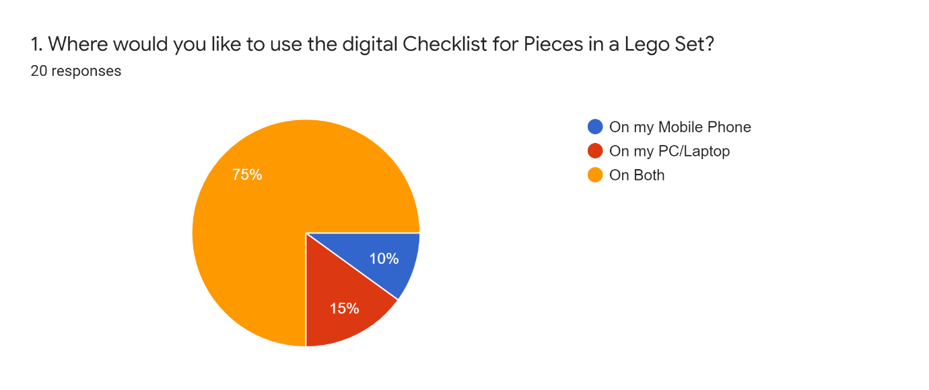

Figure – Question 1 Results

Question 1 showed me that the majority of users (75% see Figure 1 above or **Appendix B**) would like to use the digital checklist on both PC/Laptop and mobile devices, which helped inform me that my digital checklist for pieces in a Lego Set should run on both these types of systems.

I also learnt from questions answers to 2 and 3 (see **Appendix B**) that Lego enthusiasts who use a digital tool use the website Bricklink [3]. I found that on Bricklink users can add pieces from a Lego set to a “wanted list” and from there tick off parts you have. This shows the user how many pieces they need and how many they currently have found. However, this number easily be changed by accident which could cause issues. For example, users could believe they have all the pieces for a set but they accidentally decreased how many pieces they needed so are missing one, or the opposite where they increase the number they need but have all of them. Users can’t filter pieces by colour or type making it difficult to find pieces, also when pieces are fully found they are not hidden from the list. Any pieces missing can easily show a list of possible locations to buy them. Most of these issues appear because the purpose of the tool is to buy pieces for a Lego set.

The answers to question 3 (see **Appendix B**) also show some people currently use the Rebrickable website [4]. On Rebrickable, which also provides the API I am going to use, users can find a Lego set by typing in the set number or searching by a text search (i.e. Set Name) and filter by a range of year released, range of the number of parts and also filter by themes. On the page of a set (e.g. this Lego Set [5]) users can see a list of all parts, the instructions, pictures of the Lego set, the year released, the number of parts etc. Here if the user has an account they can add the set parts to a List. On the list, the user added parts too, users can filter by piece colour, type (Category) and sort by colour, Hue, part, type (category) and price to buy the Lego piece. Users can see how many each piece is required as well as the colour and price to buy it but to check a piece off the list, the user has to delete it from the list meaning you can’t undo the change, also users can change the number of certain pieces needed but not see the original number (like BrickLink see above). This is primarily due to the fact the tool is meant to help users buy Lego pieces for a set, also the same as Bricklink, but can be used as a makeshift checklist.

Overall, the results of questions 2 and 3 (see **Appendix B**) has helped me find and research similar software and helped give me ideas on what would be useful to use from these.

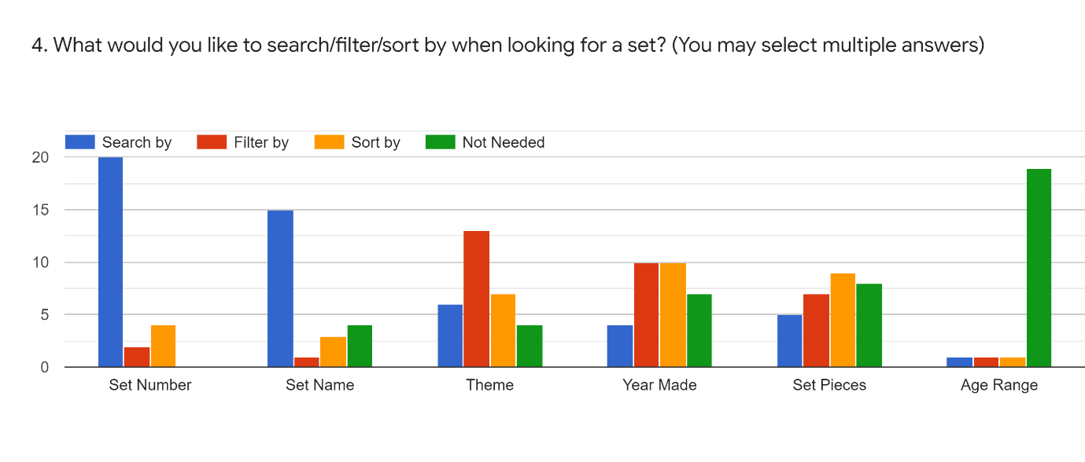

Figure – Question 4 Results

The results of question 4 (see Figure 2 above or **Appendix B**) provided lots of useful information about how users would like to search for a Lego set. Some of the answers were very conclusion for example 19 people said that searching by ‘Age Range’ for a Lego Set was not needed showing me that there is no demand for this search parameter. Likewise, all 20 respondents stated they would like to be able to search by ‘Set Number’.

The answers to the ‘Set Pieces’ section of question 4 (see **Appendix B**) are quite varied, with 8 responses saying it was ‘not needed’, which was one more than the ‘Filter by’ (7 responses) and one less than ‘Sort by’ (9 responses). This shows filter and sort for ‘Set Pieces’ only just make up the majority of responses showing that maybe this is not a key requirement when searching for a set but would still be useful.

Overall conclusions that I can draw from question 4 are that overall users would like to search by ‘set number’ and ‘set name’ when trying to locate a Lego Set. They would also like to filter by the ‘year made’, ‘theme’ and ‘Set Pieces’ as well as sorting by ‘Theme’, ‘Year Made’ and ‘Set Pieces’.

The results of Question 5 (see **Appendix B**) show that most people find it important or very important that a digital checklist the Lego pieces can be sorted by colour and type of piece, showing this should be a key feature of my digital checklist. However, being able to filter by Lego pieces type and colour is shown to be not as important and therefore are not as key to people. Finally, having a link to buy a missing Lego piece and being able to scan Lego pieces in a set to see if they are there and then check them off, have very mixed answers showing they should be nothing more than optional for the checklist.

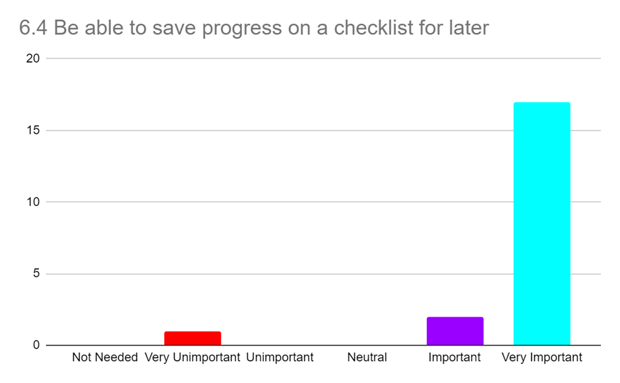

Figure – Question 6 part 4 (Be able to save progress on a checklist for later) Results

Question 6 results (see **Appendix B**) show that it is very important to most people (17/20 see Figure 3 above) to be able to save progress on a checklist making this a key requirement for the system. Being to view and download instructions is also important to most users, as is being able to save Lego sets they own to a list meaning this is also key. The responses to having a favourites list for Lego sets are very mixed but mostly positive showing that it would be nice to have but not key.

From the responses to question 6 I went and found the Brickset API [7] that requires a free API key, and I can use it to retrieve Lego set instructions (as the current Rebrickable API cannot do this). These are returned as a list of instruction PDF links, in a JSON file. This API also allows users to search for Lego Sets, but I will only use this API for retrieving instructions as it does not contain data on pieces within a Lego set, which is a vital part of the project.

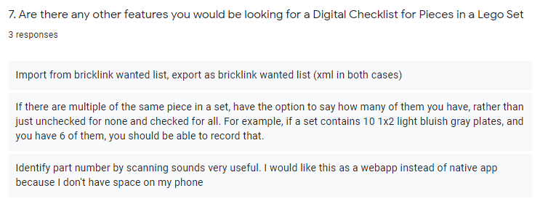

Figure – Question 7 Results

Finally, the results of question 7 (see Figure 4 above or **Appendix B**) where users are allowed to add any ideas for any other features gave some useful ideas. For example, being able to also scan bricks with a webcam as well as a mobile for PC/Laptop users. As well as if there are multiple Lego pieces of the same type and colour on the checklist being able to record the specific number of these found. Finally, another feature suggested was to import and export XML files like a Bricklink [3] wanted list. I took these suggestions into account when designing my requirements.

## Requirements

### Key Features:

* The system must be usable as a website on both mobile and PC/laptops
* The system must display a list of all Lego sets stored in Rebrickable API [1]
* The system must have a search feature that allows users to search a list of Lego sets. Can search by set number and text search (e.g. set name), and filter and sort by year made and set theme.
* Users must be able to ‘check’ piece off the checklist, showing how many more of that piece are remaining
* The system must show on the checklist (for Lego pieces in a set) a picture of the piece, with the correct colour, as well as an alternative text description including the piece name and colour
* Users must be able to sort a checklist by colour and type of a Lego piece
* The system must be usable with and without a user account
* Users must be able to save progress on a checklist

### Nice to have Features:

* The system may have an additional search parameter to sort and filter by the number of pieces in a Lego set
* The system may have an additional search parameter to sort alphabetically by Set Name
* The system may have a consistent and simple UI
* Users may be able to view instructions for a Lego set
* Users may be able to download instructions for a Lego set
* Users may be able to filter a checklist by the colour of a piece
* Users may be able to filter a checklist by type of a piece
* The system may have a link to buy a missing piece from a Lego Set
* Users may be able to create an account
* Users with an account may be able to save sets they own to a ‘Sets Owned List’, so they can easily find them later

### Optional Features:

* Users with an account could create lists for Lego sets and save sets to them, so they can easily find them later (Sets can be in multiple lists)
* Users could search their ‘Sets Owned List’ and other lists for Lego sets, like the main search feature
* The system could save a user's progress on a checklist in the database
* The system could also be a mobile application
* Users could scan Lego pieces with a phone camera or webcam to check if the piece is in a Lego list
  + If it is in the set (and not already enough of them), there is an option to check pieces off the Digital Checklist
  + If in the set but already have all that type of piece needed, it will inform the user of this
  + If not in set it will inform the user of this
* Users could import and export a checklist as an XML file in the Bricklink [3] wanted list format

## Design

### A High-level overview of the architecture of the system

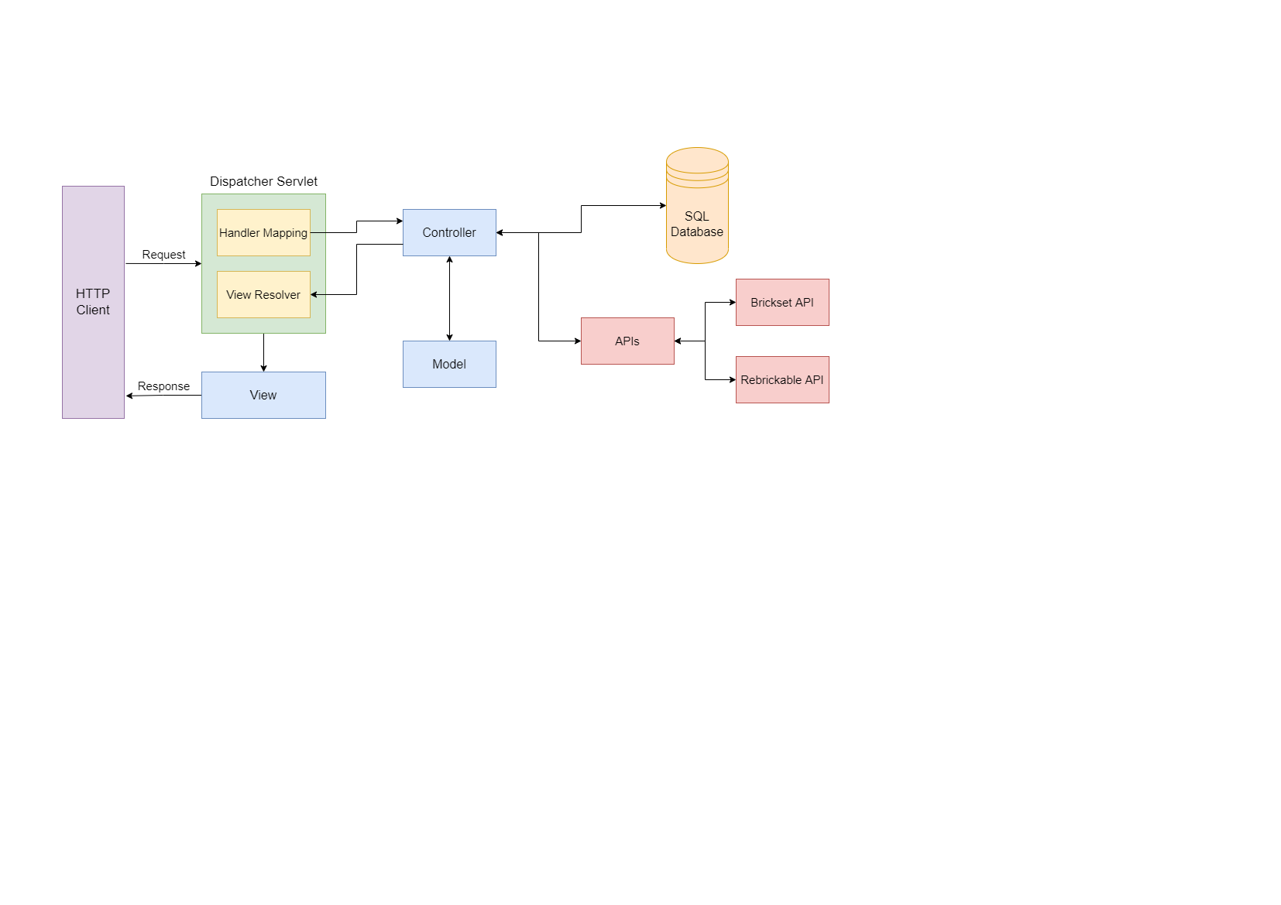

Figure – High-Level Overview

Figure 5 above shows a high-level view of the Spring MVC (Model-View-Controller) architecture that my website uses. Where the view is a JSP (Java Server Page) that is displayed to the users on the HTTP client (their web browser). When the user interacts with the View, via the web browser, a request is sent to the Dispatcher Servlet. Here the Dispatcher Servlet will use the Handler Mapping to match the request URL to the correct Controller. The controller will then call APIs or interact with the SQL database to collect and edit information as needed, it will then update attributes in the Model, before returning the name of the next View to the View Resolver. View Resolver, which locates the correct View add adds in the Model attributes. This View is then sent back to the HTTP client as a response.

### APIs

#### Rebrickable API

The Rebrickable API [1] (as mentioned above see 3 Survey of Literature/Information Sources) stores all the data about all Lego sets and the Lego pieces in these sets, as well as all the Lego themes and which sets are in them. This API will be used to search for Lego sets and retrieve all the Lego pieces in a Lego Set.

#### Brickset API

The Brickset API [7] (as mentioned above, see 3 Survey of Literature/Information Sources) will be used to obtain PDF instructions for a Lego set so users can view and download these for a Lego set.

### Database Design

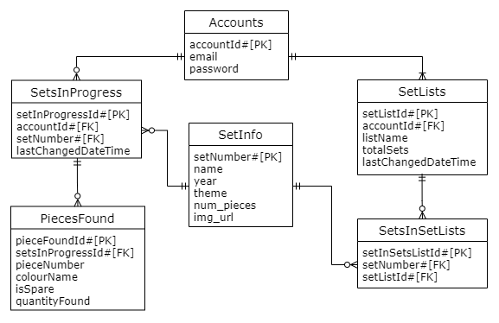

Figure – ER Class Diagram

I have used SQL for my database, and Figure 6 above shows an ER class diagram for this database, that may change depending on the requirements completed. The database has several tables called Accounts, SetsInProgress, PiecesFound, SetLists, SetsInSetsList and SetInfo. These database tables are generated using hibernate [8] and JPA [9] in the classes described in the 5.4 Class Diagram.

The Accounts table is used to store user accounts, with ‘accountId’ as the primary key, ‘email’ which is a unique attribute as an email can only belong to one account, and a ‘password’ that is encrypted using a hash and salt.

The SetsInProgress table stores the set numbers of sets (‘setNumber’) that a user currently has a checklist in progress for, the information for these sets is stored in the ‘SetInfo’ table explained below. ‘setInProgressId’ is the primary key, with the user’s ‘accountId’ as the foreign key so it's easy to find which user it belongs to. Finally, ‘lastChangedDateTime’ which stores the last time the set in progress was saved to the database, this is used so that the last 3 used sets in progress can be displayed to the user on the home page.

The PiecesFound table is used to store pieces for a ‘SetInProgress’ and contains attributes ‘pieceFoundId’ is the primary key, ‘setInProgressId’ is a foreign key so it's easy to identify which setInProgress the pieceFound belongs to. The ‘pieceNumber’, the ‘colourName’ is the colour of the piece, ‘isSpare’ shows if this is a spare provided piece with the Lego Set but not required to build the set and ‘quantityFound’ is the quantity of the particular piece that has currently been found (if 0 pieces have been found these won’t be saved to save database storage).

SetLists table stores lists the user has created, that contain Lego sets (called setlists). The table stores the name of the list (‘listName’), a primary key (‘setListId’) (used to find the sets that belong to the list in the SetsInSetsList table explained below), the total number of sets in the list (‘totalSets’), with the user’s ‘accountId’ as the foreign key so it's easy to find which user it belongs to. Finally, ‘lastChangedDateTime’ which stores the last time the setlist was saved to the database, is used so that the last 3 used setlists can be displayed to the user on the home page.

SetsInSetsList stores the set numbers of sets (‘setNumber’) saved to a setlist in the database, the information for these sets is stored in the ‘SetInfo’ table explained below. It has a primary key ‘setInSetListId’, ‘setListId’ is a foreign key so it's easy to identify which setlist this belongs to and the ‘setNumber’ for the set, which can only appear once in a setlist.

The SetInfo table holds information about sets stored in either the SetsInProgress or SetsInSetLists tables. ‘setNumber’ is the primary key that is used to link to this table in the other tables, the set’s ‘name’, ‘year’ released, ‘theme’, number of pieces in the set ‘num_pieces’ and a URL for an image of the set (‘img_url’).

### Class Diagram

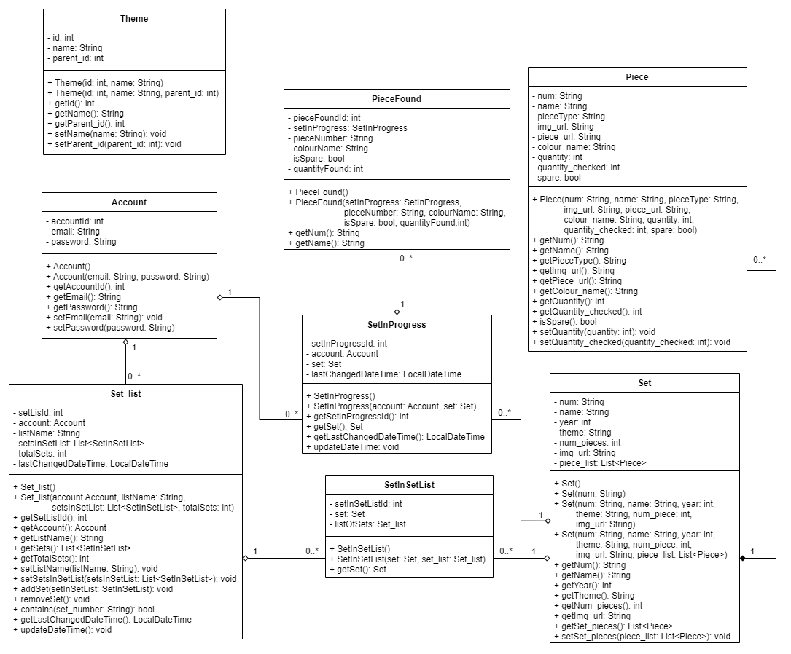

Figure – Class Diagram

Figure 7 above is a class diagram for my system, with several classes Set, Piece, SetInSetList, Set_list, SetInProgress, PieceFound, Account and Theme.

The Set class is used to store Lego Set data read from a JSON file received from the Rebrickable API [1]. This data includes the Lego Set’s Number (‘num’) which is a unique number that identifies the Lego Set, and this is a string because all set numbers contain a '-' that is followed by a version number that donates different versions of certain sets, with the standard being '-1'. It also contains the ‘name’ of the Set, the ‘year’ released, the ‘theme’ the set belongs to, the number of Lego pieces (‘num_pieces’) in the set, a URL for an image of the set (‘img_url’). Finally, there is an attribute called ‘piece_list’ which is a list of the Piece class and is used to store a list of all Lego pieces in a Lego set.

The Piece class is used to store information about a Lego piece read from a JSON file received from the Rebrickable API [1]. This contains a piece number (‘num’) as these sometimes contain letters this is a string, ‘name’ of the piece, a ‘pieceType’ which is the type of Lego piece the piece is, a URL for an image of the piece (‘img_url’) and another URL (‘piece_url’) to the piece’s page on the Rebrickable website where the user can view a list of websites to buy the Lego Piece [6]. A ‘colour_name’ that’s the colour of the piece, ‘quantity’ which is the number of these pieces that are required to build the Lego Set, ‘quantity_checked’ which is the quantity the user has checked off these pieces and finally ‘spare’ which denotes if this piece is a spare provided with the Lego Set but not required to build the set.

The SetInSetList class is used to link the Set_list and Set classes and is used for the database (using Hibernate [8] and JPA annotations [9]) so that information on a Lego set does not have to be duplicated if in several setlists, and can just save a table that links to the set via the set’s number. It contains a unique auto-generated id (‘setInSetListId’) used as the primary key for the table in the database, ‘listOfSets’ is the setlist the set is in and ‘set’ is the set that is in the setlist.

The Set_list class is used to store a list of the class SetInSetList which is created by the user or retrieved from a user’s setlist of Lego sets from the database, and as explained above SetInSetList links to the Set Class, which stores the information on Lego sets that part of a setlist. This class is also used to create the database using Hibernate [8] and JPA annotations [9]. It contains the name of a list (‘listName’), the user ‘account’ the list belongs to, ‘setListId’ is a unique auto-generated id used as the primary key in the database, the number of sets in the list (‘totalSets’), ‘lastChangedDateTime’ which holds the last date and time the class was changed and is used so that the last 3 used setlists can be displayed to the user on the home page and so that the last accessed list is at the top of the selector when selecting a setlist to add a Lego set to. Finally, there is a List of type SetInSetList (‘setsInSetList’), that is used to store all the Lego sets in the list. It contains several functions with the ‘contains()’ that checks if a set is in the list, ‘updateDateTime()’ sets the ‘lastChangedDateTime()’ to the current date and time, ‘addSet()’ adds a set to the list and increases total sets by 1, and ‘removeSet()’ that decreases total sets by 1.

The SetInProgress class also uses Hibernate [8] and JPA annotations [9] to generate a table that connects a user’s account to a Lego Set checklist that they have saved to the database. Similarly, the SetInSetList class links to the Set class so that in the database set information is not saved multiple times, by having a variable ‘set’ of type Set. This also contains the user ‘account’ the set in progress belongs to, ‘lastChangedDateTime’ which holds the last date and time the class was changed (used like Set_list to display the last 3 last saved sets in progress), and ‘setInProgressId’ is a unique auto-generated id used as the primary key in the database. This also contains a ‘updateDateTime()’ which operates in the same way as in the Set_list class.

The PieceFound class is another class that is used to create the database (using Hibernate [8] and JPA annotations [9]). This class is used to store pieces from SetsInProgress, and only contains information that makes each piece unique, the ‘pieceNumber’ which is unique, the piece’s colour (‘colourName’) and if it is a spare piece (‘isSpare’) and finally how many of this particular Lego piece has been found (‘quantityFound’). It also has an auto-generated primary key ‘pieceFoundId’.

The Account class is used to create the database table (with Hibernate [8] and JPA annotations [9]) that holds an account user’s information. It has a user’s auto-generated primary key (‘accountId’), the user's ‘email’ and ‘password’ that is used by a user when logging into the website.

Finally, the Theme class holds information about Lego Set themes retrieved from the Rebrickable API [1] as a JSON file. This class is separate from the other tables and is used to store all the themes, so that each time a set is received from the Rebrickable API [1], the program does not have to call the API again with a theme number to retrieve that theme’s name. It contains a unique ‘id’ used to identify the theme, the theme’s ‘name’ and ‘parent_id’ which is the id of the theme that this theme is a sub-theme for.

### User Interface Design

Throughout the UI all buttons, links and images contain tooltips informing the user on what action is performed when clicking the button, link or image. Input boxes also have tooltips informing the user what should be inputted. All images have alternative text informing the user what the image is. Additionally, in all the initial design Figures, a blue square denotes an image.

#### Home Page

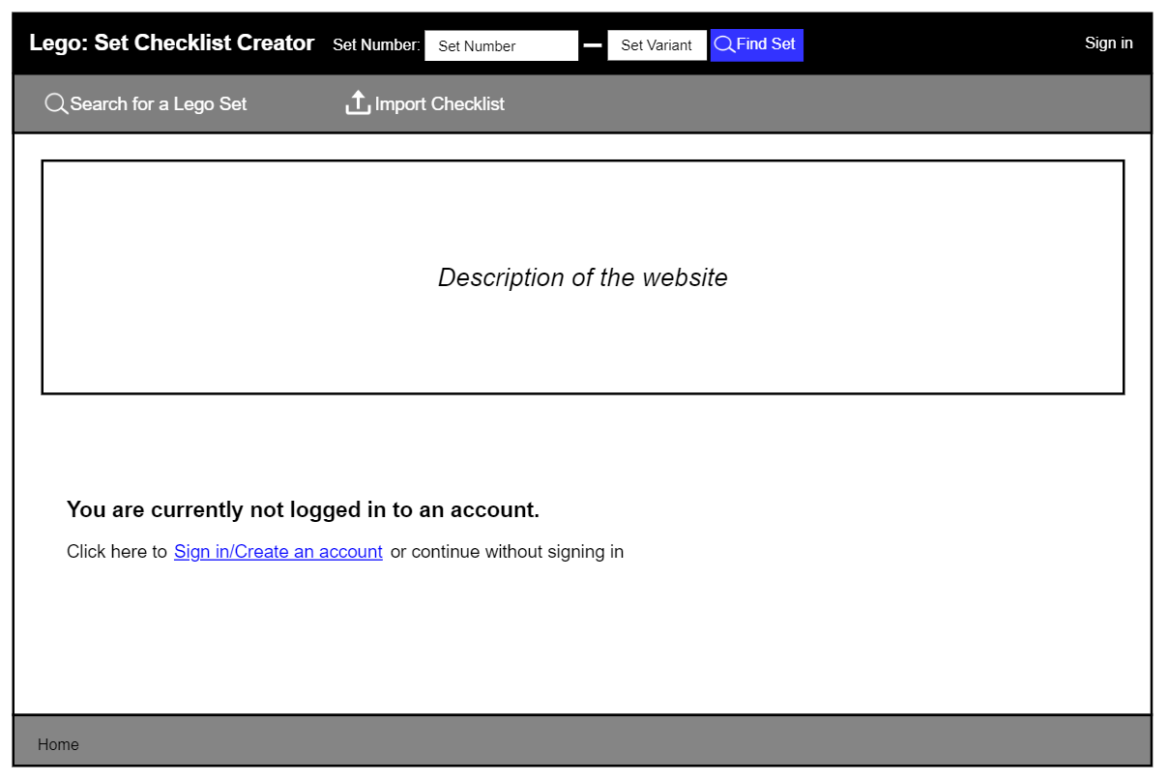

Figure : Initial Home Page - logged out

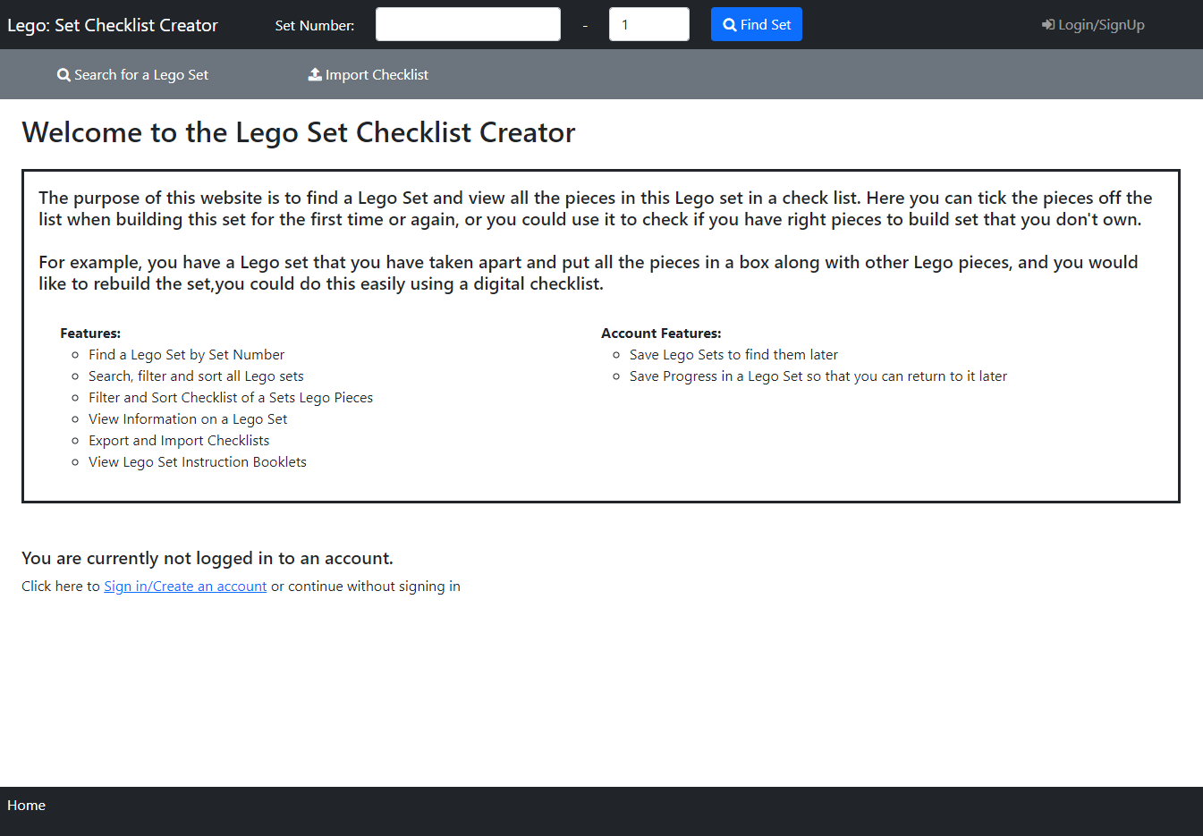

Figure : Home Page - logged out

The first page that appears to the user when they access the site is the home page (Figure 9). On this page, welcome message with the site name which I added so it was immediately clear to users which site they are viewing. Under this users can view a description of the website and what it is used for, helping useability by making it clear what the website does. There is also some text informing the user that they are not logged in, offering users the option to ‘Sign in/Create an account’ (which is a hyperlink), but also making it clear to users that they can continue without these. When this hyperlink is clicked it opens the Login and Sign-Up Popup with the Login Tab Selected (Figure 40), explained below.

At the top of the page is a black navbar containing the website's name so it’s clear to users what website they are on. Then there are 2 number boxes where users can enter a Lego set number and variant number (at least 1) and a ‘Find Set’ button that will search for the Lego Set and return Figure 17 or Figure 19, these are explained in Set Page below. Finally, there is a ‘Login/SignUp’ link which opens the Login and Sign-Up Popup with the Login Tab Selected (Figure 40), explained below.

Underneath the navbar is a secondary navbar with a ‘Search’ link that opens the Search Page (below) and an ‘Import Checklist’ link that opens Figure 37: Import Checklist Popup where users can import a previously exported checklist.

The breadcrumb trail, in the footer at the bottom of the page, has the current page in white text, informing them of their current position in the user journey.

Compared to the initial design in Figure 8 the final design (Figure 9) are mostly the same, except the final design also includes a welcome message with the site name above the website description box (which has also now been filled in). In addition, the ‘Sign in’ navbar link text has been replaced by ‘Login/SignUp’ in the final design.

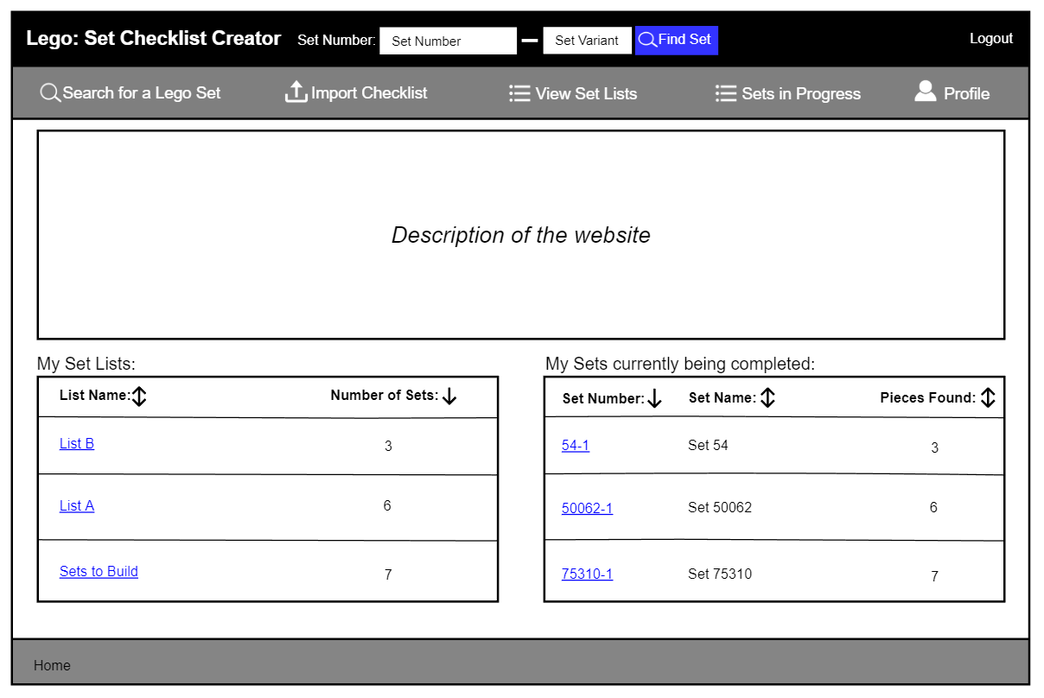

Figure : Initial Home Page - logged in

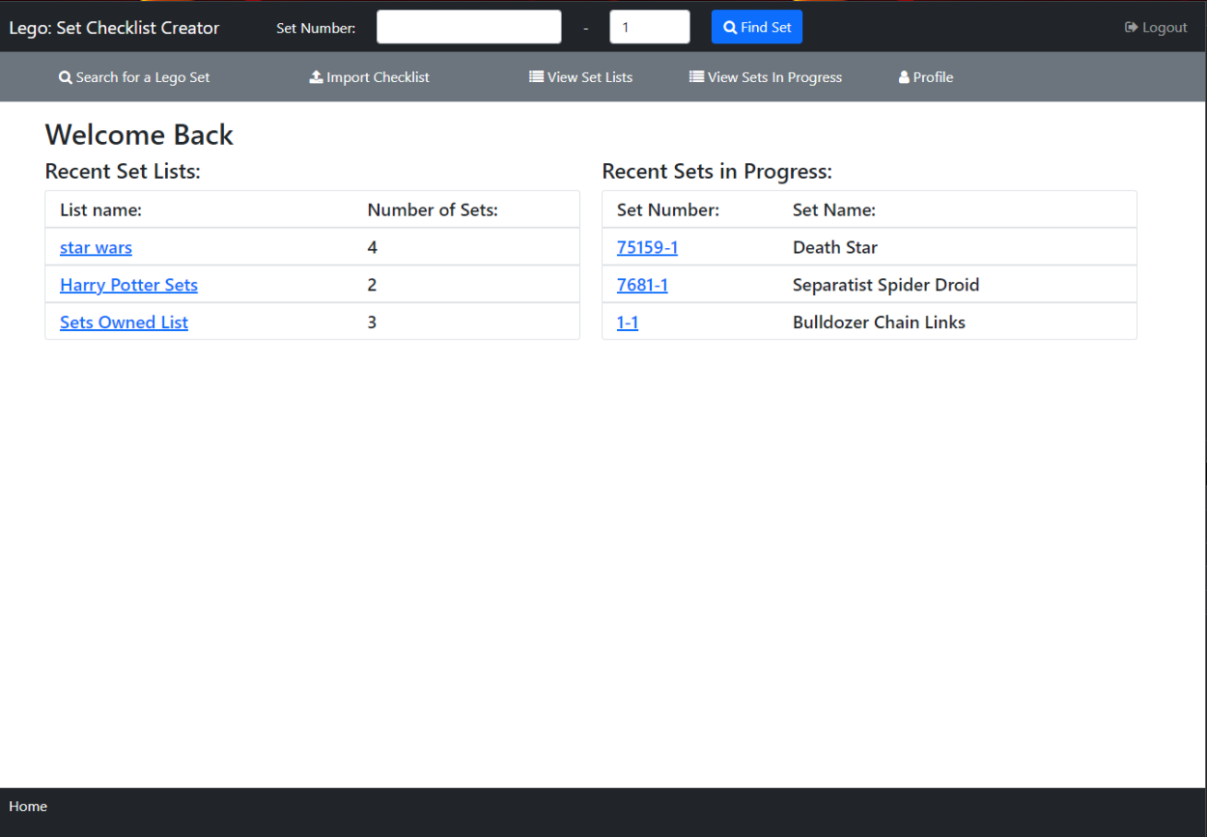

Figure : Home Page - logged in

The home page displayed to a logged-in user (Figure 11) is mostly the same but with a few differences. The ‘Login/SignUp’ link has been replaced with ‘Logout’, which when clicked opens Figure 55: Logout Popup, explained later.

Additional links are now shown to the user on the secondary navbar, with links to view their ‘Set Lists’ (Set Lists Page below), ‘Sets In Progress’ (Sets in Progress Page below) and their account ‘Profile’ page (Profile Page below).

The not logged in message is replaced with the user's last three edited setlists, with links that can be used for quick access to view these, along with the user's last three saved sets in progress, accessed by clicking the hyperlinks for the ‘List Name’ and ‘Set Number’ respectively.

There is a difference between the initial design (Figure 10) and the final design (Figure 11). In the final design, I removed the website description as I felt if users already had an account they would not need to have the website explained to them, the final design instead includes a welcome back message to greet users back to the site.

#### Search Page

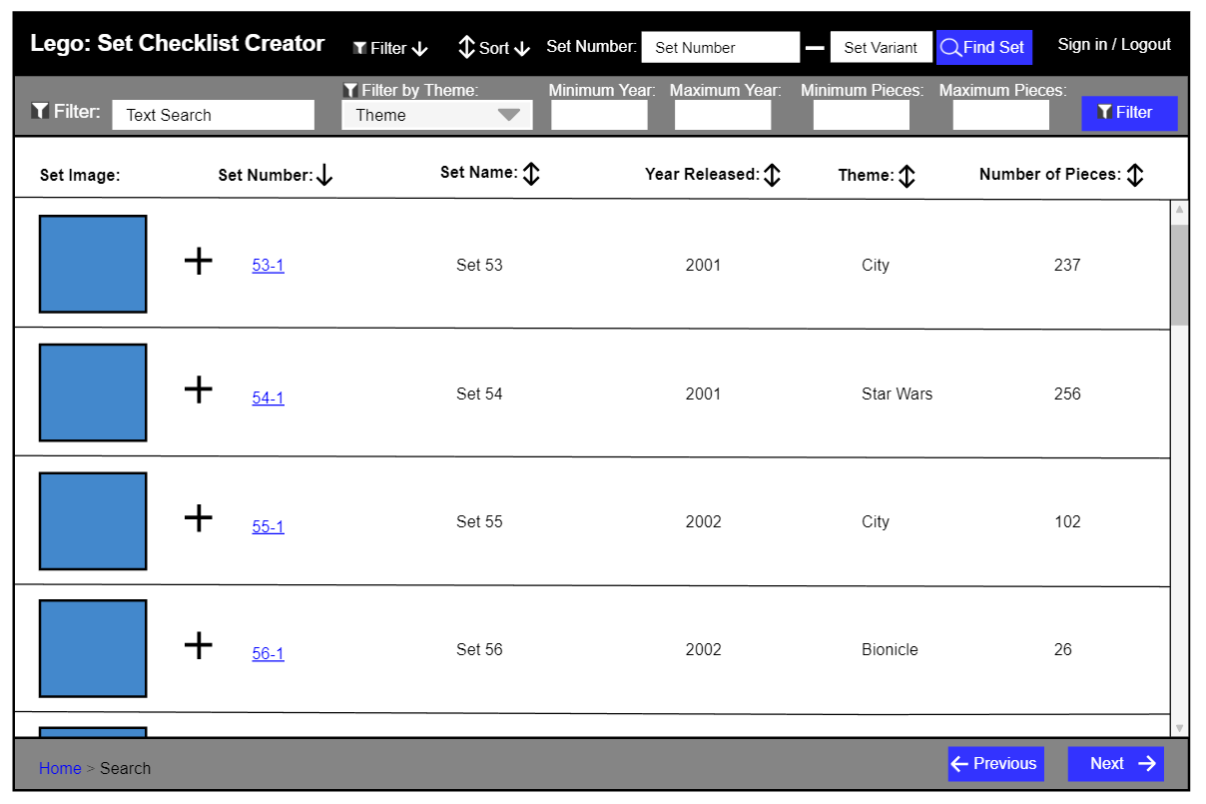

Figure : Initial Search Page - Filter Bar Open

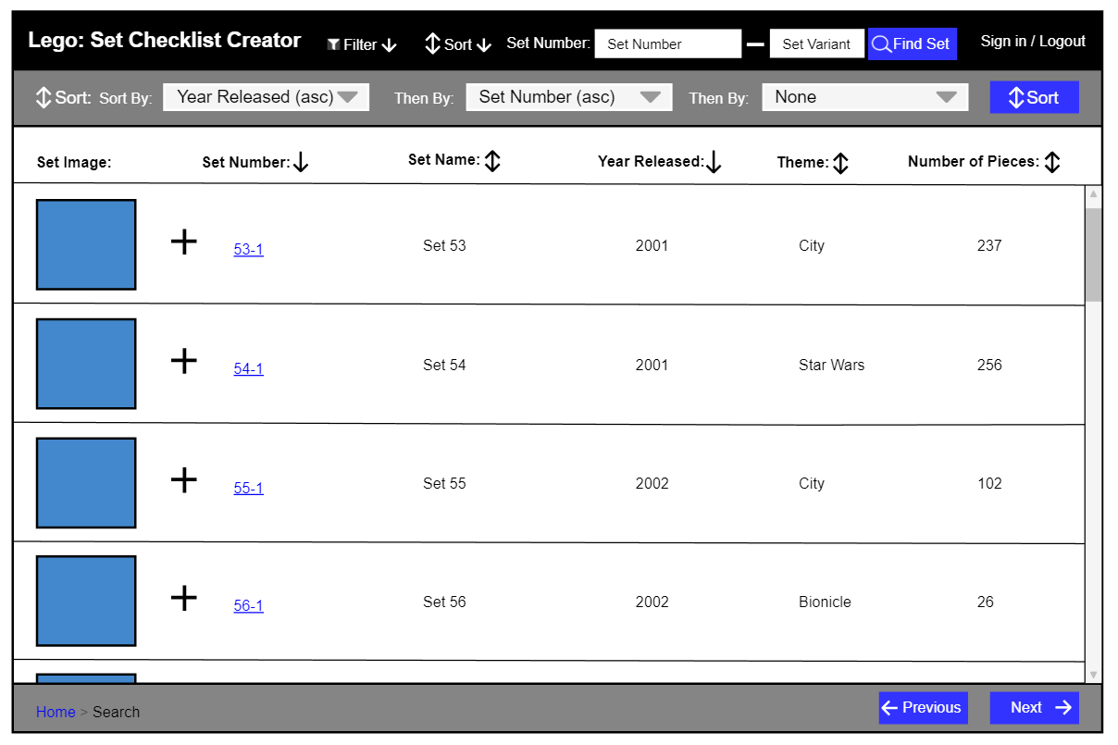

Figure : Initial Search Page - Sort Bar Open

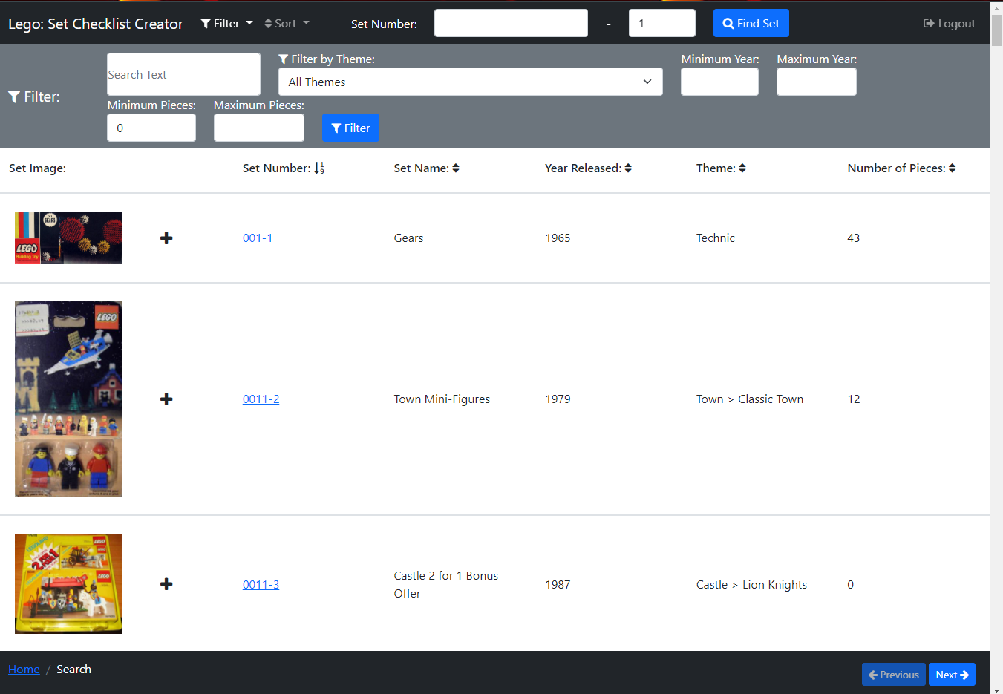

Figure : Search Page - Filter Bar Open

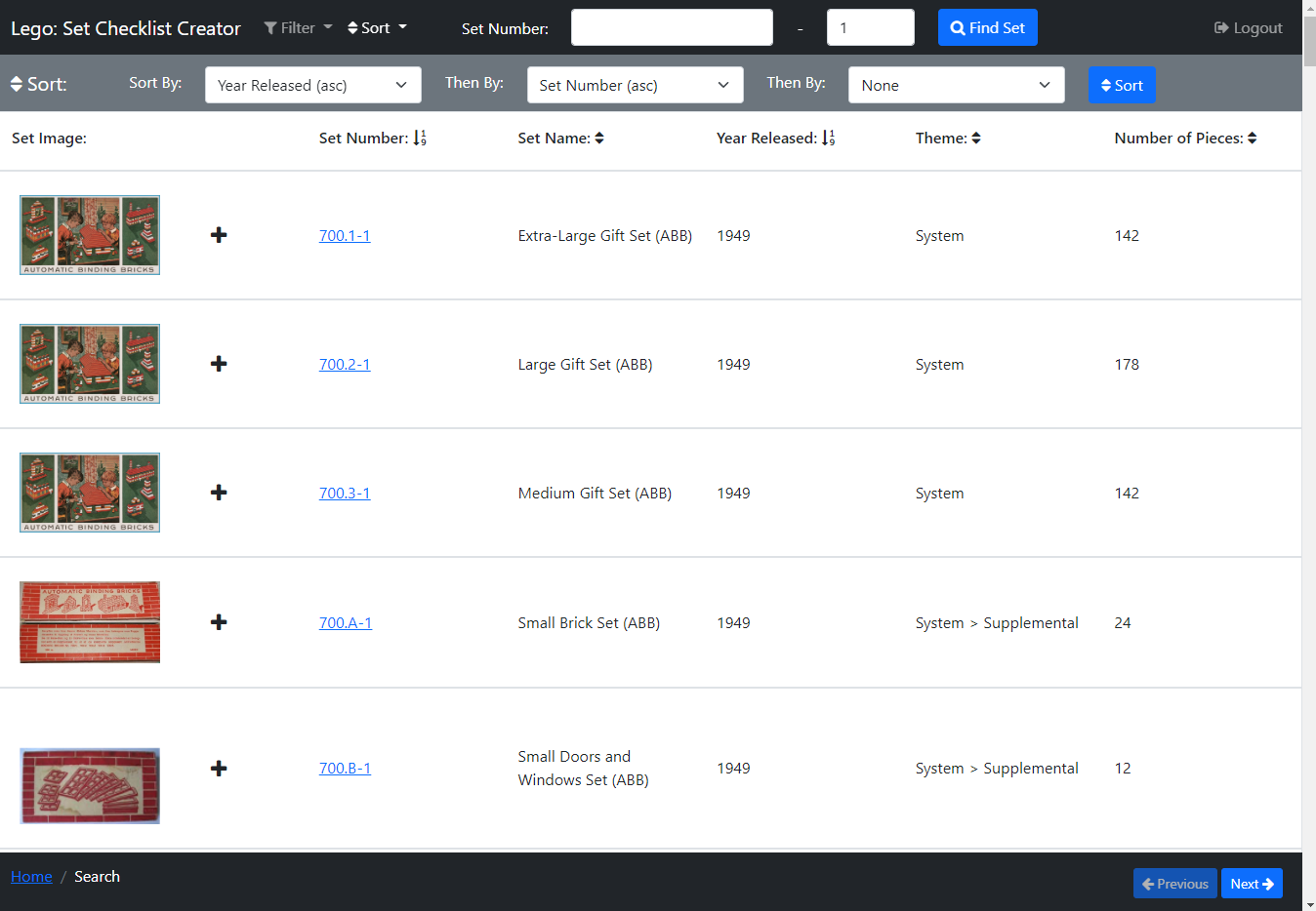

Figure : Search Page - Sort Bar Open

The Search Page (Figure 14 and Figure 15) can be accessed by clicking the ‘Search’ link on the secondary navbar on the Home Page (above), or the ‘BACK TO SEARCH’ button on the Set Page (below) or breadcrumb links on other pages. On this page users can search for a Lego Set they would like to view.

In the centre of the page, a list of Lego sets is displayed in rows, with columns displaying different bits of information on Lego sets. There is an image of each Lego Set in each row, that when clicked will open Figure 35 to view the image enlarged (see more detail below). There is a ‘plus’ icon button that only appears to signed-in users, that when clicked opens a popup (Figure 73) to add a set to a setlist.

Above the list of sets is a header that has the name for each column, so it is clear to the user what each of these columns contains. Each of these column names (excluding ‘Set Image’), has an arrow next to it, these show if the sets are being sorted by that column, with a down arrow showing the list is being sorted ascending in that column, an up arrow shows descending and an up-down arrow shows the sets are not being sorted by that column. For example, in Figure 14 the sets are being sorted by ‘Set Number’ ascending and not by any other column.

Clicking one of these arrows will sort the sets in the column the arrow is adjacent to. If a down arrow is clicked the sets will be sorted descending and the arrow will change to an up arrow, if it’s an up arrow they will be sorted ascendingly, and the arrow will change to a down arrow. If an up-down arrow is clicked the sets will be sorted ascendingly, and this arrow will change to a down arrow and any other arrows that are not up-down arrows will change to up-down as those columns are no longer being filtered. Clicking on an arrow to sort a list will remove any other sorts currently active including a multi-sort selected via the sort bar, which is explained below.

There is a scroll bar down the side of the page so users can scroll through this list of Lego Sets, and in the footer, at the bottom of the page there are two buttons ‘Previous’ and ‘Next’, which go to the previous page of sets or the next page of sets, these are disabled if it is the first list of sets or last list of sets respectively.

If the user clicks a Set’s set number, which is a hyperlink, Figure 17: Lego Set Information Page will open displaying the selected set.

At the top of the page is a black navbar containing the website's name so it’s clear to users what website they are on, which when clicked acts as a link returning the user to the Home Page (above). There is a navbar link ‘Filter’ which opens a filter bar underneath the navbar (shown open in Figure 14), closing the sort bar (shown open in Figure 15) if it is open. Likewise, the ‘Sort’ navbar link opens a sort bar underneath the navbar shown open in Figure 15, closing the filter bar if it is open. Then there are 2 number boxes where users can enter a Lego set number and variant number (at least 1) and a ‘Find Set’ button that will search for the Lego Set and return Figure 17 or Figure 19, these are explained in Set Page below. Finally, there is a ‘Logout’ navbar link which will appear as ‘Login/SignUp’ when the user is not logged into an account, and ‘Logout’ when they are. ‘Login/SignUp’ opens the Login and Sign-Up Popup with the Login Tab Selected (Figure 40) and ‘Logout’ opens Figure 55: Logout Popup, these are both explained later.

The filter bar (Figure 14) contains filters the user can use to filter the Lego Sets, there is a text box to search by text (e.g. ‘Clone’), a select box to filter by Lego Set Theme (e.g. Star Wars, Lego City, Batman), ‘Minimum Year’ and ‘Maximum Year’ number boxes that filter between these years, ‘Minimum Pieces’ and ‘Maximum Pieces’ number boxes that filters the sets by the minimum and the maximum number of Lego Pieces in the set and the ‘Filter’ button then applies these filters to all Lego Sets.

The sort bar (Figure 15) contains three select boxes so a user can perform a multi-sort, containing all the columns sorts ascending and descending with also the option of none. The first select must always be selected, and by default, the sets are sorted by ‘Set Number’. This is used by selecting a column to sort by and then the preceding column to sort by, up to a maximum of three columns, this means where the first column values of sets match then they are compared by the second column value instead e.t.c. There is then a ‘Sort’ button that when pressed applies this sort to the list. For example, in Figure 15 the sets are first being filtered by ‘Year Released’ ascending and then by ‘Set Number’ ascending, so the ‘Extra-Large Gift Set (ABB)’ and ‘Large Gift Set (ABB)’ both have ‘Year Released’ of ‘1949’ so they are then compared by ‘Set Number’ and as ‘Extra-Large Gift Set (ABB)’ has a set number of ’700.1-1’ and ‘Large Gift Set (ABB)’ has a set number of ’700.2-1’ therefore ‘Extra-Large Gift Set (ABB)’ appears first.

The breadcrumb trail, also in the footer, has the current page in white text, with the previous pages to the right with hyperlinks to those pages. I added this so a user can see their position on the user journey.

There are no differences between the initial design (Figure 12 and Figure 13) and the final design (Figure 14 and Figure 15) on this page, however, in the final design the ‘Sign in’ link has changed to ‘Login/SignUp’.

#### Set Page

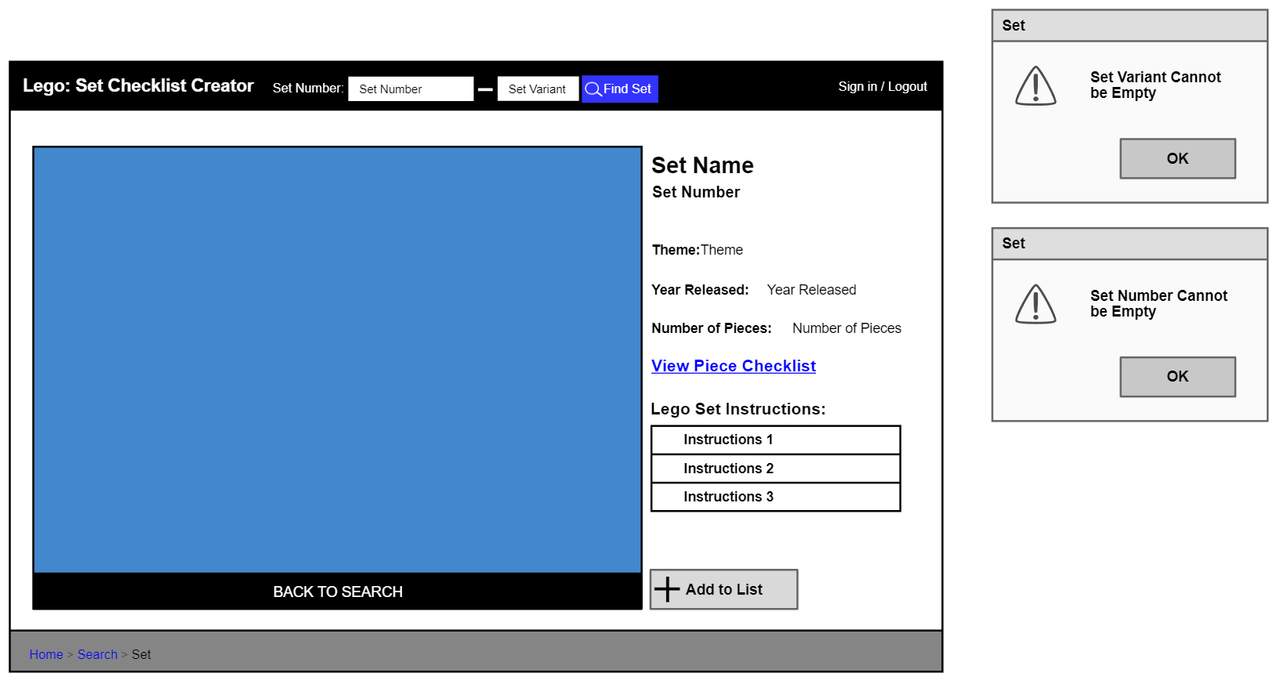

Figure : Initial Lego Set Information Page

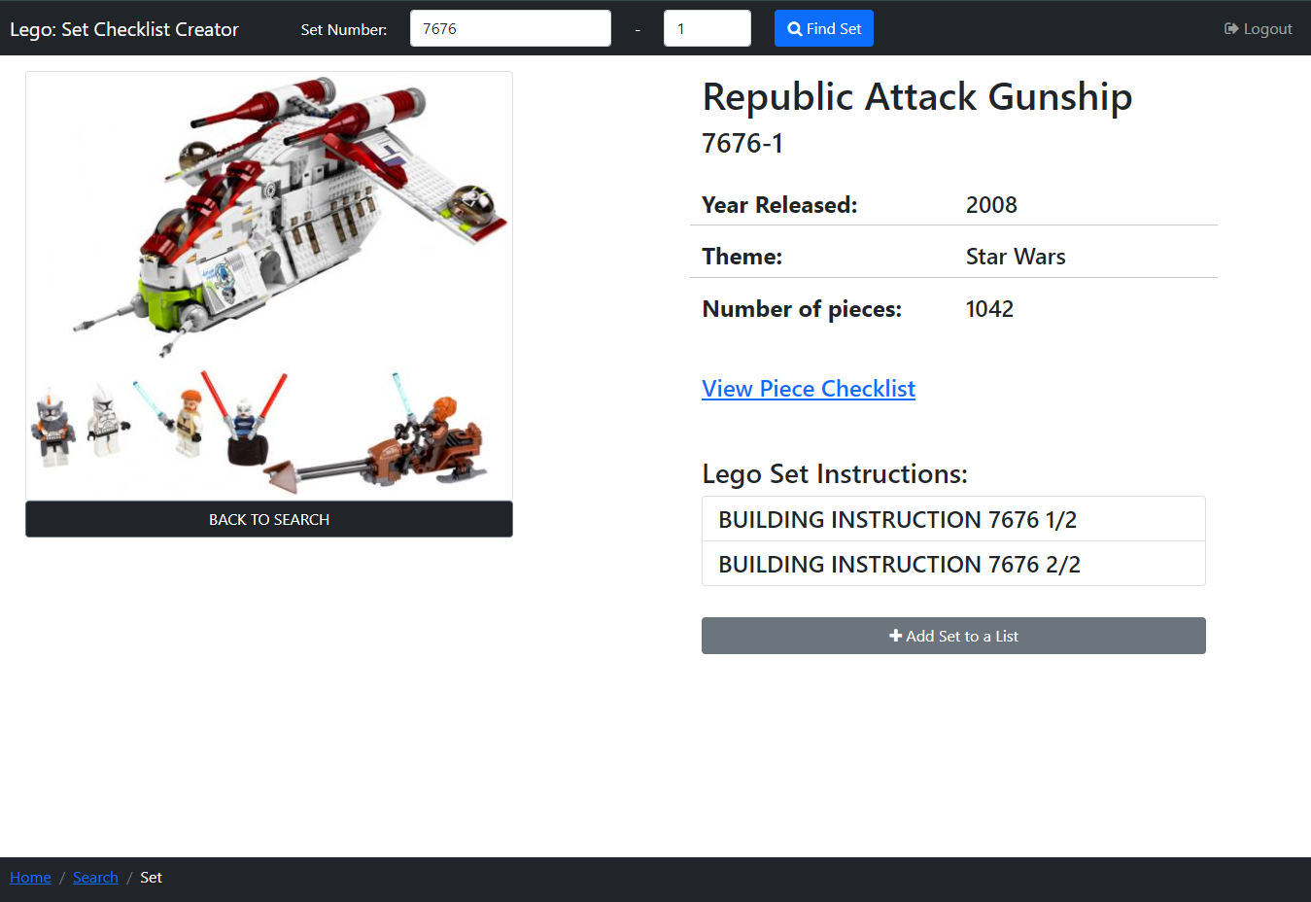

Figure : Lego Set Information Page

The Set Page (Figure 17) can be accessed by entering a Set Number and Variant in the navbar on the Home Page (above), Search Page (above) and this page, it can also be accessed by clicking a sets ‘Set Number’ hyperlink on Search Page (above), Sets in Progress Page (below) and the Set List Page (below), or via the breadcrumb link on Piece Checklist Page (below).

On this page, users can view information on a Lego Set, view the Set’s building instructions, access the Set’s pieces in a checklist and signed in users and add the set to a setlist, this example Set ‘Republic Attack Gunship’ is being shown.

In the centre of the page, there is an image of a Lego Set that when clicked will open Figure 35 to view the image enlarged (see more detail below). Below this image is a ‘BACK TO SEARCH’ button which returns users to the Search Page with the previous Filters and Sorts applied. On the right of the image, information on the Lego Set is displayed.

Under this is the ‘View Piece Checklist’ hyperlink, which when clicked opens Figure 25: Piece Checklist Page, which displays a checklist of the Lego sets pieces (explained in more detail below).

There is some text ‘Lego Set Instructions’ beneath which, there are some boxes containing the names of Lego Set building instruction booklets, which when clicked opens the selected instruction booklet in a new tab on the browser being used where the user can view these.

There is a ‘Add to List’ button that only appears to signed-in users, which when clicked opens a popup (Figure 73) to add a set to a setlist.

At the top of the page is a black navbar containing the website's name so it’s clear to users what website they are on, which when clicked acts as a link returning the user to the Home Page (above). Then there are 2 number boxes where users can enter a Lego set number and variant number (at least 1) and a ‘Find Set’ button that will search for the Lego Set and return Figure 17 or Figure 19 which are explained here. On this page, the set number box and set variant number box are pre-filled with this set’s information, in this case, ‘7676’ and ‘1’. I have added this information here as if the user has used this method to find the set they can still see what they entered.

Finally, there is a ‘Logout’ navbar link which will appear as ‘Login/SignUp’ when the user is not logged into an account, and ‘Logout’ when they are. ‘Login/SignUp’ opens the Login and Sign-Up Popup with the Login Tab Selected (Figure 40) and ‘Logout’ opens Figure 55: Logout Popup, these are both explained later.

The breadcrumb trail, also in the footer, has the current page in white text, with the previous pages to the right with hyperlinks to those pages. I added this so a user can see their position on the user journey.

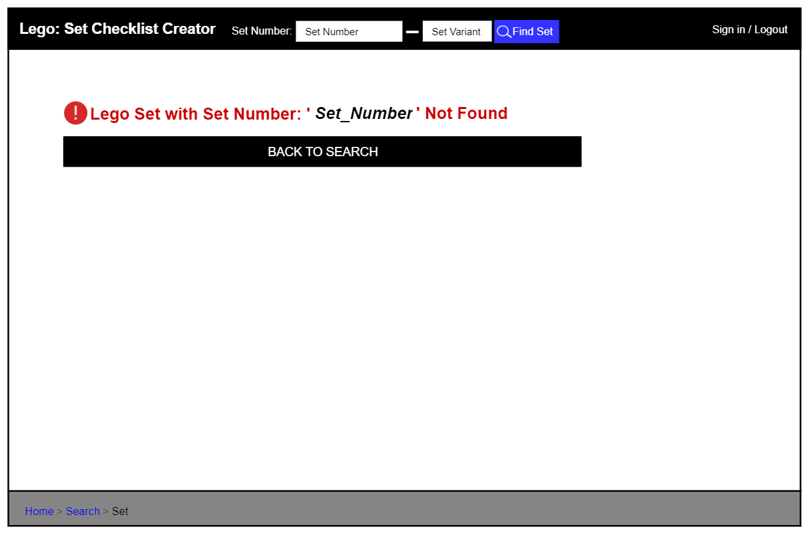

Figure : Initial Lego Set Not Found Page

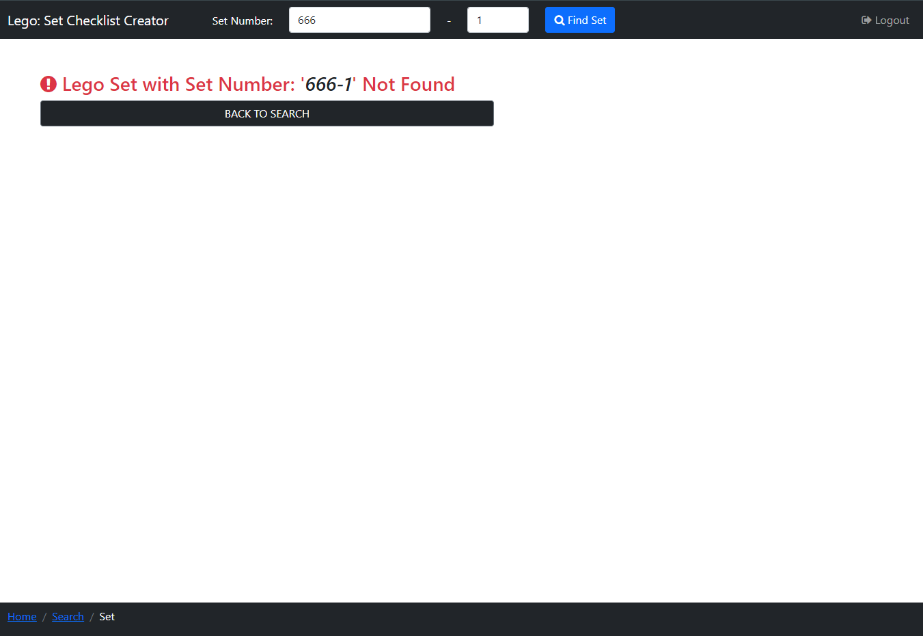

Figure : Lego Set Not Found Page

If the page is accessed by entering in a Set Number and this Set Number is not found, Figure 19 is displayed, this is mostly the same as Figure 17 (Lego Set Information Page) but the main body is replaced with a message informing the user that the set number (in this case ‘666-1’) entered was not found and with the same ‘BACK TO SEARCH’ button. I have put this message in red text with a recognised error logo so it draws the user's attention and is clear to users why a set has not been displayed.

The initial design for this page is shown in Figure 16 and Figure 18, and there are no differences between these and the final design (Figure 17 and Figure 19), apart from the ‘Sign in’ link which has changed to ‘Login/SignUp’ in the final design.

#### Set Number and Variant Search Errors



Figure : Initial Set Number Search Missing Number Error Popups



Figure : Set Number Search - Missing Set Number



Figure : Set Number Search - Missing Set Variant



Figure : Set Number Search - Missing Both Set Number and Variant

If a user clicks the ‘Find Set’ button in the navbar on the Home Page (above), Search Page (above) and Set Page (above), but either the Set Number box or Set Variant box is empty, the set number is not searched for. If the Set Number box is empty it is highlighted red (Figure 21), or if the Set Variant box is empty it is highlighted red (Figure 22), and if both boxes are empty, they are both highlighted red (Figure 23). I have highlighted these empty boxes in red to show there is an error, as this is a recognised colour for errors. In Figure 21 and Figure 22 the Set Variant box and the Set Number Box are highlighted in green (respectfully) to make it clear to users these boxes are not the problem.

I had initially planned to use popups to display to the user if a number was missing (see Figure 20), but I decided to highlight the boxes in red as this makes it clear to the user that an error has occurred without the user having to spend time closing an alert popup breaking up their flow.

#### Piece Checklist Page

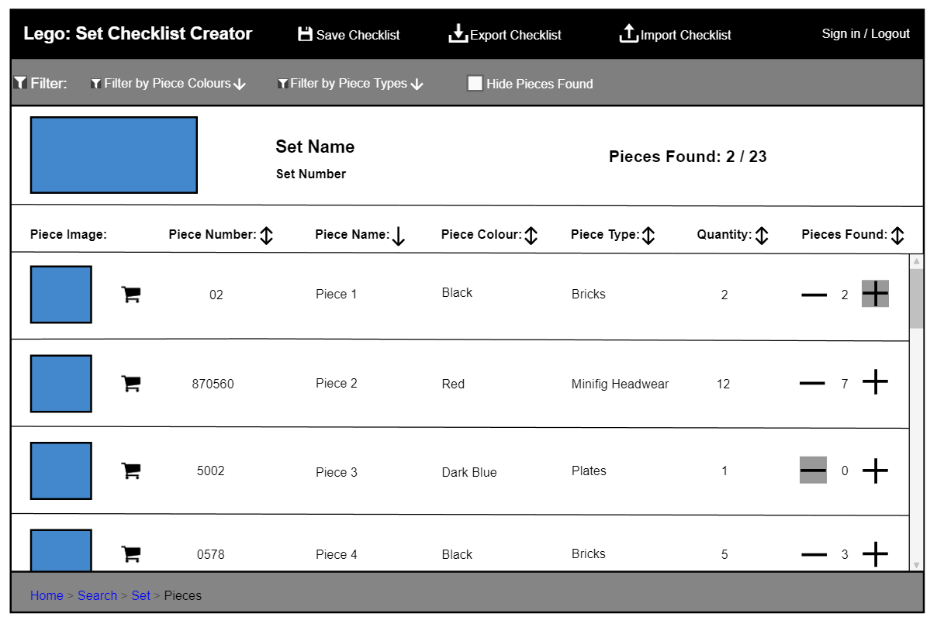

Figure : Initial Piece Checklist Page

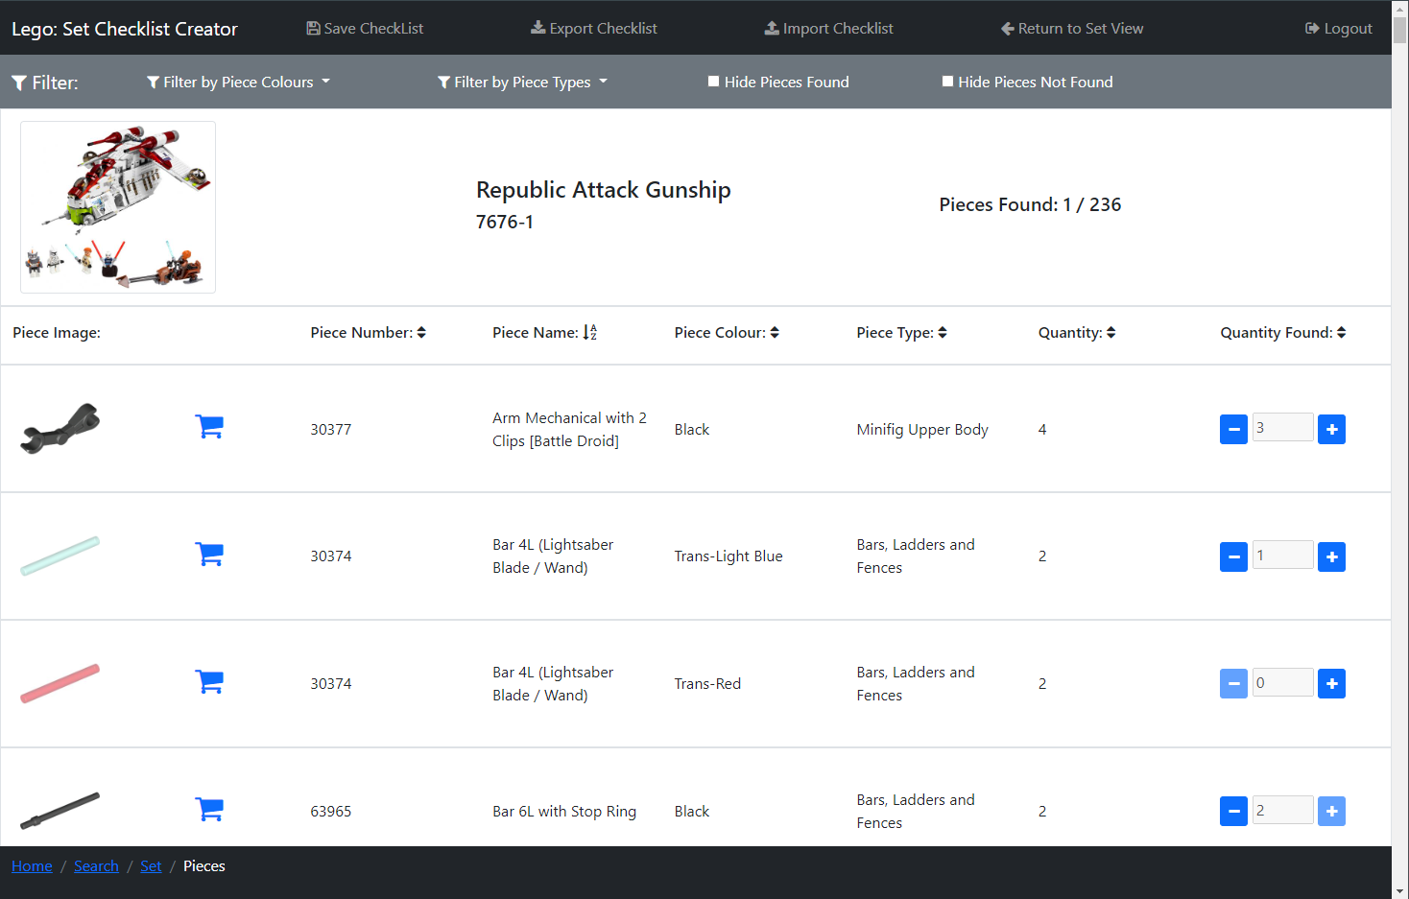

Figure : Piece Checklist Page

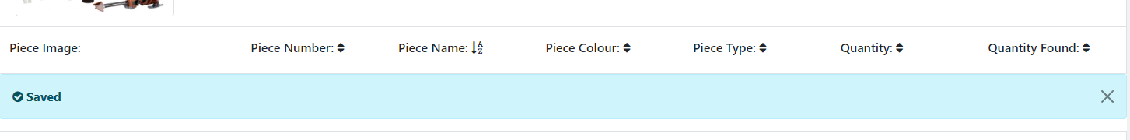

Figure : Piece Checklist Save Alert

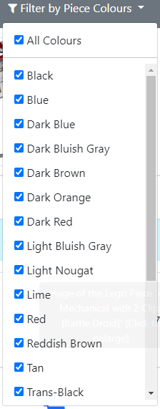

Figure : Piece Checklist Filter - Piece Colour

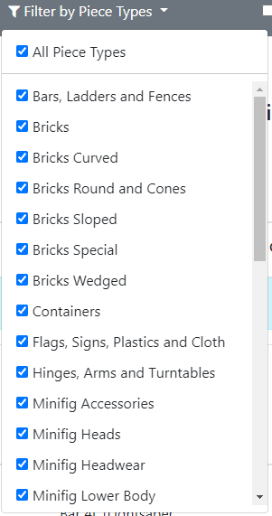

Figure : Piece Checklist Filter - Piece Type

The Piece Checklist Page (Figure 25) can be accessed by clicking the ‘View Piece Checklist’ link on the Set Page (Figure 17). On this page, users can view all Lego pieces in a set in a checklist and can check pieces off when they have been found, so the user can build said set.

In the centre of the page, the list of Lego pieces in the set are displayed in rows, with columns displaying different bits of information on Lego pieces. There is an image of each Lego Piece, that is the same colour as the piece, in each row, that when clicked will open Figure 34 to view the image enlarged (see more detail below). There is a ‘shopping cart’ icon button that when clicked opens the Lego pieces page on the Rebrickable website [6] where the user can view a list of websites to buy the Lego Piece. I used, this so if a user was missing a Lego piece that is required to build a Lego Set, they could then see a list of websites where they could buy the missing piece.

Each row has the piece’s name and colour so users can easily identify by the name and if there are multiple pieces with the same name then by their colour. There is also a ‘Quantity’ field which is the number of this piece required to build the set. There is a ‘Quantity Found’ field which is how many of this piece the user has found so far. This is initially set as 0 unless the user has imported the checklist or is a logged-in user who has previously saved the checklist to the database, as in these cases the ‘Quantity Found’ would be set as the same value as the imported or saved piece’s value.

There is a button on either side of the ‘Quantity Found’ number, a ‘minus’ and ‘plus’ icon buttons, that decrease and increase the ‘Quantity Found’ respectfully, with a minimum of 0 and the maximum of the ‘Quantity’ needed. When the ‘Quantity Found’ is 0 the ‘minus’ icon box is disabled and when it is the same as the ‘Quantity’ the plus icon is disabled, this is because the user should not be able to decrease or increase the ‘Quantity Found’ past these points.

Above the list of pieces is a header that has the name for each column, so it is clear to the user what each of these columns contains. Each of the column names (excluding ‘Piece Image’), has an arrow next to it, these show if the sets are being sorted by that column, which works the same as the Search Page above.

There is a scroll bar down the side of the page so users can scroll through this list of Lego Sets.

At the top of the page is a black navbar containing the website's name so it’s clear to users what website they are on, which when clicked acts as a link returning the user to the Home Page (section 5.5.1). Then there is the ‘Save Checklist’ link, which only appears to a logged-in user, which when clicked saves the user's progress on the checklist, and a light blue dismissible alert appears under the piece list header informing the user of this (Figure 26). I used an alert here so it was clear to the user that the checklist was saved and made it dismissible so the user can remove it once they have read it. There is an ‘Export Checklist’ link that exports the checklist to the user's device and an ‘Import Checklist’ link that opens Figure 37: Import Checklist Popup where users can import a previously exported checklist. There is then a link ‘Return to Set View’ which returns the user to the Set Page (Figure 17) for this piece checklist. Finally, there is a ‘Logout’ navbar link which will appear as ‘Login/SignUp’ when the user is not logged into an account, and ‘Logout’ when they are. ‘Login/SignUp’ opens the Login and Sign-Up Popup with the Login Tab Selected (Figure 40) and ‘Logout’ opens Figure 55: Logout Popup, these are both explained later.

There is a filter bar under the navbar that, contains filters the user can use to filter the Lego pieces. There is a dropdown ‘Filter by Piece Colours’ (Figure 27) where users can filter by all piece colours in the checklist, that has tick boxes allowing users to select all colours or tick only the piece colours they would like to view. There is another dropdown ‘Filter by Piece Types’ (Figure 28) that works the same as ‘Filter by Piece Colours’ but for the type of Lego Piece. There is a checkbox ‘Hide Pieces Found’ that hides all the pieces fully found (have a ‘Quantity Found’ that matches ‘Quantity’), which I added so users can easily see which pieces they still need to find. After this, a checkbox ‘Hide Pieces Not Found’ is the opposite of the last checkbox, and shows only those pieces fully found, which I added so if users needed to decrease a ‘Quantity Found’ of a fully found piece they could just view these pieces to find it quicker.

Under the filter bar is a white row that has the image of the Lego Set the checklist is for, which when clicked will open Figure 35 to view the image enlarged (see more detail below). There is also the Set’s name and Set Number, which I added, so it was clear to users which set’s piece checklist they are currently viewing. Then there is ‘Pieces Found’ which to the right has how many pieces have fully been found out of the total number of different types and colours of pieces in the checklist. Does this mean mum red 4*4, blue 4*4, blue 2*4 e.c.t. does the above make sense?

The breadcrumb trail, also in the footer, has the current page in white text, with the previous pages to the right with hyperlinks to those pages. I added this so a user can see their position on the user journey.

I made some changes from the initial design of this page (Figure 24) and the final design (Figure 25). I added the ‘Return to Set View’ link, as apart from the breadcrumb link there was no other way to easily return to this piece checklists set information page (Figure 17). I also added the checkbox ‘Hide Pieces Not Found’ as, as mentioned above, if users wanted to decrease a ‘Quantity Found’ of a fully found piece, they could just view the pieces that had been fully found to find it quicker. I also added the Save Alert (Figure 26) in the final design, so it was clear to users the checklist was successfully saved.

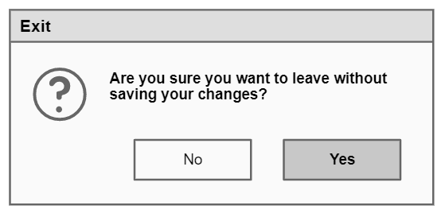

Figure : Initial Exit Checklist without Saving Popup

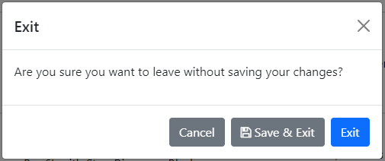

Figure : Exit Checklist without Saving Popup

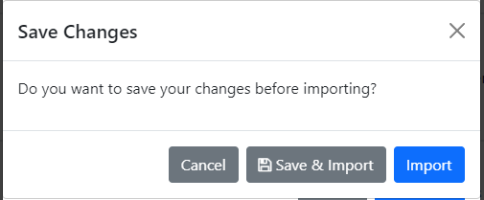

Figure : Import Checklist without Saving Current Checklist Popup

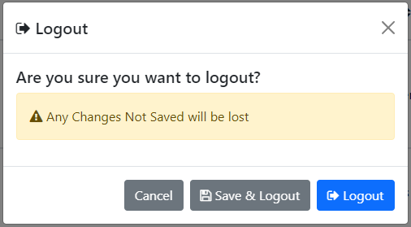

Figure : Logout without Saving Checklist Popup

When a logged-in user tries to exit this page after making changes to the piece quantities without saving, a popup (Figure 30) appears asking the user if they want to leave without saving their changes, with a ‘Cancel’ button and ‘X’ in the top right corner, which both to close the popup keeping the user on this page, a ‘Save & Exit’ button that saves the checklist progress before letting the user exit the page and an ‘Exit’ button which closes the popup and allows the user to leave the page.

If the user is trying to import a checklist using Figure 37 (explained below) and clicks the ‘Import’ button without saving changes to the checklist, a popup (Figure 31) opens over the top of this popup. This popup informs the user the checklist is not saved, with a ‘Cancel’ button and ‘X’ in the top right corner, which both close the popup keeping the user on this page, a ‘Save & Import’ button that saves the checklist progress before attempting the import and an ‘Import’ button which closes the popup and attempts the import.

If the user tries to logout after making changes to the checklist popup Figure 32 appears instead of Figure 55. This popup is the same as Figure 55 (see below) but with the addition of a yellow alert (which is yellow to draw the user's attention so they read it), informing the user their changes won’t be saved and a ‘Save & Logout’ button that will save the checklist before continuing the Logout process (for more detail see below).

Compared to the initial design (Figure 29), in the final design (Figure 30, Figure 31 and Figure 32) I have added the option to save and continue on the popup as this makes it easier to save and leave, as well as making more specific popups to leave without saving (Figure 31 and Figure 32).

#### Image Popups

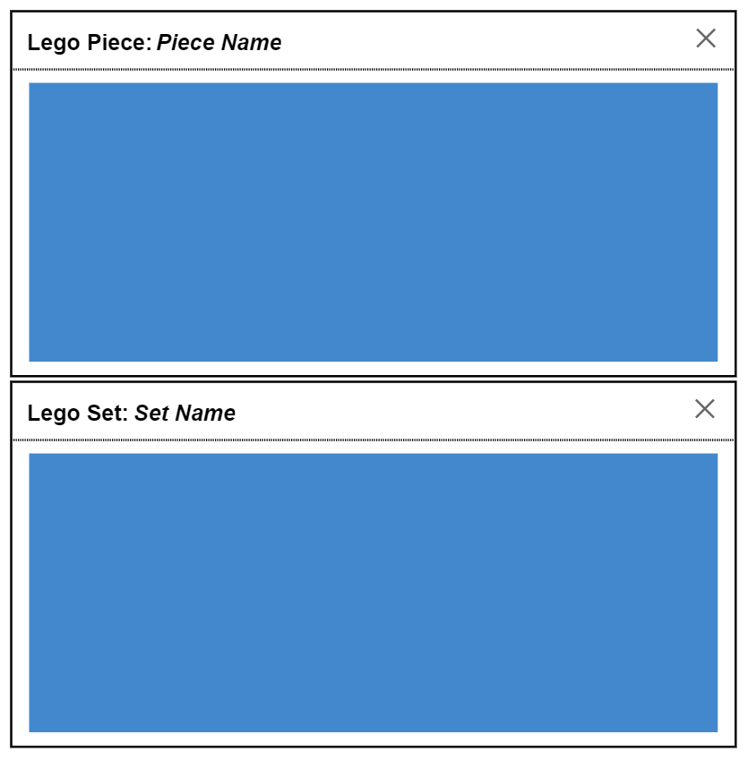

Figure : Initial Popups for Piece Images and Set Images

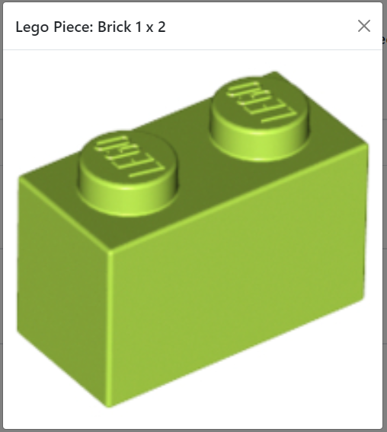

Figure : Popup for Piece Image

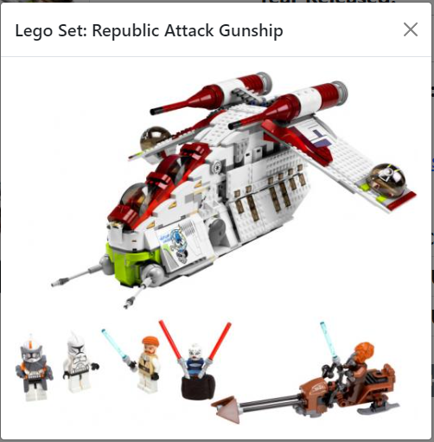

Figure : Popup for Set Image

Figure 34 and Figure 35 are two popups both of which display images. Figure 34 displays the image of a Lego Piece (in this case ‘Brick 1 x 2’) and Figure 35 displays the image of a Lego Set (in this case ‘Republic Attack Gunship’). These popups are opened when a picture of a Lego Piece or Lego Set is clicked on. These popups are used so that if the image on the page is small, users can expand it so they can see it easier. The ‘X’ in the top right corner of both popups dismisses them.

Figure 33 shows the initial design of both popups which are the same as the final design.

#### Import Checklist Popup

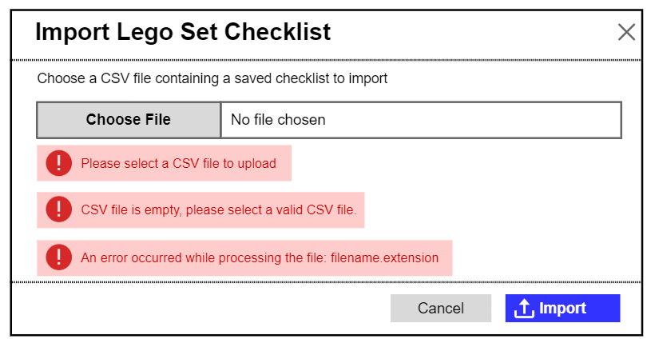

Figure : Initial Import Checklist Popup

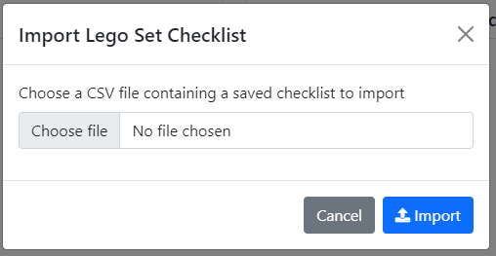

Figure : Import Checklist Popup

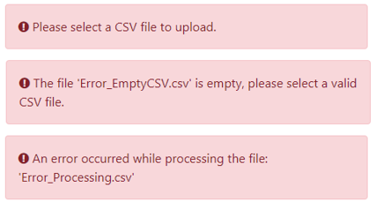

Figure : Import Checklist Error Alert Boxes

The import checklist popup (Figure 37) is used to import a Lego Set Piece checklist CSV file that has been previously exported and is opened via clicking the ‘Import Checklist’ link on the navbar of the Home Page or the Piece Checklist Page (Figure 25). Clicking the ‘Choose File’ button will open the file browser on the system the user is viewing the website on, they can then select a file to upload to the website. The name of this file will then replace the ‘No file chosen’ text.

The ‘Import’ button when clicked will try to import the selected file, if the file is valid (in the right format and a CSV file) the pieces stored will be imported and the user will be redirected to Figure 17: Lego Set Information Page. If they then click the ‘View Piece Checklist’ link on that page, Figure 25: Piece Checklist Page will be opened showing the pieces of the imported set, with the piece quantities found matching those from the imported CSV file.

There are also three error alerts in Figure 38 in red boxes, these are displayed when the user clicks the ‘Import’ button but there is an error while importing, these alert boxes appear beneath the ‘Choose File’ button and the ‘Choose File’ button and box adjacent are highlighted red to show there is an error. The top error alert is displayed if a file is not selected, the second alert is displayed if the CSV file is empty (where ‘Error_EmptyCSV.csv’ is the file the user tried to import), and the third alert is displayed if the file is not a CSV file or not correctly formatted so cannot be read (where ‘Error_Processing.csv’ is the file the user tried to import). Here I have used these alerts in the popup instead of a separate alert popup, as this makes it clear to the user that an error has occurred without the user having to spend time closing an alert popup breaking up their flow. The name of the file that could not be imported is displayed in the popups so users can see which file they tried to import.

The ‘Cancel’ button and ‘X’ in the top right corner, dismiss the popup.

The initial design for this popup (Figure 36) is the same as the final design (Figure 37 and Figure 38), apart from some rewording of alert boxes text (Figure 38).

#### Login and Sign-Up Popup

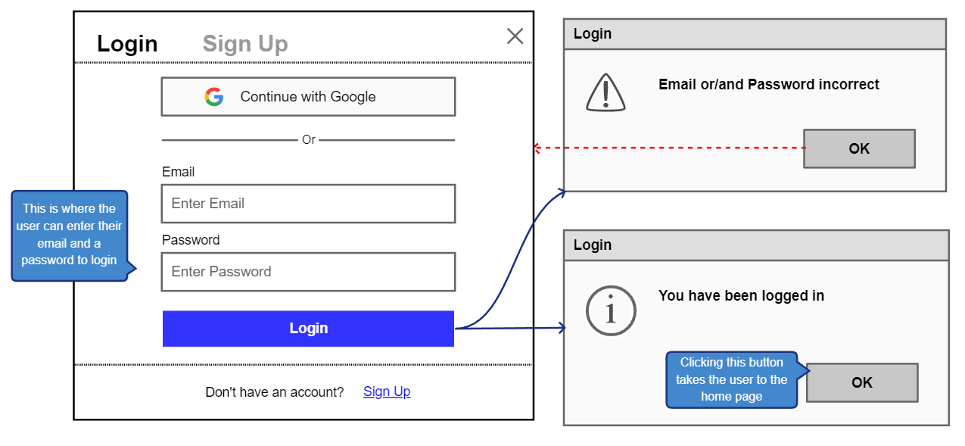

Figure : Initial Login and Sign Up Popup – Login Tab Selected

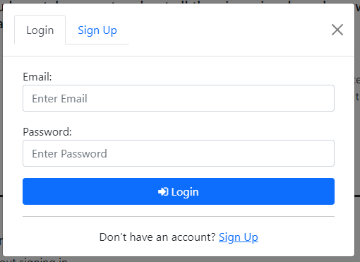

Figure : Login and Sign-Up Popup – Login Tab Selected

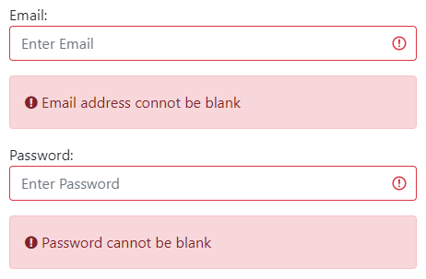

Figure : Login/Sign Up Error – Email Blank



Figure : Login Error – Password Blank

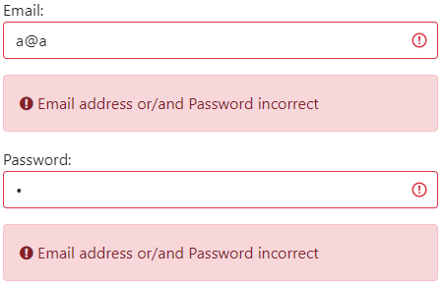

Figure : Login Error – Email or Password incorrect

When the ‘Login/SignUp’ link is clicked in the black navbar on the Home Page, the Search Page, the Set Page or the Piece Checklist Page, a popup (Figure 40) appears where users can Login or create an account.

There are two tabs at the top of the popup, in Figure 40 the ‘Login’ tab is selected, and the ‘Sign Up’ tab when clicked opens the Sign-Up tab in the popup (Figure 45). As the ‘Login’ tab is selected in the main body of the popup there are input boxes where user can enter their details to login to their account. At the bottom of the popup is some text and a hyperlink ‘Sign Up’ which also opens the Sign-Up tab in the popup (Figure 45).

There is an ‘Email’ input box where the user must enter the email address connected to their account and a ‘Password’ input box where the user must enter their account’s password. If the entered email is not valid the corresponding Invalid Alert will be displayed (see Entered Email Invalid Alerts below for more details). There is an ‘X’ in the top right corner to dismiss the popup, and a ‘Login’ button, that when clicked will check both the user’s entered email address and password. If the ‘Email’ or ‘Password’ input boxes are blank, they are highlighted red and the red alert boxes in Figure 41 and Figure 42 are shown respectfully.

If the entered email address does not belong to an account, or if it does belong to an account but the entered password is incorrect, then error alert boxes will appear (Figure 43) informing the user the ‘Email’ or ‘Password’ is incorrect and highlighting the ‘Email’ and ‘Password’ input boxes in red. I chose here to use an ambiguous message on if the email or password was wrong, as this way an attacker could not trial and error their way into logging into an account as they would not know if the entered email address belongs to an account or not.

Red alerts and input boxes are highlighted red for errors so users can easily see this is an error.

If the entered email belongs to an account and the password entered matches the account's stored password, then the user is logged into their account. After this, the popup is closed, and the logged-in Home Page is shown (Figure 11).

In the initial design for the ‘Login’ tab (Figure 39) I had planned to use popups to inform the user the entered Email or Password was incorrect, however, in the final design (Figure 43) I chose to use error alert boxes to inform the user of this, I made this decision so the user wouldn’t have to spend time closing alert popups breaking up their flow. I also removed the logged in alert popup in the final design, as I felt it was obvious to the user they had logged in as the Home Page displayed (Figure 11) is different to the logged-out Home Page (Figure 9).

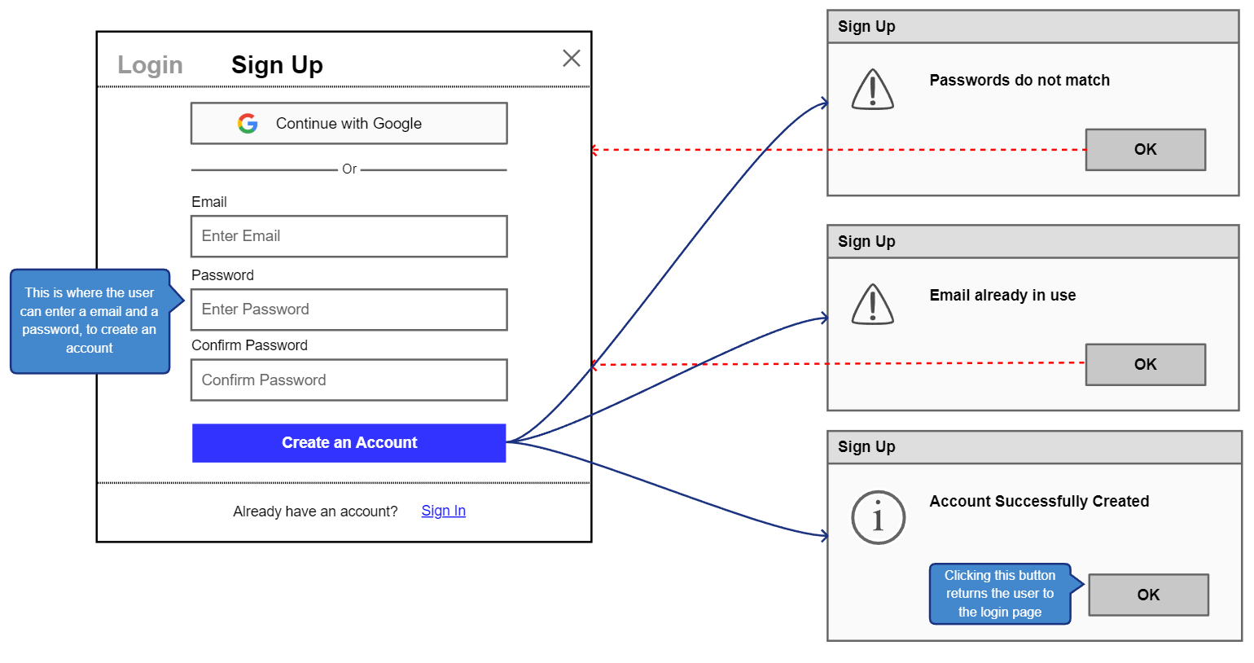

Figure : Initial Login and Sign-Up Popup – Sign Up Tab Selected

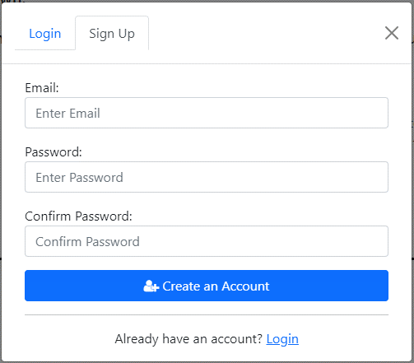

Figure : Login and Sign-Up Popup – Sign Up Tab Selected

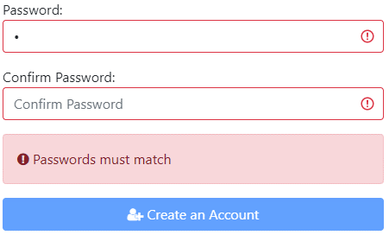

Figure : Sign Up Error – Passwords Must Match

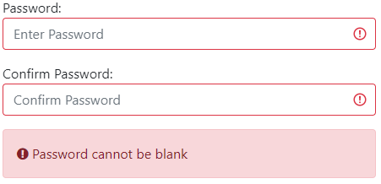

Figure : Sign Up Error – Password Blank

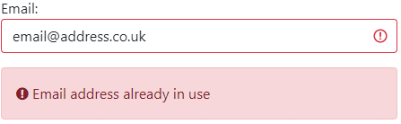

Figure : Sign Up Error – Email Not Unique

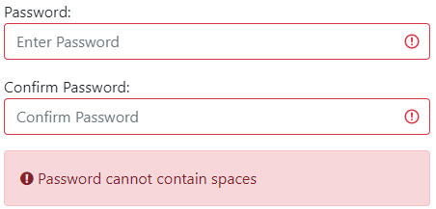

Figure : Sign Up Error – Password Cannot Contains Spaces

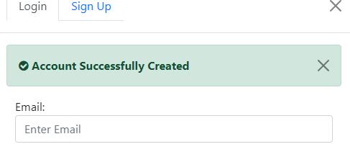

Figure : Account Created Alert

The ‘Sign Up’ tab (Figure 45) in the Login and Sign-Up Popup is opened by selecting the ‘Sign Up’ tab at the top of the popup, or the ‘Sign Up’ link at the bottom of the Login tab body (Figure 40).

At the top of the popup, in Figure 45 the ‘Sign Up’ tab is selected, and the ‘Login’ tab when clicked opens the Login tab in the popup (Figure 40). As the ‘Sign Up’ tab is selected in the main body of this popup there are input boxes where user can enter their details to create an account. At the bottom of the popup is some text and a hyperlink ‘Login’ which also opens the Login tab in the popup (Figure 40).

There is an ‘Email’ input box where the user must enter the email address they would like to use for their account. If the entered email is not valid the corresponding Invalid Alert will be displayed (see Entered Email Invalid Alerts below for more details).

There is a ‘Password’ input box where they can input a password for their account, and a ‘Confirm Password’ input box, which is used because in these input boxes text is hidden it checks the user entered the password they meant. If the text enter in the ‘Password’ and ‘Confirm Password’ input boxes do not match they are highlighted red and a red error alert box will appear (Figure 46) informing the user that they don’t match and disabling the ‘Create Account’ button.

There is an ‘X’ in the top right corner to dismiss the popup, and a ‘Create Account’ button, that when clicked will check both the user’s entered email address and password.

If the ‘Email’ or ‘Password’ and ‘Confirm Password’ input boxes are blank, they are highlighted red and the red alert boxes in Figure 41 and Figure 47 are shown respectfully. If the email entered belongs to another account, then an error alert box will appear (Figure 48) informing the user of this and highlighting the ‘Email’ input box in red. If the new password contains spaces, the ‘Password’ and ‘Confirm Password’ input boxes are highlighted red and the red alert boxes in Figure 49 are shown. Red alerts and input boxes are highlighted red for errors so users can easily see this is an error.

If the entered email address is valid and not in use and the ‘Password’ is not blank and does not contain spaces, then a new account is created for the user using this email and password. Then the ‘Login’ tab (Figure 40) is displayed in the popup, with a light green dismissible alert (Figure 50) open under the popup header, informing the user that they successfully created an account. I chose to direct users to the ‘Login’ tab as if I user is creating an account it's likely that afterwards, they would like to use it.

In the initial design for the ‘Sign Up’ tab (Figure 44) I had planned to use popups to inform the user that the ‘Password’ and ‘Confirm Password’ did not match, the email was already in use, and their account was created. However, in the final design (Figure 46, Figure 48 and Figure 50) I chose to use error alert boxes for non-matching passwords, email not unique, and a dismissible alert when an account was created. I made this decision so the user wouldn’t have to spend time closing alert popups breaking up their flow.

In the initial design of the whole popup (Figure 39 and Figure 44) there is a button ‘Continue with Google’ in both the ‘Sign Up’ and ‘Login’ tabs, that when clicked would allow users to sign-up and login with a Google account, but I removed this to login with a Google account in the final design (Figure 40 and Figure 45), as this feature was not essential to the website as there is already another way to sign-up and login, and so I felt that my time would be better spent on implementing other features.

#### Entered Email Invalid Alerts

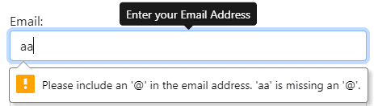

Figure : Login/SignUp Error Email should contain '@'

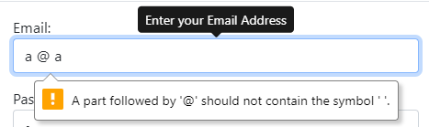

Figure : Login/SignUp Error Email Should not contain spaces

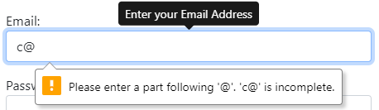

Figure : Login/SignUp Error Email not complete

If the user enters an email address in the input boxes in the Login and Sign-Up Popup (Figure 40 and Figure 45) or the Change Email Popup (Figure 93), and this entered email is invalid a popup appears under the input box informing the user of this.

If the email is missing an ‘@’ symbol Figure 51 informs the user of this, if it contains spaces Figure 52 informs the user, and if there is no text following the ‘@’ symbol Figure 53 informs the user.

#### Logout Popup

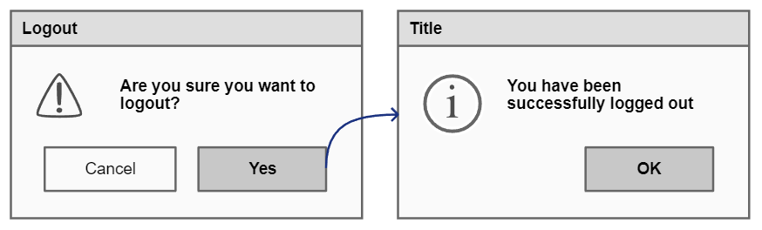

Figure : Initial Logout Popup

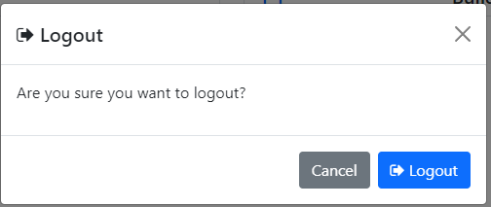

Figure : Logout Popup

The Logout Popup (Figure 55) appears when a user clicks the ‘Logout’ link in the navbar on all pages (which is only visible when a user is logged in), this is used to confirm that the user wants to logout of their account and stops users logging out by misclicking. If the user clicks the ‘Cancel’ button or ‘X’ in the top right corner, the popup is dismissed. If they click the ‘Logout’ button the user is logged out and returns the user to the Home Page (Figure 9).

In the initial design (Figure 54) I had planned to show a popup informing users they have been logged out when they clicked the ‘Yes’ button (which I changed to ‘Logout’ as I felt this explained clearly what the button does), however, I choose to not use this because I felt it was already clear enough as the user is sent to the home page variant (Figure 9) that only appears to logged-out users.

#### Sets in Progress Page

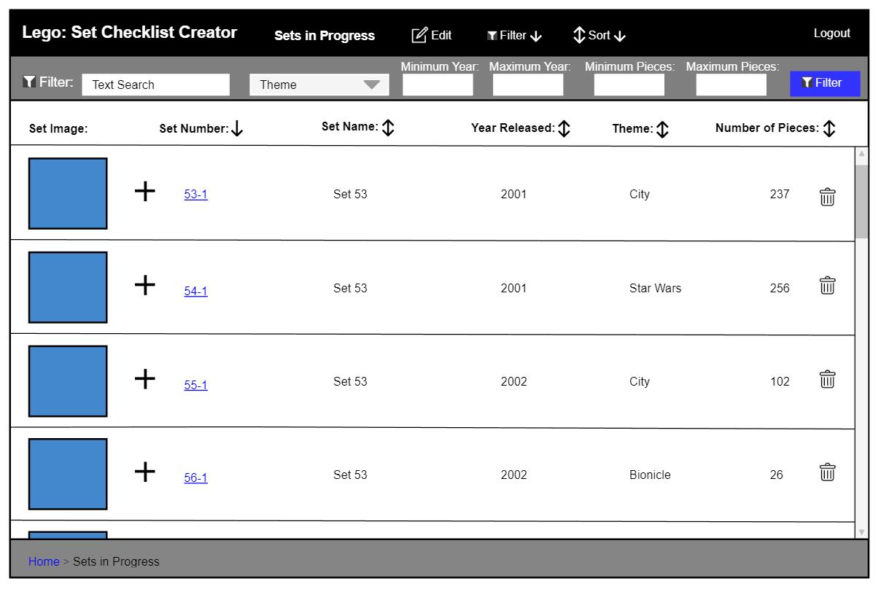

Figure : Initial Sets in Progress - Filter Bar Open

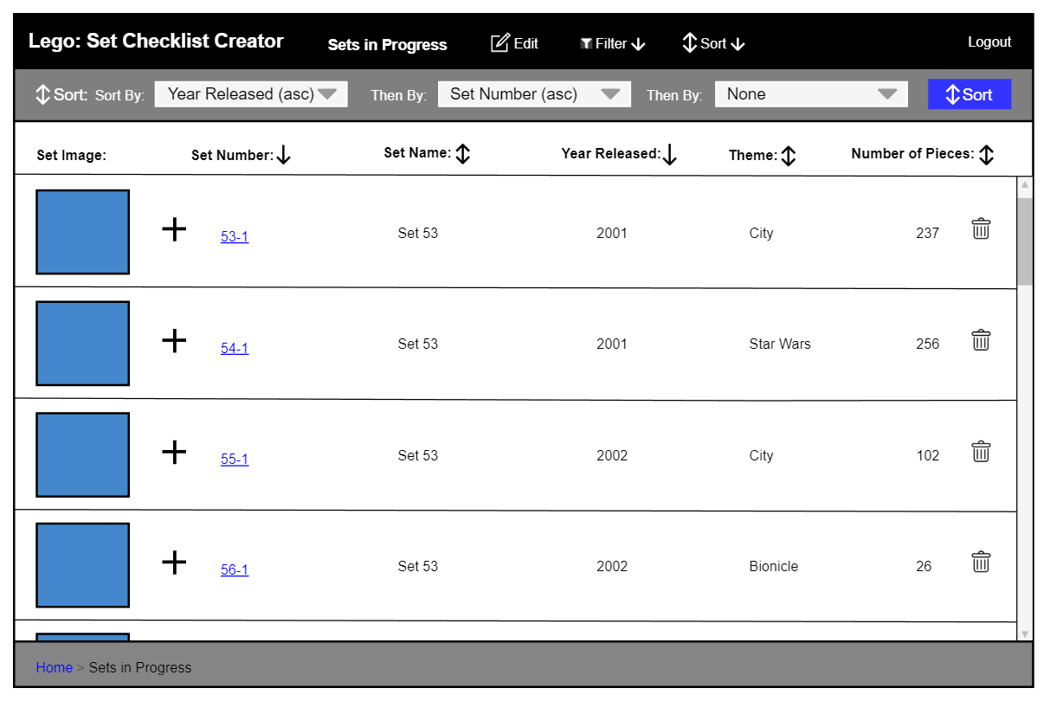

Figure : Initial Sets in Progress - Sort Bar Open

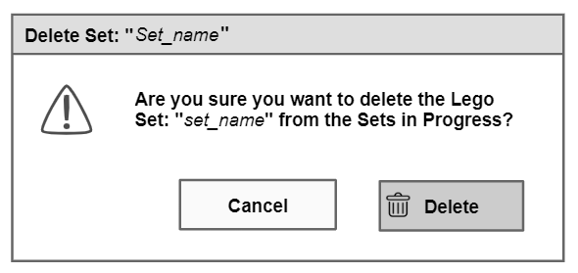

Figure : Initial Delete Set from Sets in Progress Popup

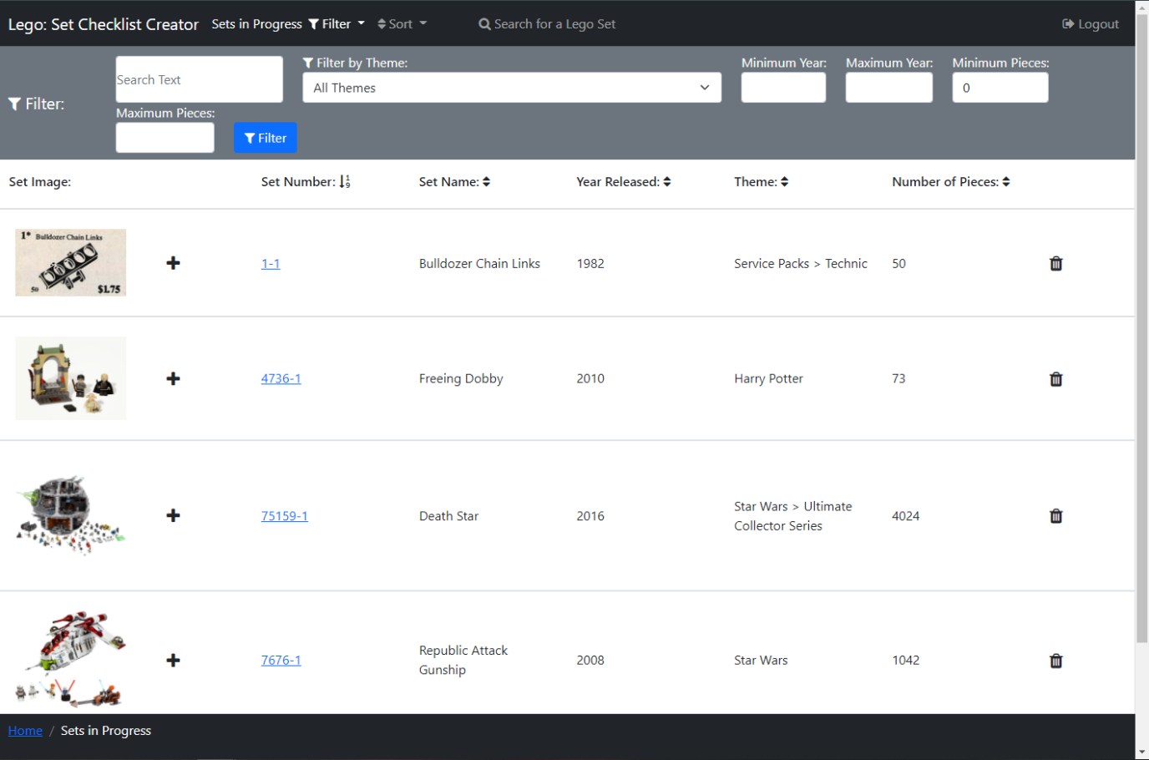

Figure : Sets in Progress - Filter Bar Open

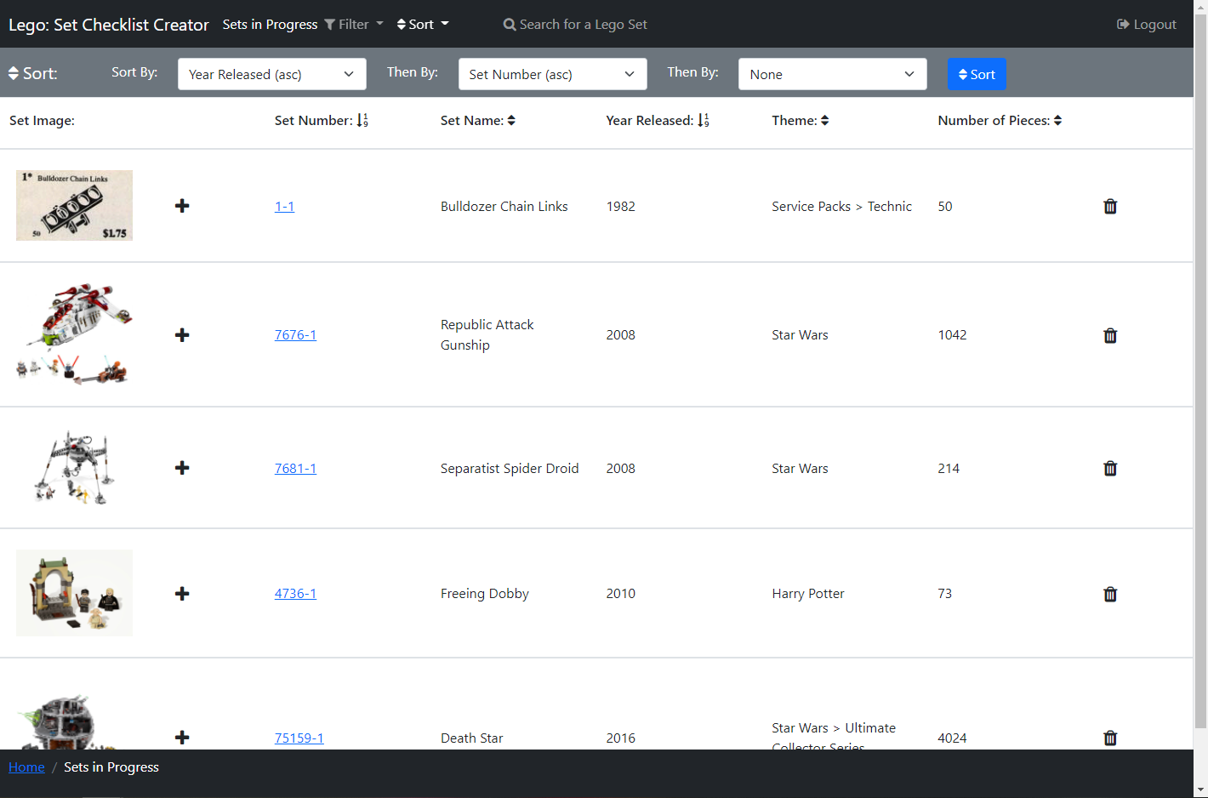

Figure : Sets in Progress - Sort Bar Open

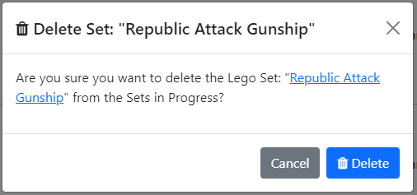

Figure : Delete Set from Sets in Progress Popup



Figure : Deleted Set from Sets in Progress Alert

The Sets in Progress Page (Figure 59 and Figure 60) can be accessed by a user, who is logged in, by clicking the ‘Sets in Progress’ link on the secondary navbar on the Home Page (Figure 11). On this page, users can search their Sets in Progress to find a Set they wish to continue a checklist for.

Similar to the Search Page, in the centre of the page, a list of Lego sets is displayed in rows, with columns displaying different bits of information on Lego sets. There is an image of each Lego Set in each row, that when clicked will open Figure 35 to view the image enlarged (see more detail above). There is a ‘plus’ icon button that when clicked opens a popup (Figure 73) to add a set to a setlist.

There is a ‘bin’ icon in each set row, that when clicked a popup (Figure 61) appears asking the user if they want to delete the selected set from their sets in progress, this is used so that users don’t accidentally delete a set from Sets in Progress by misclicking. The text ‘Republic Attack Gunship’ is replaced with the name of the set that will be deleted, and the second set name is a hyperlink to the Set Page (Figure 17) so users can check the set they are going to delete before they delete it. There is a ‘Cancel’ button and ‘X’ in the top right corner, which both dismiss the popup when clicked. There is a ‘Delete’ button that will delete the selected set from the Sets in Progress, and a light blue dismissible alert (Figure 62) appears under the list of sets header informing the user of this, with the set name (in this case ‘Republic Attack Gunship’) a hyperlink to the deleted Sets page (Figure 17).

Above the list of sets is a header that has the name for each column, so it is clear to the user what each of these columns contains. Each of the column names (excluding ‘Set Image’), has an arrow next to it, these show if the sets are being sorted by that column, which works the same as the Search Page above.

There is a scroll bar down the side of the page so users can scroll through this list of Lego Sets.

If the user clicks a Set’s set number, which is a hyperlink, Figure 17: Lego Set Information Page will open displaying the selected set. If they then click the ‘View Piece Checklist’ link on that page Figure 25: Piece Checklist Page will be opened showing the saved progress of the Set, with the piece quantities found matching those saved previously.

At the top of the page is a black navbar containing the website's name so it’s clear to users what website they are on, which when clicked acts as a link returning the user to the Home Page. Next to this is some text informing the user they are viewing their Sets in Progress. There is a navbar link ‘Filter’ which opens a filter bar underneath the navbar (shown open in Figure 59), closing the sort bar (shown open in Figure 60) if it is open. Likewise, the ‘Sort’ navbar link opens a sort bar underneath the navbar shown open in Figure 60, closing the filter bar if it is open. Then there is a link ‘Search for a Lego Set’ which opens the Search Page (above). Finally, there is a ‘Logout’ navbar link that opens Figure 55: Logout Popup explained above.

The filter bar (Figure 59) contains filters the user can use to filter the Lego Sets and functions the same as on the Search Page but filtering a user’s Sets in Progress instead of sets from the Rebrickable API [1].

The sort bar (Figure 60) contains three select boxes so a user can perform a multi-sort, which functions the same as on the Search Page but sorts a user’s Sets in Progress instead.

The breadcrumb trail, also in the footer, has the current page in white text, with the previous pages to the right with hyperlinks to those pages. I added this so a user can see their position on the user journey.

There are not many differences between the initial design (Figure 56 and Figure 57) and the final design (Figure 59 and Figure 60), however, there is a link ‘Edit’ in the initial design which is removed because there is nothing a user needs to edit in the Sets in Progress, instead, I added the ‘Search for a Lego Set’ link so users could go and find another set to complete straight from this page. I added a hyperlink to the set number in the final delete popup design (Figure 61) for the reasons explained above, whereas it is not in the initial design (Figure 58). I also added the Deleted Set Alert (Figure 62) in the final design, so it was clear to users the set was successfully deleted from the Sets in Progress.

#### Set Lists Page

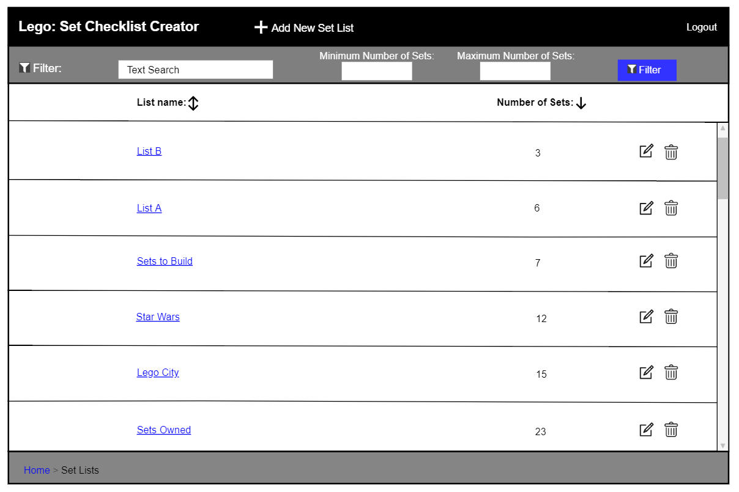

Figure : Initial Set Lists Page

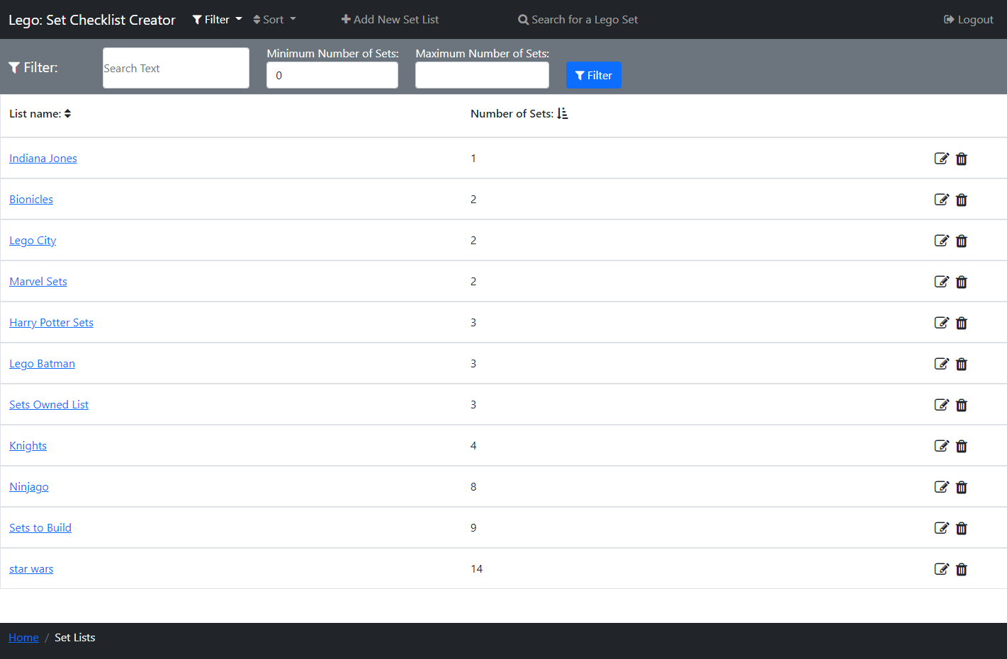

Figure : Set Lists Page - Filter Bar Open

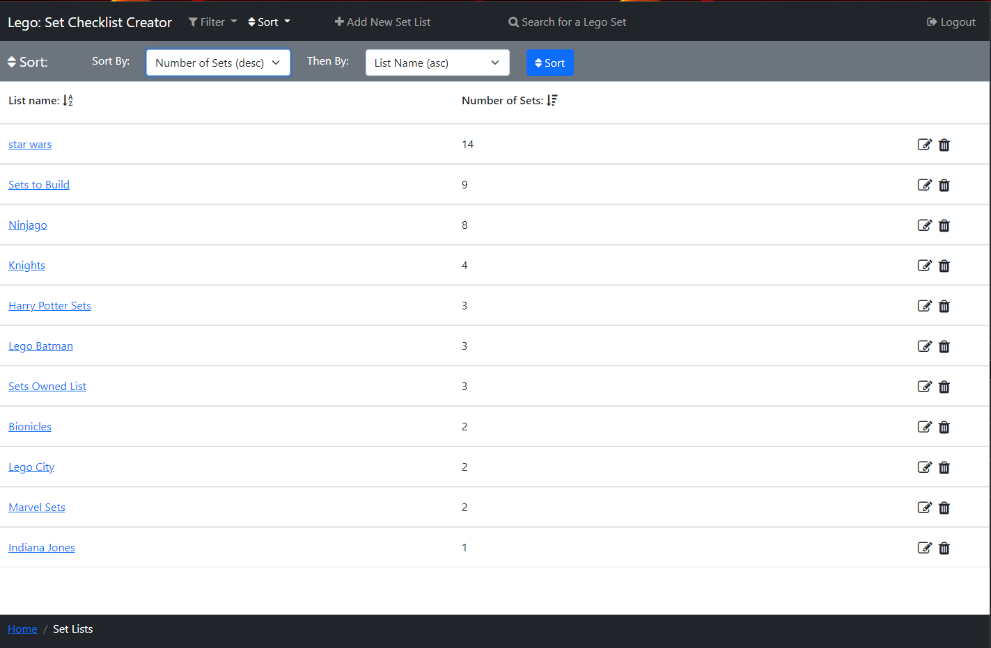

Figure : Set Lists Page - Sort Bar Open

The Set Lists Page (Figure 64 and Figure 65) can be accessed by a user, who is logged in, by clicking the ‘View Set lists’ link on the secondary navbar on the Home Page (Figure 11), or via the breadcrumb link on the Set List Page. On this page, users can view their Setlists saved to the database.

Similar to the Search Page, in the centre of the page, a list of the user's setlists are displayed in rows, with columns and a header displaying the ‘List Name’ and ‘Number of Sets’ in the setlist. If the user clicks a Setlist’s ‘List Name’ hyperlink, the Set Lists Page (above) will open displaying the selected setlist.

There is an ‘edit’ icon in each setlist row, that when clicked opens a popup (Figure 83) that allows the user to change the name of the selected Setlist, and also a ‘bin’ icon, that when clicked opens a popup (Figure 87) that allows users to delete the selected Setlist.

The list of setlists header has the name for both columns, so it is clear to the user what each of these columns contains. Both column names have an arrow next to them, that shows if the setlists are being sorted by that column, which works the same as the Search Page above.

There is a scroll bar down the side of the page so users can scroll through this list of Lego Sets.

At the top of the page is a black navbar containing the website's name so it’s clear to users what website they are on, which when clicked acts as a link returning the user to the Home Page (above). There is a navbar link ‘Filter’ which opens a filter bar underneath the navbar (shown open in Figure 64), closing the sort bar (shown open in Figure 65) if it is open. Likewise, the ‘Sort’ navbar link opens a sort bar underneath the navbar shown open in (Figure 65), closing the filter bar if it is open. Next to this, there is a link ‘Add New Set List’ that when clicked, opens the Create New Set List Popup (Figure 68) where users can create a new setlist to add the set too, then there is a link ‘Search for a Lego Set’ which opens the Search Page (above). Finally, there is a ‘Logout’ navbar link that opens Figure 55: Logout Popup explained above.

The filter bar (Figure 64) contains filters the user can use to filter the Setlists, there is a text box to search by text in the list name (e.g. ‘City’), ‘Minimum Number of Sets’ and ‘Maximum Number of Sets' number boxes that filter between these number of sets and the ‘Filter’ button then applies these filters to the Setlists.

The sort bar (Figure 65) contains two select boxes so a user can perform a multi-sort, containing all the columns sorts ascending and descending with also the option of none. The first select must always be selected, and by default, the sets are sorted by ‘List name’. This is used by selecting a column to sort by and then the preceding column to sort by, this means where the first column values of sets match then they are compared by the second column value instead. There is then a ‘Sort’ button that when pressed applies this sort to the list. For example, in Figure 65 the sets are first being filtered by ‘Number of Sets’ descending and then by ‘List name’ ascending, so the ‘Harry Potter Sets’ and ‘Lego Batman’ setlists both have a ‘Number of Sets’ of ‘3’ so they are then compared by ‘List Name’ and as alphabetically ‘Harry Potter Sets’ is above ’Lego Batman’ therefore ‘Harry Potter Sets’ appears first.

The breadcrumb trail, also in the footer, has the current page in white text, with the previous pages to the right with hyperlinks to those pages. I added this so a user can see their position on the user journey.

There are a few differences between the initial design (Figure 63) and the final design (Figure 64 and Figure 65). I added the ‘Search for a Lego Set’ link so users could go and find another set to add to a setlist straight from this page. I also added the sort bar (see open in Figure 65) in the final design, as I felt users would benefit from being able to perform a multi-sort on their setlists.

#### Create New Set List Popup

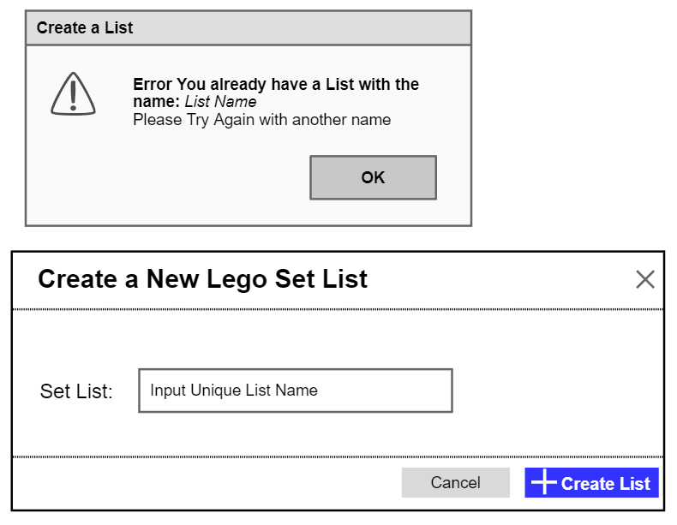

Figure : Initial Create New Set List Popup



Figure : Initial Create Set List Error – Name Not Unique

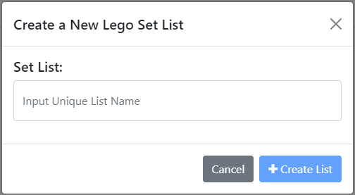

Figure : Create New Set List Popup

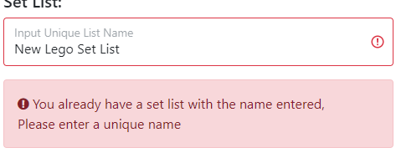

Figure : Create Set List Error – Name Not Unique



Figure : Created New Set List Alert

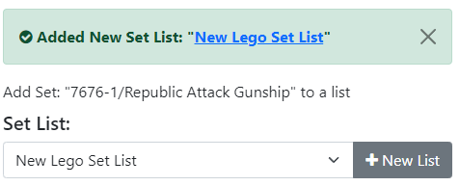

Figure : Small Created New Set List Alert on Add Set to a List Popup

The Create New Set List Popup (Figure 68) is displayed when a logged-in user clicks the ‘Add New Set List’ button on the Set Lists Page (above) or clicks the ‘New List’ button on the Add Set to Set List Popup (Figure 73 below). Using this popup users can create a new Set List by entering the name they would like the setlist to have in the text box, where ‘Input Unique List Name’ is a placeholder.

If the setlist name entered matches one of the user's saved setlist names then an error alert box will appear (Figure 69) informing the user the name must be unique and highlighting the input box in red so users can easily see this is the error, also while the name matches the ‘Create List’ button is disabled.

If the user clicks the ‘Cancel’ button or ‘X’ in the top right corner, the popup is dismissed. There is a tick box which has to be ticked to activate the ‘Create List’ button that, when clicked, will create a new setlist with the entered name and then close the popup. If the user opened the popup from the Set Lists Page a light green dismissible alert (Figure 70) appears under the navbar and filter or sort bar on that page, or if they opened the popup using the Add Set to a Set List Popup a light green dismissible alert (Figure 71) appears underneath the Add Set to a Set List Popup header, with the new setlist selected in the selector. Both these popups inform the user a setlist has been created, where ‘New Lego Set List’ is the name of the user’s setlist, which is a hyperlink to the that Set’s Set List Page (below). I made this a hyperlink so that users could easily access their new setlist instantly.

There are a few differences between the initial design (Figure 66) and the final design (Figure 68). I had initially planned to use a popup to display to the user if the setlist name entered was not unique (Figure 67), but I decided to highlight the textbox in red with a red alert box (Figure 69) this makes it clear to the user that an error has occurred without the user having to spend time closing an alert popup breaking up their flow. Finally, I added the Created Set List Alert in the final design (Figure 70 and Figure 71), so it was clear to users the setlist name was successfully changed.

#### Add Set to a Set List Popup

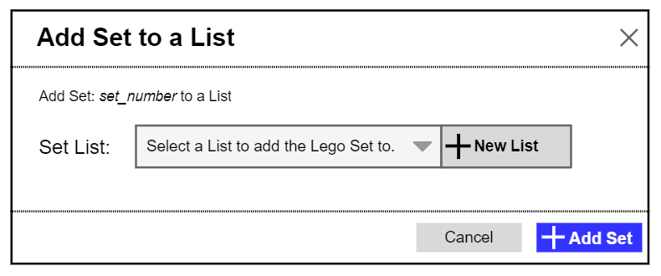

Figure : Initial Add Set to Set List Popup

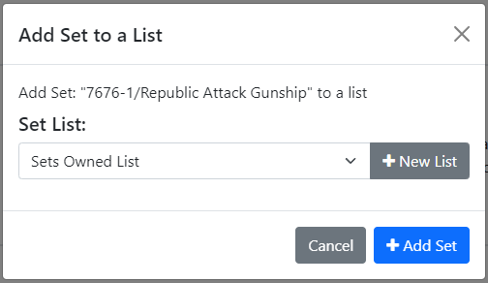

Figure : Add Set to Set List Popup



Figure : Added Set to Set List Alert

The Add Set to a Set List Popup (Figure 73) is displayed when a logged-in user clicks the ‘plus’ icon button on the Search Page, Sets in Progress Page, Set List Page or clicks the ‘Add Set to List’ button on the Set Page. Using this popup users can add a Lego Set to one of their setlists. The text ‘7676-1/Republic Attack Gunship’ is replaced with the set number of the set that the user wants to add to a list, followed by a ‘/’ and then this set’s name.

Using the select dropdown, the user can select which of their setlists to add the set too, where ‘Sets Owned List’ is the name of a setlist. The ‘Add Set’ button adds the set to the selected list and a light green dismissible alert (Figure 74) appears under the navbars and headers informing the user the set has been added to a setlist, where ‘7676-1’ is the Set’s set number and ‘Sets Owned List’ is the selected setlist. These are both hyperlinks to the set and setlist, respectfully, so that users can quickly access these pages after adding the set to a setlist.

The ‘Cancel’ button and ‘X’ in the top right corner both dismiss the popup, and the ‘New List’ button opens the Create New Set List Popup (Figure 68) over the top of this popup, where users can create a new setlist to add the set too.

There are a few small differences between the initial design (Figure 72) and the final design (Figure 73). In the initial design, there was text ‘set_number’ which I changed to the set number ‘/’ set name in the final design, I did this so the user could easily see the set they were adding to the setlist by both its number and name. I also added the added Set to a Setlist Alert (Figure 74) in the final design, so it was clear to users that a set was added to a setlist and which set and setlist these were.

#### Set List Page

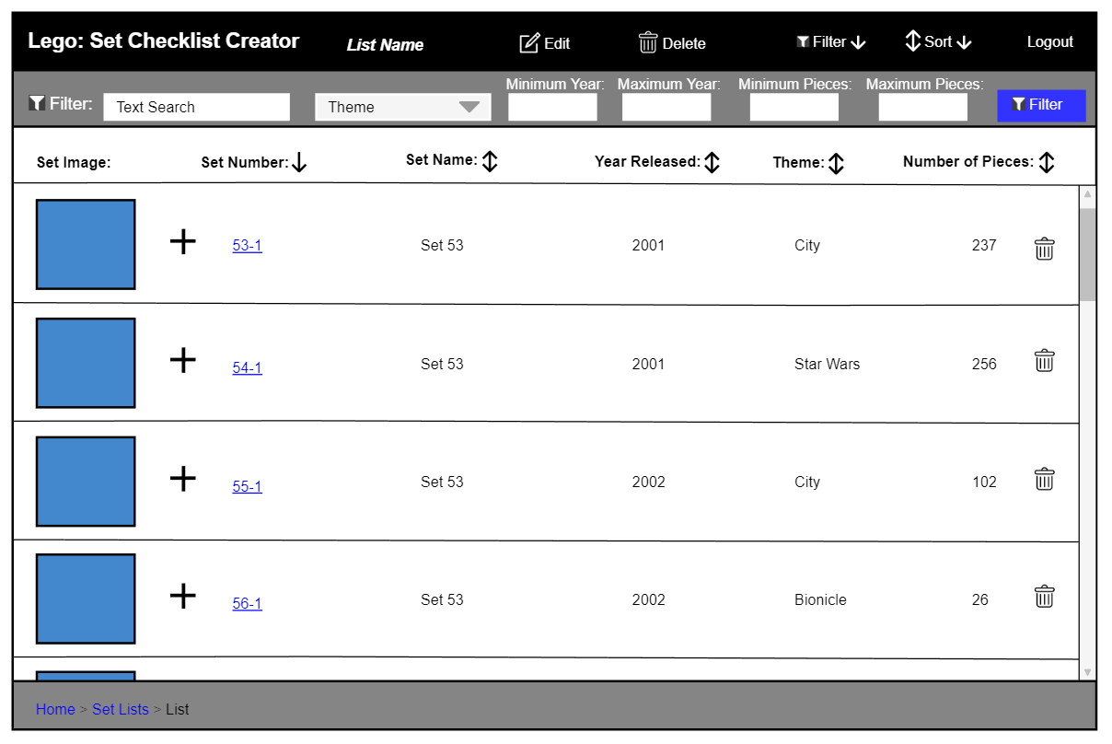

Figure : Initial Set List - Filter Bar Open

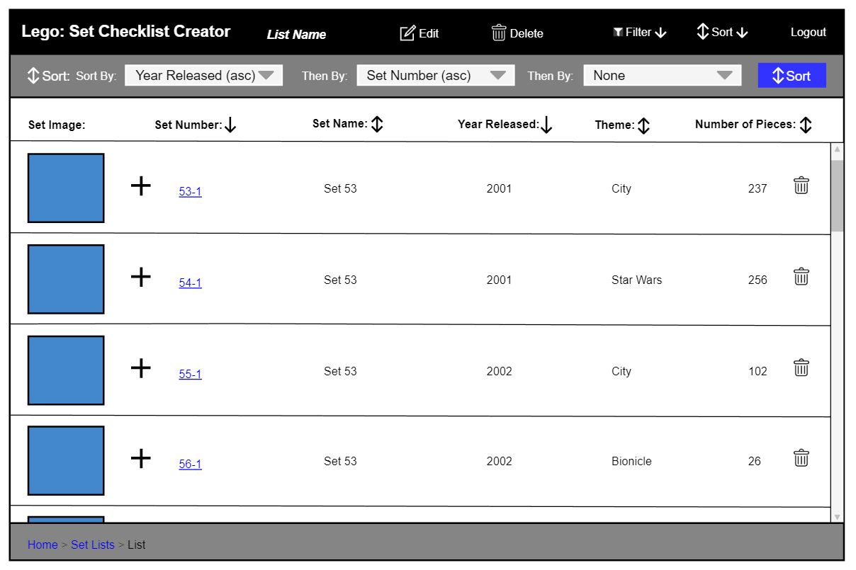

Figure : Initial Set List - Sort Bar Open

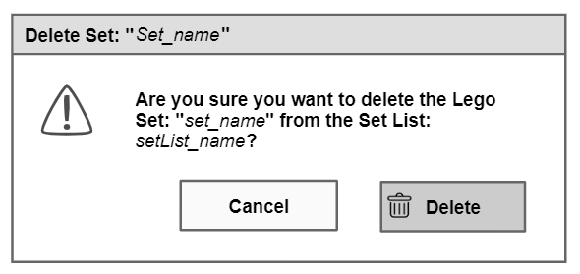

Figure : Initial Delete Set from Set List Popup

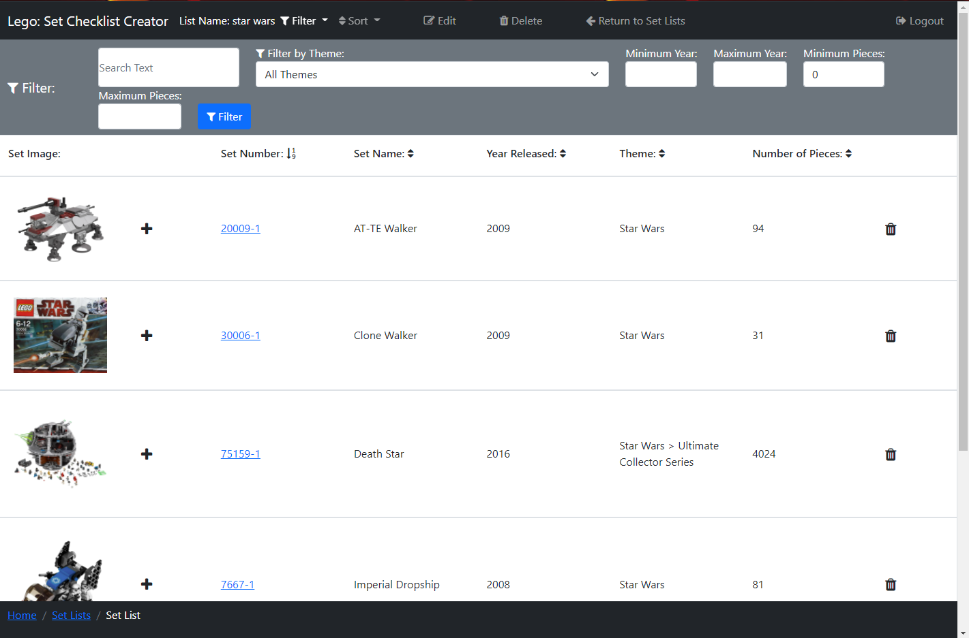

Figure : Set List - Filter Bar Open

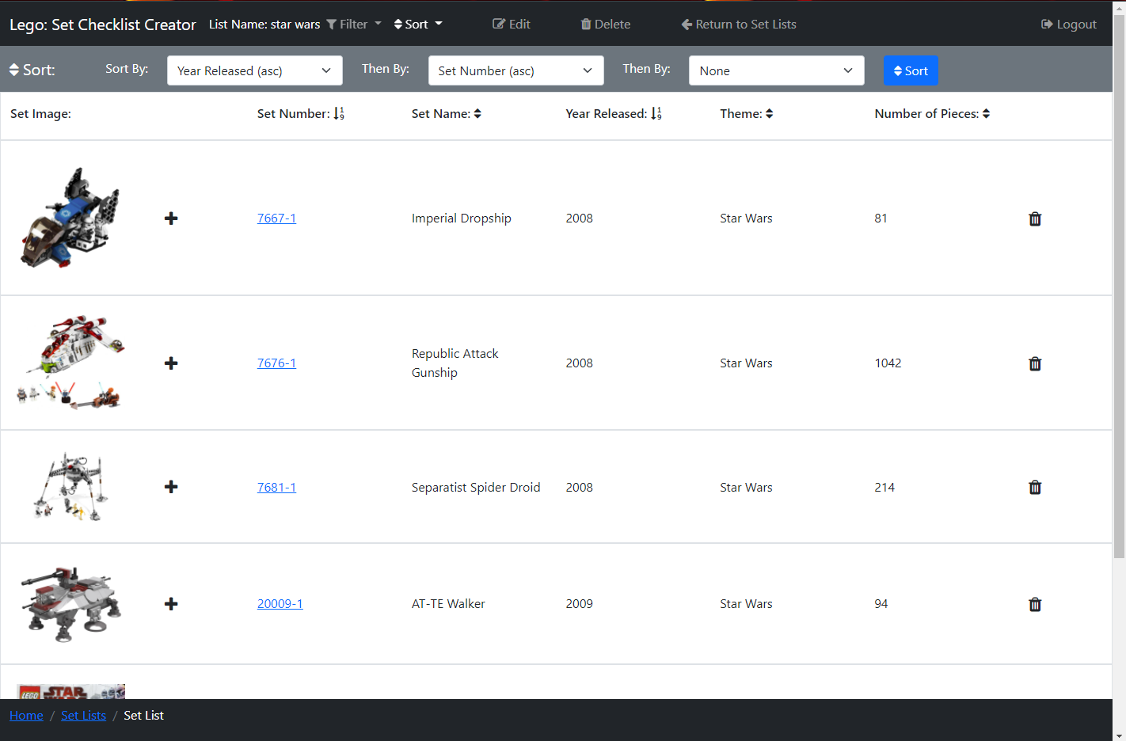

Figure : Set List - Sort Bar Open

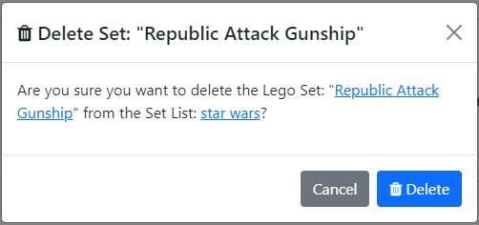

Figure : Delete Set from Set List Popup



Figure : Deleted Set from Set List Alert

The Set List Page (Figure 78 and Figure 79) can be accessed by a user, who is logged in, by clicking the ‘List Name’ hyperlink on the Home Page (Figure 11) from the last 3 edited setlists, or via the Set Lists Page (Figure 63: Initial Set Lists Page). On this page, users can search the sets that they have added to the Setlist, to find a Set they wish to view.

Similar to the Search Page, in the centre of the page, a list of Lego sets is displayed in rows, with columns displaying different bits of information on Lego sets. There is an image of each Lego Set in each row, that when clicked will open Figure 35 to view the image enlarged (see more detail above). If the user clicks a Set’s set number, which is a hyperlink, Figure 17: Lego Set Information Page will open displaying the selected set.

There is a ‘plus’ icon button that when clicked opens a popup (Figure 73) to add a set to a setlist. There is also a ‘bin’ icon in each set row, that when clicked a popup (Figure 80) appears asking the user if they want to delete the selected set from the setlist, this is used so that users don’t accidentally delete a set from a list by misclicking. The text ‘Republic Attack Gunship’ is replaced with the name of the set that will be deleted and ‘star wars’ with the setlist name. The second set name is a hyperlink to the Set Page (Figure 17), and the setlist name is a hyperlink to the Set List Page, I added these so users can check the Lego Set before they delete it from the setlist. There is a ‘Cancel’ button and ‘X’ in the top right corner, which both dismiss the popup when clicked. There is a ‘Delete’ button that will delete the selected set from the setlist and a light blue dismissible alert (Figure 81) appears under the list of sets header informing the user of this with the set name (in this case ‘Republic Attack Gunship’) a hyperlink to the deleted Sets page (Figure 17).

Above the list of sets is a header that has the name for each column, so it is clear to the user what each of these columns contains. Each of the column names (excluding ‘Set Image’), has an arrow next to it, these show if the sets are being sorted by that column, which works the same as the Search Page above.

There is a scroll bar down the side of the page so users can scroll through the Lego Sets in the setlist.

At the top of the page is a black navbar containing the website's name so it’s clear to users what website they are on, which when clicked acts as a link returning the user to the Home Page. Next to this is the name of the setlist the user is currently viewing, I added this, so it was clear to users which setlist they are viewing. There is a navbar link ‘Filter’ which opens a filter bar underneath the navbar (shown open in Figure 78), closing the sort bar (shown open in Figure 79) if it is open. Likewise, the ‘Sort’ navbar link opens a sort bar underneath the navbar shown open in Figure 79, closing the filter bar if it is open. Then there is a link ‘Edit’ that opens a popup (Figure 83) that allows the user to change the name of the Setlist, and a ‘Delete’ link that opens a popup (Figure 86 initial) to allow users to delete the Setlist. There is then a link ‘Return to Set Lists’ which returns the user to the Set Lists Page (see above). Finally, there is a ‘Logout’ navbar link that opens Figure 55: Logout Popup explained above.

The filter bar (Figure 78) contains filters the user can use to filter the Lego Sets and functions the same as on the Search Page but filtering a user’s setlist instead of sets from the Rebrickable API [1].

The sort bar (Figure 79) contains three select boxes so a user can perform a multi-sort, which functions the same as on the Search Page but sorts a user’s setlist instead.

The breadcrumb trail, also in the footer, has the current page in white text, with the previous pages to the right with hyperlinks to those pages. I added this so a user can see their position on the user journey.

There are not many differences between the initial design (Figure 75 and Figure 76) and the final design (Figure 78 and Figure 79), however, I added the ‘Return to Set Lists’ link, as apart from the breadcrumb link there was no other way to easily return to this to the user’s Set Lists Page (see above). I added a hyperlink to the set number in the final delete popup design (Figure 80) for the reasons explained above, whereas it is not in the initial design (Figure 77). I also added the Deleted Set Alert (Figure 81) in the final design, so it was clear to users the set was successfully deleted from the Sets in Progress.

#### Edit Set List Popup

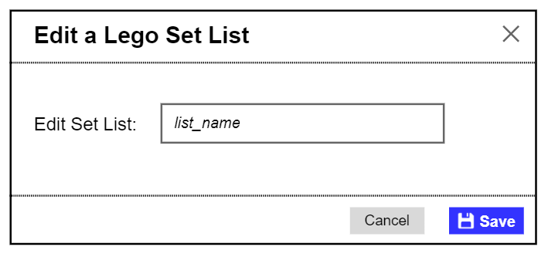

Figure : Initial Edit Set List Popup

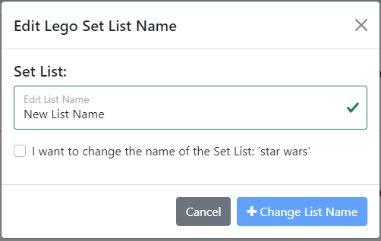

Figure : Edit Set List Popup

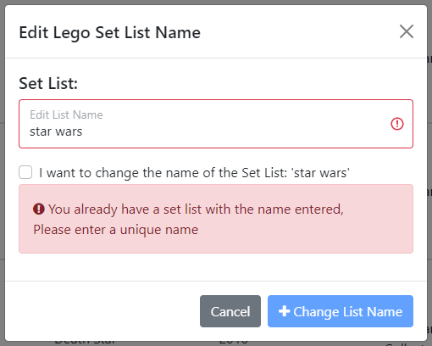

Figure : Edit Set List Error - Name Not Unique



Figure : Set List Edited Alert

When the ‘edit’ icon is clicked on a setlist row on the Set Lists Page or the ‘edit’ link in the navbar on the Set List Page (see above) is clicked, a popup (Figure 83) appears where a user can enter a new name for their setlist. The text ‘New List Name’ is replaced with the new name for the setlist that the user has entered, and ‘star wars’ is the old name of the setlist. If the new list name entered matches one of this user's saved setlist names then an error alert box will appear (Figure 84) informing the user the name must be unique and highlighting the input box red so users can easily see this is the error, also while the name matches the ‘Change List Name’ button is disabled.

If the user clicks the ‘Cancel’ button or ‘X’ in the top right corner, the popup is dismissed. There is a tick box which has to be ticked to activate the ‘Change List Name’ button that, when clicked, will update the selected setlist with the new name, and a light green dismissible alert (Figure 85) appears under the navbars and headers informing the user the setlist’s name has been changed, where ‘New List Name’ is the new name of the user’s setlist.

There are a few differences between the initial design (Figure 82) and the final design (Figure 83). In the initial design, there is a button with the text ‘Save’ which I changed to ‘Change List Name’ in the final design as I felt this better described what the button does. I also added the tick box in the final design so that the user had to confirm the new name of the setlist. In the final design, I also added the red alert box (Figure 84), as in the initial design there was no way of informing the user if the setlist name was already in use. Finally, I added the Set List Name changed Alert (Figure 85) in the final design, so it was clear to users the setlist name was successfully changed.

#### Delete Set List Popup

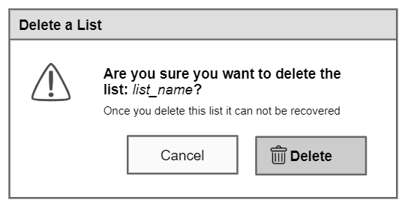

Figure : Initial Delete Set List Popup

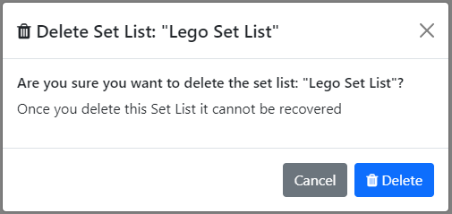

Figure : Delete Set List Popup



Figure : Deleted Set List Alert

When the ‘bin’ icon is clicked on a setlist row on Set Lists Page (above) or the ‘delete’ link in the navbar on the Set List Page (above) is clicked, a popup (Figure 87) appears asking the user if they want to delete the selected setlist, this is used so that users don’t accidentally delete a list by misclicking. The text ‘Lego Set List’ is replaced with the name of the setlist that will be deleted. If the user clicks the ‘Cancel’ button or ‘X’ in the top right corner, the popup is dismissed. There is a ‘Delete’ button that will delete the selected setlist, sending the user to the Set Lists Page with a light blue dismissible alert (Figure 88) open under the navbar and sort or filter bar, informing the user the setlist has been deleted with ‘Lego Set List’ the name of the setlist that has been deleted.

There are no differences between the initial design (Figure 86) and the final design (Figure 87), however, I added the Deleted Set List Alert (Figure 88) in the final design, so it was clear to users the setlist was successfully deleted.

#### Profile Page

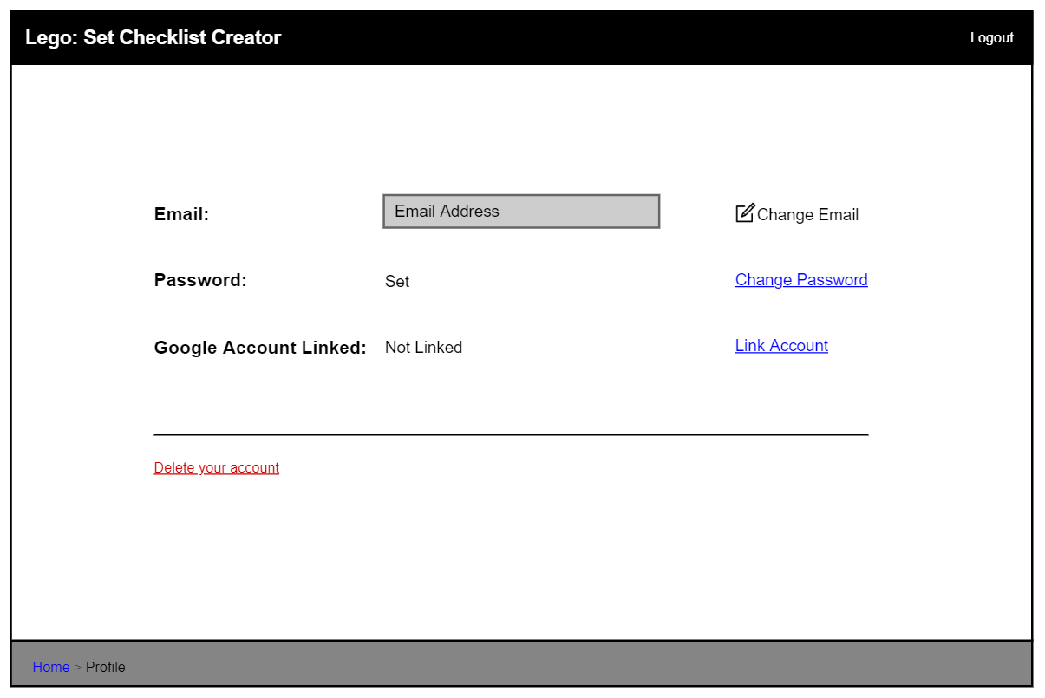

Figure : Initial Profile Page - Password Set, Google Account Not Linked

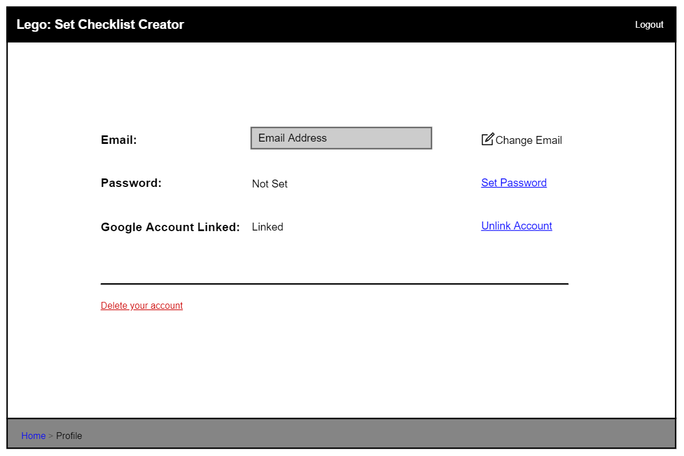

Figure : Initial Profile Page - Password Not Set, Google Account Linked

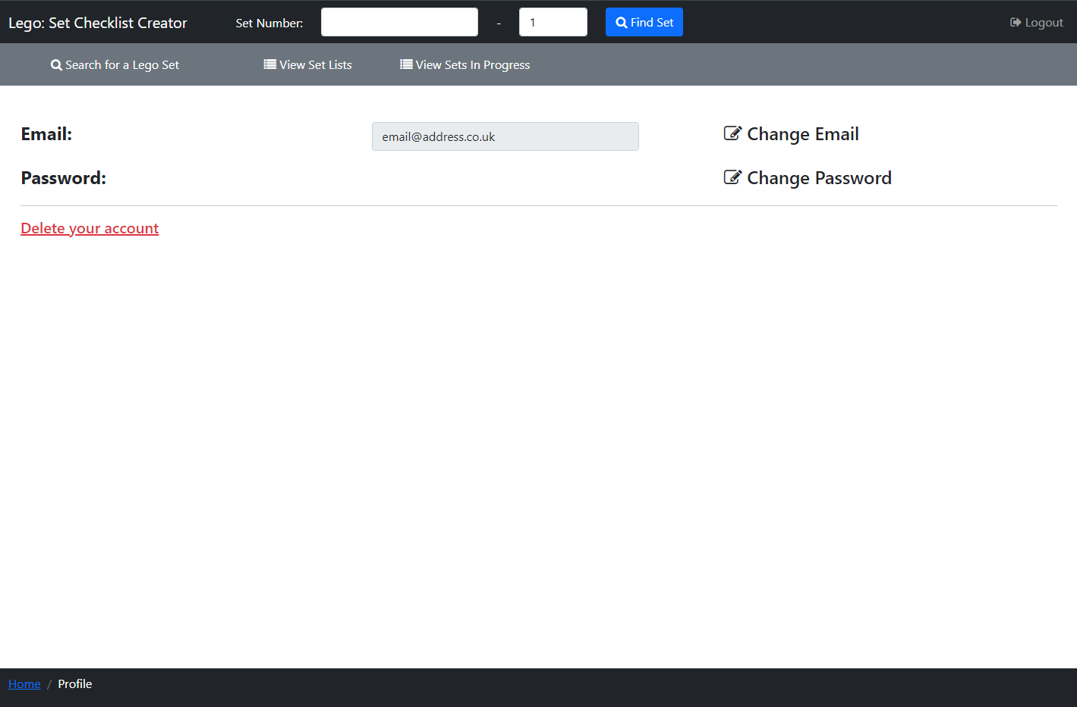

Figure : Profile Page

The Profile Page (Figure 91) can be accessed by a user, who is logged in, by clicking the ‘Profile’ link on the secondary navbar on the Home Page (Figure 11). On this page, users can view their account Email address, and can change their email and password, as well as the option to delete their account.

There is an ‘Email’ disabled text box, where users can view their current Email Address, which I added so users can check what email is on their account. Adjacent to this is a link ‘Change Email’ which opens a popup (Figure 93) where the user can change their email address. Additionally, the link ‘Change Password’ opens a popup (Figure 100) where the user can change their password.

There is a red link ‘Delete your account’ which opens a popup where a user can then delete their account. I decided to make this link red so users were warned that clicking it would do something

At the top of the page is a black navbar containing the website's name so it’s clear to users what website they are on. Then there are 2 number boxes where users can enter a Lego set number and variant number (at least 1) and a ‘Find Set’ button that will search for the Lego Set and return Figure 17 or Figure 19, these are explained in Set Page above. Finally, there is a ‘Logout’ navbar link that opens Figure 55: Logout Popup explained above.

Underneath the navbar is a secondary navbar with a ‘Search’ link that opens the Search Page (above), a link so users can view their ‘Set Lists’ (Set Lists Page above) and their ‘Sets In Progress’ (Sets in Progress Page above).

The breadcrumb trail, in the footer at the bottom of the page, has the current page in white text, informing them of their current position in the user journey.

In the initial design (Figure 89 and Figure 90) information on whether the users have a linked ‘Google Account’ or not, however, in the final design (Figure 91) I removed this as I decided against using a ‘Google Account’ to SignUp and Login to an account, which I explained above in the Login and Sign-Up Popup section. Also, as I removed the option of linking a ‘Google Account’ the user must have a password set to login, and therefore I removed the text informing the user if their password was set in the final design. I additionally added the set number search and second navbar in the final design so users have more accessibility to access other pages without having to return to the Home Page (Figure 11) first.

#### Change Email Popup

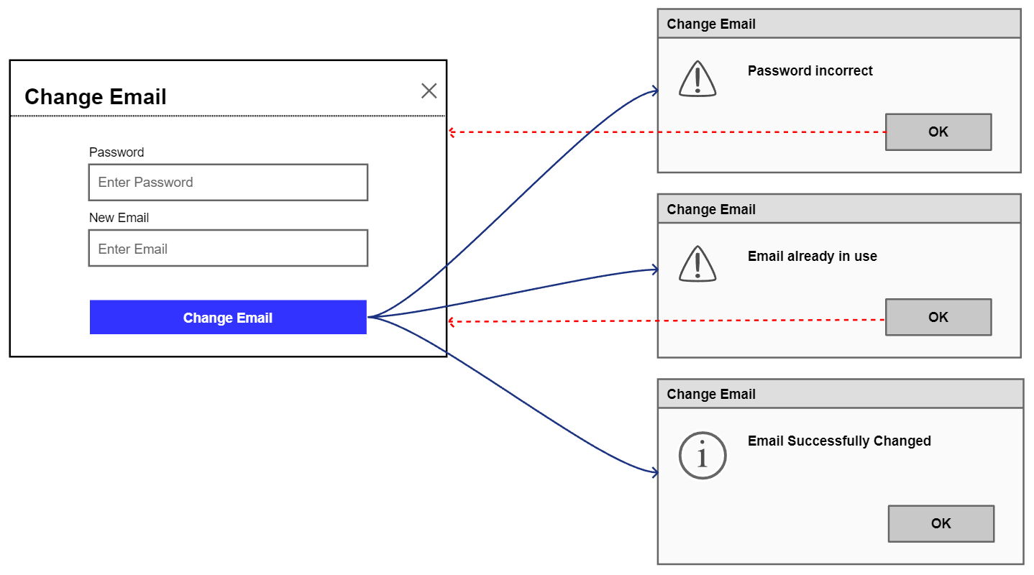

Figure : Initial Change Email Popup

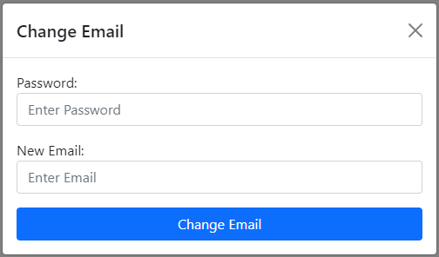

Figure : Change Email Popup

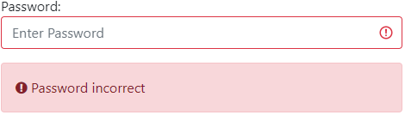

Figure : Change Email Error - Password Incorrect

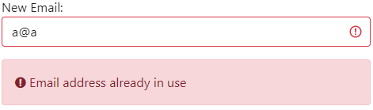

Figure : Change Email Error - New Email Not Unique

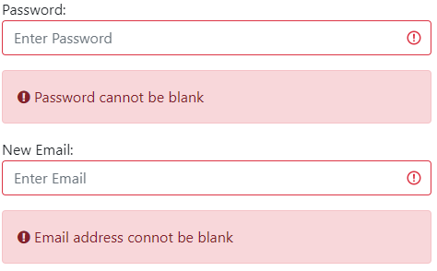

Figure : Change Email Error - Password Blank



Figure : Change Email Error - Email Blank



Figure : Email Address Changed Alert

When the ‘Change Email’ link is clicked on the Profile Page, a popup (Figure 93) appears where the user can change their email address. There is a ‘Password’ input box where the user must enter their password, to be able to change their email, and a ‘New Email’ input box where they can input a new email address, and if the entered email is not valid the corresponding Invalid Alert will be displayed (see Entered Email Invalid Alerts above for more details). There is a ‘Cancel’ button and ‘X’ in the top right corner that both dismiss the popup, and a ‘Change Email’ button, that when clicked will check both the user’s entered password and new email address.

If the password entered is incorrect then an error alert box will appear (Figure 94) informing the user that the entered password is incorrect and highlighting the ‘Password’ input box in red. If the email entered belongs to another account, then an error alert box will appear (Figure 95) informing the user of this and highlighting the ‘New Email’ input box in red. If the ‘Password’ or ‘New Email’ input boxes are blank, they are highlighted red and the red alert boxes in Figure 96 and Figure 97 are shown respectfully. Red alerts and input boxes are highlighted red for errors so users can easily see this is an error.

If the password entered is correct and the email address is valid and not in use, then the user’s email address is changed. After this, the popup is closed, and the Profile Page (Figure 91) is shown with the email input box displaying the user's new email, and with a light green dismissible alert (Figure 98) open under the secondary navbar, informing the user that their email address was successfully changed.

In the initial design (Figure 92) I had planned to use popups to inform the user the entered Password was incorrect, the email was in use and their email was changed. However, in the final design (Figure 94, Figure 95 and Figure 98) I chose to use error alert boxes for an incorrect password and an email being in use, and a dismissible alert when an email was changed. I made this decision so the user wouldn’t have to spend time closing alert popups breaking up their flow.

#### Change Password Popup

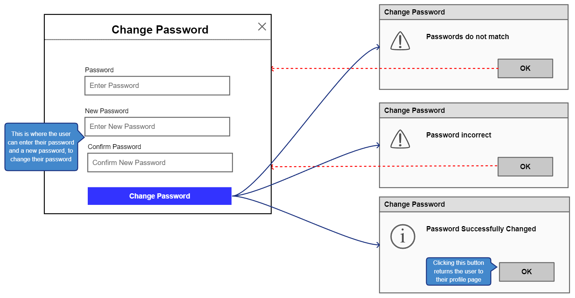

Figure : Initial Change Password Popup

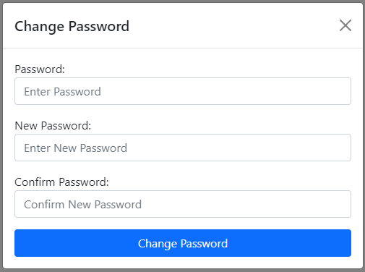

Figure : Change Password Popup

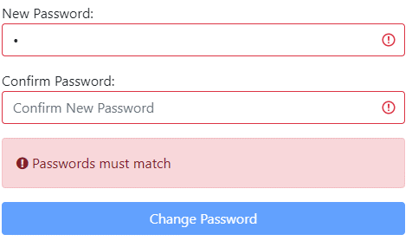

Figure : Change Password Error - Passwords Must Match

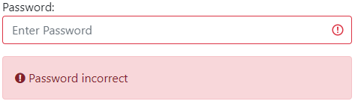

Figure : Change Password Error - Password Incorrect



Figure : Change Password Error - Password Blank

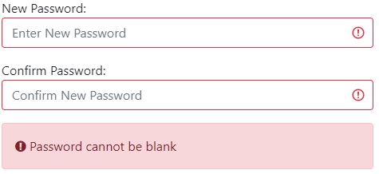

Figure : Change Password Error - New Password Blank

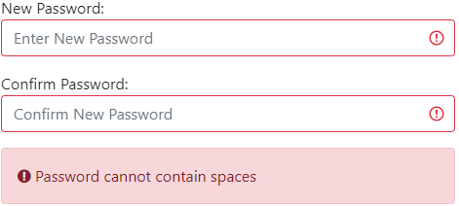

Figure : Change Password Error - Password Cannot Contain Spaces



Figure : Password Changed Alert

When the ‘Change Password’ link is clicked on the Profile Page, a popup (Figure 100) appears where the user can change their password. There is a ‘Password’ input box where the user must enter their current password, to be able to change their password, a ‘New Password’ input box where they can input a new password, and a ‘Confirm Password’ input box, which is used because in these input boxes text is hidden it checks the user entered the password they meant. If the text enter in the ‘New Password’ and ‘Confirm Password’ input boxes do not match they are highlighted red and a red error alert box will appear (Figure 101) informing the user that they don’t match and disabling the ‘Change Password’ button. There is a ‘Cancel’ button and ‘X’ in the top right corner that both dismiss the popup, and a ‘Change Password’ button, that when clicked will check both the user’s entered current password and new password.

If the ‘Password’ entered is incorrect then an error alert box will appear (Figure 102) informing the user the entered password is incorrect and highlighting the ‘Password’ input box in red. If the ‘Password’ or ‘New Password’ and ‘Current Password’ input boxes are blank, they are highlighted red and the red alert boxes in Figure 103 and Figure 104 are shown respectfully. If the new password contains spaces, the ‘New Password’ and ‘Current Password’ input boxes are highlighted red and the red alert boxes in Figure 105 are shown. Red alerts and input boxes are highlighted red for errors so users can easily see this is an error.

If the ‘Password’ entered is correct and the ‘New Password’ is not blank and does not contain spaces, then the user’s password is changed. After this, the popup is closed, and the Profile Page (Figure 91) is shown with a light green dismissible alert (Figure 106) open under the secondary navbar, informing the user their email address was successfully changed.

In the initial design (Figure 99) I had planned to use popups to inform the user that the ‘New’ and ‘Confirm’ passwords did not match, the current password was incorrect, and their password was changed. However, in the final design (Figure 101, Figure 102 and Figure 106) I chose to use error alert boxes for non-matching passwords, an incorrect password, and a dismissible alert when a password was changed. I made this decision so the user wouldn’t have to spend time closing alert popups breaking up their flow.

#### Delete Account Popup

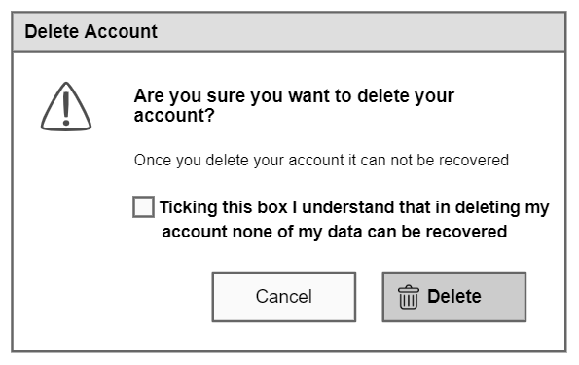

Figure : Initial Delete Account Popup

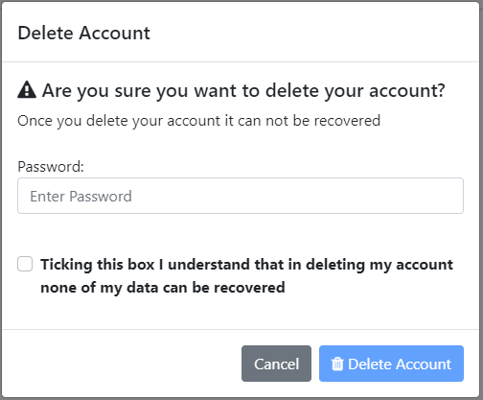

Figure : Delete Account Popup

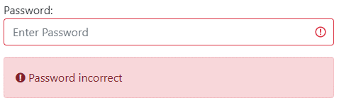

Figure : Delete Account Error Password Incorrect

When the ‘Delete your account’ link is clicked on the Profile Page, a popup (Figure 108) appears asking the user if they are sure they want to delete their account, with a ‘Password’ input box where the user must enter their password to be able to delete their account. There is also a tick box that must be ticked to activate the ‘Delete’ button so the user can click that button to delete their account. When the ‘Delete’ button is clicked, if the password entered is correct the user's account is deleted and they are sent to the Home Page (Figure 9). If the password entered is incorrect then an error alert box will appear (Figure 109) informing the user the entered password is incorrect and highlighting the input box red so users can easily see this is the error. There is also a ‘Cancel’ button to dismiss the popup.

This popup is used so that users don’t accidentally delete their account by misclicking and the tick box ensures the user understands they are deleting their account.

In the initial design (Figure 107) users only had to click a tick box to delete their account, however, I felt this was insecure and so I add the ‘Password’ tickbox in the final design (Figure 108) so that if a user left their account logged in someone could not then delete their account.

#### Access Denied Page

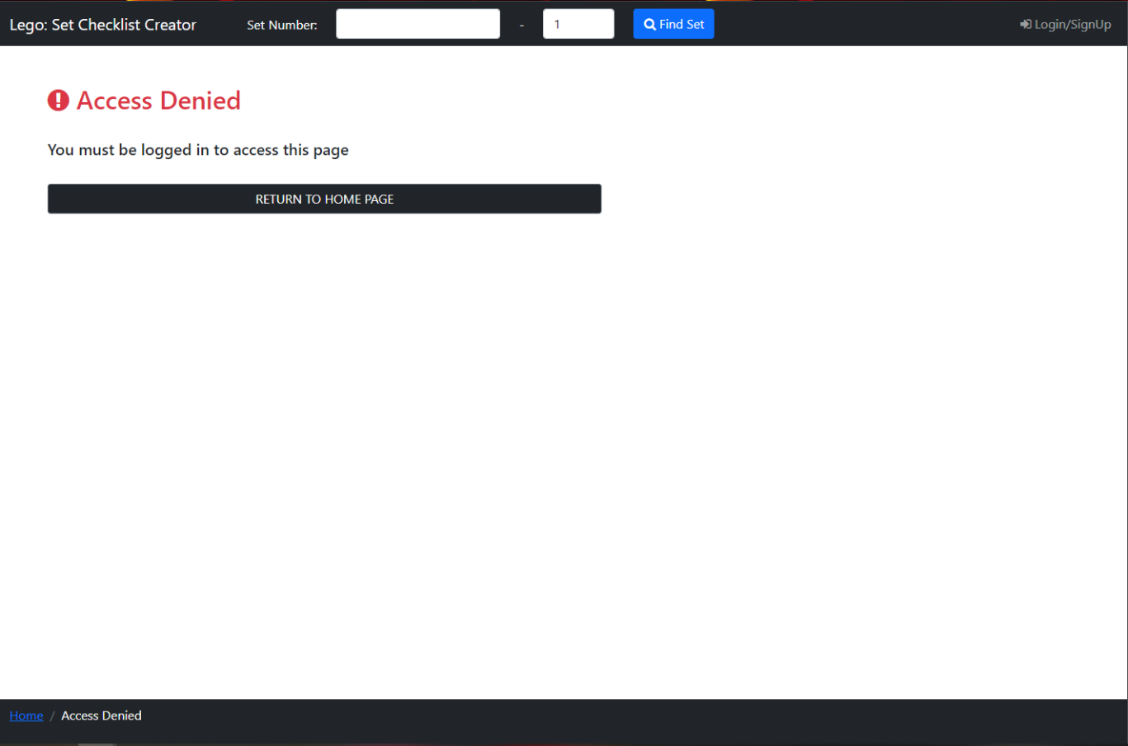

Figure : Access Denied Page

If a logged-out user tries to access a page meant only for logged-in users, then they are sent to the Access Denied Page (Figure 110). This page informs the user they need an account to access the requested page, with the word ‘this’ replaced with the name of the page in question. There is a button ‘RETURN TO HOME PAGE’, which returns users to the Home Page (Figure 9), so users can quickly return to a page they have access to.

At the top of the page is a black navbar containing the website's name so it’s clear to users what website they are on, which when clicked acts as a link returning the user to the Home Page (above). Then there are 2 number boxes where users can enter a Lego set number and variant number (at least 1) and a ‘Find Set’ button that will search for the Lego Set and return Figure 17 or Figure 19, these are explained in Set Page above, which I added this here so user could easily find a set and go back to a valid page. Finally, there is a ‘Login/SignUp’ link which opens the Login and Sign-Up Popup with the Login Tab Selected (Figure 40) explained above, so users can easily login and access the page that is currently denied.

The breadcrumb trail, also in the footer, has the current page in white text, with the previous pages to the right with hyperlinks to those pages. I added this so a user can see their position on the user journey.

#### Popup for Page Loading

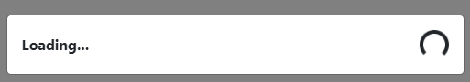

Figure : Loading Popup

The loading popup (Figure 111) is displayed when the user clicks on a page link or imports a checklist informing the user that the page or checklist is being loaded. I added this so it was clear to users the website was loading and so they didn’t think it was not functioning.

## Implementation

### Retrieving and Reading Data from the APIs

To retrieve information on Lego Sets from the Rebrickable API [1], the system has to perform an HTTP request with the URI containing the API’s URL, information on what data to retrieve and an API key, and this URI to retrieve the required data is written using the Rebrickable API documentation [2]. I then used the RestTemplate class [10] is used to perform the HTTP request with the URI to the Rebrickable API, using the method ‘getForObject’, which returns a JSON tree as a string with the requested data. I also used the RestTemplate class when retrieving Lego Set instruction booklets from the Brickset API [7].

To read the JSON tree stored in strings that contains the data returned from an API, I used Jackson-core [11] and Jackson-databind [12] libraries. Using the ‘ObjectMapper’ class and its method ‘readTree’ with the JSON string as a parameter, retrieves a ‘JsonNode’ which is the root node in the JSON tree. Then using the ‘path’ method on a ‘JsonNode’ with a string parameter returns a ‘JsonNode’ node that is a child of the root node, where its name matches the string, for example, ‘set_num’.

If a ‘JsonNode’ has no child then it can be transformed into a datatype (‘String’, ‘int’, ‘boolean’ etc.) which means information received from an API can be read, like a Lego Set’s number, name and year released etc.

A ‘JsonNode’ can also be an array of JSON trees, and to retrieve data from each tree the ‘JsonNode’ is iterated by every ‘JsonNode’ it contains. For example, when searching for a Lego Set using the Rebrickable API [1] the list of Lego sets is returned as a JSON array and is iterated through to get all data in this array.

If data received, now stored in variables, is from the Rebrickable API [1] then this information is added to an instance of the relevant class the data is for ‘Set’, ‘Piece’ or ‘Theme’, which are explained above in the Class Diagram in the Design section or the Classes section below.

If the data is for instruction booklets for a Lego Set, retrieved from the Brickset API [7], then the data from each ‘JsonNode’ in the JSON array is stored in a list of string arrays that contain the URL to the PDF instruction booklet and a description for the booklet. This list is then used to display the list of Lego set instructions on the Set Page (Figure 17 above).

### Classes

#### Set Class

I implemented the Set Class in Java to match the design explained in the 5.4 Class Diagram section above. I added Hibernate [8] and JPA [9] annotations to this class to generate the SetInfo table in the database, which is explained below in 6.6 Database Implementation.

The class constructors create an instance of the Set class with only the values inputted (see Figure 7) to the constructors initialised. The getter and setter functions in this class are basic and only set and retrieve values.

#### Piece Class

I implemented the Piece Class in Java to match the design explained in the 5.4 Class Diagram section above.

The class constructors create an instance of the Piece class with only the values inputted (see Figure 7) to the constructors initialised. The getter and setter functions in this class are basic and only set and retrieve values.

#### SetInSetList Class

I implemented the SetInSetList Class in Java to match the design explained in the 5.4 Class Diagram section above. I added Hibernate [8] and JPA [9] annotations to this class to generate the SetsInSetList table in the database, which is explained below in 6.6 Database Implementation. The ‘setInSetListId’ variable in this class is auto-generated, also explained in Database Implementation.

The class constructors create an instance of the SetInSetList class with only the values inputted (see Figure 7) to the constructors initialised. The getter function in this class is basic and only retrieves the instance of the Set Class this class contains.

#### Set_list Class

I implemented the Set_list Class in Java to match the design explained in the 5.4 Class Diagram section above. I added Hibernate [8] and JPA [9] annotations to this class to generate the Set_list table in the database, which is explained below in 6.6 Database Implementation. The ‘setListId’ variable in this class is auto-generated, also explained in Database Implementation.

The class constructors create an instance of the Set_list class with only the values inputted (see Figure 7) to the constructors initialised, apart from the ‘lastChangedDateTime’ which is set as the current date and time this class is initialised. The getter and setter functions in this class are basic and only set and retrieve values. The ‘updateDateTime()’ function updates the ‘lastChangedDateTime’ to the current date and time. The ‘addSet()’ function adds an instance of the SetInSetList Class to the list ‘setsInSetList’, and increases ‘totalSets’ by 1, and ‘removeSet()’ decreases ‘totalSets’ by 1. The ‘contains()’ function takes a String ‘set_number’ as input, and iterates through all the SetInSetLists in the list ‘setsInSetList’, checking if any of these have the same Set Number, and thus the Setlist contains that Lego Set.

#### SetInProgress Class

I implemented the SetInProgress Class in Java to match the design explained in the 5.4 Class Diagram section above. I added Hibernate [8] and JPA [9] annotations to this class to generate the SetInProgress table in the database, which is explained below in 6.6 Database Implementation. The ‘setInProgressId’ variable in this class is auto-generated, also explained in Database Implementation.

The class constructors create an instance of the SetInProgress class with only the values inputted (see Figure 7) to the constructors initialised, apart from the ‘lastChangedDateTime’ which is set as the current date and time this class is initialised. The getter and setter functions in this class are basic and only set and retrieve values. The ‘updateDateTime()’ function updates the ‘lastChangedDateTime’ to the current date and time.

#### PieceFound Class

I implemented the PieceFound Class in Java to match the design explained in the 5.4 Class Diagram section above. I added Hibernate [8] and JPA [9] annotations to this class to generate the PieceFound table in the database, which is explained below in 6.6 Database Implementation. The ‘pieceFoundId’ variable in this class is auto-generated, also explained in Database Implementation.

The class constructors create an instance of the PieceFound class with only the values inputted (see Figure 7) to the constructors initialised. The getter setter functions in this class are basic and only retrieve values.

#### Account Class

I implemented the Account Class in Java to match the design explained in the 5.4 Class Diagram section above. I added Hibernate [8] and JPA [9] annotations to this class to generate the Account table in the database, which is explained below in 6.6 Database Implementation. The ‘accountId’ variable in this class is auto-generated, also explained in Database Implementation.

The class constructors create an instance of the Account class with only the values inputted (see Figure 7) to the constructors initialised. The getter and setter functions in this class are basic and only set and retrieve values.

#### Theme Class

I implemented the Theme Class in Java to match the design explained in the 5.4 Class Diagram section above. I added Hibernate [8] and JPA [9] annotations to this class to generate the Theme table in the database, which is explained below in 6.6 Database Implementation.

The class constructors create an instance of the SetInProgress class with only the values inputted (see Figure 7) to the constructors initialised. The getter and setter functions in this class are basic and only set and retrieve values.

### Controllers

Controllers contain methods which handle URL requests to load the JSPs that display my website pages to users and update data in the database. Controllers can also send variables containing data for a JSP to use, which are added to the JSP as Model Attributes, are accessed by JSPs to use via code explained in the 6.5 User Interface Implementation section.

Controller methods can also send a URL request for another controller method, which changes the page URL to this Redirect URL. Users can also send variables to the JSP loaded by the redirected controller method, these are called Redirect Attributes and work similarly to Model Attributes except they are applied after the Redirect.

The Controllers in my System are Explained Below:

#### Main Controller

This controller loads the Home Page, and if a user is logged in this adds their last changed 3 changed setlists and last 3 saved sets in progress as Model Attributes so they can view these on this page.

The ‘onStartUp’ method in this controller, is run every time the system starts and calls the runs the Theme Controller and Piece Type Controller to create Hash Maps for all Theme ids and Theme names, and Piece Type ids and Piece Type Names.

#### Set Controller

The Set Controller handles views that involve Lego Sets.

This controller interacts with the Rebrickable API [1] to retrieve information on a Lego Set using the Set’s ‘Set Number’, and then reads the data returned, this is achieved via the implementation explained above in 6.1 Retrieving and Reading Data from the APIs. This data is then added to an instance of the Set Class. This controller then interacts with the Piece Controller (below) to retrieve a list of the Piece Class and adds this list to the set class. Then this instance of the Set class is then added to the JSP for the Set Page as a Model Attribute, so it can then be displayed to the user on the Set Page using code explained in the User Interface Implementation section.

It can also retrieve a list of Lego Sets from the API using the method explained above. The request sent to the API to retrieve these sets can have additional parameters that can sort and filter the returned sets, which are decided by the user on the Search Page (Figure 14 and Figure 15), and how the user can add these is explained above in the User Interface Design section. These Lego sets are each added to an instance of the Set Class and then to a Java list of type Set. This list along with the Hash Map of all Themes (see 6.3.4 Theme Controller below) are added to the JSP for the Search Page as Model Attributes. The list of sets is added so they can then be displayed to the user on the Search Page, and the Theme Hash Map so that all Themes can be displayed to the user, so they can select one to filter the Sets by.

This controller can also retrieve instruction booklets for a Lego Set from the Brickset API [7], via the method explained above, so that these can be added to the JSP for the Set Page as Model Attributes, and are displayed on the Lego Sets Page (Figure 17) where the user can access these instructions.

This set also handles the importing of a Lego Set Checklist, which is explained below in the 6.4.2 Import CSV section.

This Controller also has a method which handles the displaying of a logged-in user's setlists on the Set List Page (Figure 64 and Figure 65). It has a Session Attribute ‘set_lists’ which is a list of all the user's setlists, which is added as a Session Attribute when a user logs into their account (see Database Controller below). As this is a Session Attribute it does not need to be added again as a Model Attribute, however, the number of setlists is added as a Model Attribute, and is used when iterating through all the setlists when filtering them, see 6.5 User Interface Implementation. This method also handles the sorting of setlists by a sort a user has selected on the Set List Page and parsed into the method. To does this by sorting the setlists by the parsed sort and because this is a Session Attribute it is updated here and does not have to be added again. This method can also have filters, that are currently applied to the setlists, parsed into the method, which is then added as Model Attributes so that once a sort has been applied to the setlists and displayed on the Set List Page, the previous filters can then be reapplied via the JSP for this page.

#### Piece Controller

The Piece Controller handles the retrieval of pieces in a Lego Set, as well as, controlling the Piece Checklist Page.

This controller interacts with the Rebrickable API [1] to retrieve information on all Pieces in a Lego Set using the Set’s ‘Set Number’, and then reads the data returned, this is achieved via the implementation explained above in 6.1 Retrieving and Reading Data from the APIs. Each piece’s information is added to an instance of the Piece Class and then added to a list of the type Piece Class. The controller also retrieves all the pieces needed to build any Minifigures in the Lego Set and adds these pieces to the Piece List. This Piece List is then returned to the Set Controller (above) so it can be added to the instance of the Set Class that contains information on the Lego set that these pieces are for.

This controller has a method that handles URL requests for the Piece Checklist Page (Figure 25), adding the Model Attribute of the instance of the Set Class the user wants to view a checklist for. It also adds two Model Attributes which are both Java lists of Strings. These lists contain all the Lego Piece Colours and piece types in the Lego Set, and these lists are created by iterating through all pieces and adding their colour and piece type to the respective list if it does not already contain that colour or piece type. These lists are added so that on the Piece Checklist Page a user can filter the pieces by colour and piece type, and how this is implemented is explained below in 6.5 User Interface Implementation.

This method also handles the sorts for the Set’s Piece List by a sort a user has selected on the Piece Checklist Page and parsed into the method. To does this by sorting the Set’s Piece List by the parsed sort and then adding this updated list to the Set Class, and then adding the fully updated Set instance as a Model Attribute so when the list of Lego pieces is displayed on the Piece Checklist Page, they are in their sorted order. This method can also have filters that are currently applied to a Checklist parsed into the method, which is then added as Model Attributes so that once a sort has been applied to the piece list and displayed on the Piece Checklist Page, the previous filters can then be reapplied via the JSP for this page. A comma-separated list of each Piece’s ‘Quantity Found’ is also parsed when applying a sort, these are in the same order the list is currently in, and the Piece classes ‘quantity_checked’ field on each piece is updated to match this before a sort is performed so that the ‘Quantity Found’ of each piece remains the same after a sort.

This set also handles the exporting of the Pieces in a Lego Set Checklist, which is explained below in the 6.4.1 Exporting CSV section.

#### Theme Controller

The Theme Controller is run on start-up via the ‘onStartUp’ method in the Main Controller and connects to the Rebrickable API [1] to get all the Lego Set Themes. Each theme’s unique ‘id’, ‘name’ and ‘parent_id’ which the Theme that this theme is a sub-theme for (e.g. Lego City is the parent of Police) and adds these to an instance of the ‘Theme’ class described above add a link when added, and adds the Theme to a Hash Map of these with the Theme ‘id’ as the identifier.

Once all the themes are added to the Hash Map the system goes through all the themes and checks to see if the theme's ‘parent_id’ is 0, meaning there is no parent theme. If it is not 0 the parent themes name is added in front of the child theme name with a ‘>’ so that it is identifiable where each theme name is separated, then the parent theme is checked to so if its own ‘parent_id’ is 0 and if it is not that theme name is added. This goes on until the ‘parent_id’ is 0, and then the full name of the original theme is set and its ‘parent_id’ can be set as 0. This is then repeated for all the Lego Set themes.

This is done so that when Lego Sets are received from the Rebrickable API [1], the system does not have to call the API again with each set’s ‘theme_id’ to find out the theme name, but can instead use the hash map which speeds up the program and stops the Rebrickable API Server from timing-out as there are too many requests.

#### Piece Type Controller

This Piece Type Controller is run on start-up via the ‘onStartUp’ method in the Main Controller and connects to the Rebrickable API [1] to get all the different types of Lego Pieces. Each piece’s unique ‘id’ and ‘name’ are added to a Hash Map containing will contain all the Piece Types. The ‘id’ is used as the unique identifier for the Hash Map and the ‘name’ as the data.

This is done so that when Lego Pieces are received from the Rebrickable API [1], the system does not have to call the API again with each piece’s ‘pieceType_id’ to find out the name of the piece type, but can instead use the hash map which speeds up the program and stops the Rebrickable API Server from timing-out as there are too many requests.

#### Database Controller

This controller handles all database functions between the views and database. It handles the displaying of all pages a logged-in user tries to view.

This handles account functions to sign-up, login, logout, delete an account, and change an account email and password. It also handles URL requests for the Profile Page (Figure 91) for a logged-in user.

When creating a user account, the controller uses the ‘Account Validator’ to check the email and the password entered can be used to create an account. The validator checks that no other user has an account with the entered email address, the password contains no spaces and if the email address and password entered are not blank. If any of these conditions are not true the validator returns these errors to the Database Controller, which redirects the user back to the Home Page (Figure 9) via the Main Controller. The errors with creating an account are added as Redirect Attributes. Another Redirect Attribute is also added that informs the JSP for this page there was an error, so the JSP opens the Login and Sign-Up Popup with the Sign-Up tab selected (Figure 45), this is done so the user can view the errors. If there are no errors a new account is created and stored in the database with the password hashed and salted (see 6.7 Password Hashing and Salt). A new setlist is also created for the user account with the name ‘Sets Owned List’ and saved to the database. The user is then redirected to the Home Page (Figure 9) with a Redirect Attribute informing this page’s JSP that an account was created. As this Redirect Attribute is present, the JSP opens the Login and Sign-Up Popup with the Login tab selected (Figure 39), with an alert bar informing the user they have created an account (Figure 50).

When attempting to log into an account, the controller uses the ‘Account Validator’ to check the email entered belongs to an account and the password matches the saved password.

The validator checks if the entered email address and password entered are blank and if the email address belongs to an account and if it does that account’s hashed password and salt are received from the database, after which the entered password is hashed and salted with the same has and salt as the account’s password before the two hashed and salted passwords are compared.

If the email and password are blank, the email does not belong to an account or the password is incorrect, the validator returns these errors to the Database Controller, which redirects the user back to the Home Page (Figure 9) via the Main Controller. The errors with logging in are added as Redirect Attributes. Another Redirect Attribute is also added that informs the JSP for this page there was an error, so the JSP opens the Login and Sign-Up Popup with the Login tab selected (Figure 39), this is done so the user can view the errors. If there are no errors the user's email address is added as a Session Attribute ‘accountLoggedIn’ so that JSPs and controllers know if the user is logged in and which account it is. The account user’s setlists are retrieved from the database as a list of the Set_list Class and added as a Session Attribute ‘set_lists’ so that they don’t have to be retrieved from the database every time the user needs to select one to add a Set to a Setlist (Figure 73). Finally, the user is redirected to the logged-in Home Page (Figure 11).

The method that controllers logs users out of their account firstly removes the Session Attributes ‘accountLoggedIn’ and ‘set_lists’ so that the system knows that there is now no account logged in and other users cannot access the previously logged-in user's setlists. The user is then redirected to the Home Page (Figure 9) via the Main Controller.

To change an email, change a password or delete an account the ‘Account Validator’ is again used to check that the user’s current password entered is correct. Changing an email also uses the ‘Account Validator’ to check the email entered is unique, and when changing the account password checks the entered new password is valid. If there are any errors the user is redirected back to the Profile Page (Figure 91), with a Redirect Attributes containing these errors. When changing an email if the password entered is correct and the new email is valid, then the user’s account’s email is changed, and their account is resaved to the database. When changing a password if the current password entered is correct and the new password is valid, then the user’s account’s password is changed, and their account is resaved to the database. After changing an email or a password the user is redirected to the Profile Page (Figure 91), with a Redirect Attribute used to inform the page’s JSP that one of these was changed so the appropriate alert bar can be displayed (Figure 98 and Figure 106). If the password entered is correct when a user wants to delete their account, then the user’s account is deleted from the database with other related rows in other tables deleted too (see 6.6 Database), then the user is redirected to the Logout controller method so the account’s Session Attributes can be removed and the user returned to the Home Page (Figure 9).

This controller also retrieves a logged-in user's setlists from the database, as a list of type Set_list Class, and adds this as a Model Attribute so they can be displayed on the Set Lists Page (Figure 64 and Figure 65). It can also retrieve all Lego sets in a setlist from the database, as a list of type Set Class, and adds this as a Model Attribute so they can be displayed on the (Figure 78 and Figure 79). The controller can add and delete setlists from the database and change the names of setlists, furthermore, it can add and remove Lego ets from a setlist and update the database to show this.

This controller can get logged-in user’s Sets in Progress from the database, as a list of the type SetInProgress Class, and adds this as a Model Attribute so they can be displayed on the Sets in Progress Page (Figure 59 and Figure 60). The controller can save a Set in Progress to the database and remove it from the database too.

Finally, this controller also displays the Access Denied Page (Figure 110), when a logged-in tries to access a page only available to logged-in users. This is done when a user tries to enter a page meant only for logged-in users, the method in the database which handles the URL for this page checks to see if there is a Session Attribute ‘accountLoggedIn’ that if set holds the currently logged-in user’s email, and if this session attribute does not exist then the Access Denied Page (Figure 110) is displayed.

### Exporting and Importing CSV Files

One of my key requirements for my project (4.1), was that users could save progress on a checklist, even without an account. To do this I decided that any user could export and import their Lego Set Piece Checklist.

I found a website [13] that explains how to read and write to a CSV file using ‘OpenCSV’ which is added to the ‘build.grade’ file as an ‘implementation’ () so that it can be used in my program.



#### Exporting CSV

To export a Checklist as a CSV file the program retrieves all the ‘Quantity Checked’ from the Piece Checklist Page (Figure 25) for the Lego set.

The name of the CSV file to be exported is the Set’s name followed by ‘_Checklist.csv’ so that once the files have been exported the user knows what the checklist is for.

I combined code from two website articles [13] and [14] to create and export a CSV file for a Lego Set checklist on a client's machine, as this was not vital to the main function of the program.

The first website article [13] as mentioned above explains how to read and write to a CSV file, and I used code from this article to help me Write data to the CSV file.

The second website article [14] explains how to export data in a CSV file in Spring Boot, in the form of a download on the client's device via their browser. Figure 112 below shows the code I used from the article [14], which sets the ‘HTTPServletResponse’ content type to a CSV file and the name of the CSV file. This code is inside a controller method which after the code in Figure 112 adds the data to the CSV file and when the method ends exports the file to the client’s device.



Figure : Exporting CSV File on Clients Device Code

The data that is stored in the CSV file is as follows. First the Lego Set’s ‘Set Number’ is written to the first line of the CSV file. After this, there is a line for each Lego Piece that has a ‘Quantity Found’ above 0 that contains unique identifying information for that piece, as there is no need to store these as during the CSV import (explained below) pieces missing in the CSV file have their ‘Quantity Found’ set as 0. The piece information exported is the piece’s number, the name of the piece's colour, if it is a spare piece and the ‘Quantity Found’.



This shows how the

#### Import CSV

To import a CSV file the user selects a file to upload in the Import Checklist Popup (Figure 37), and this file is uploaded using code from a website article [15] that explains how to upload a file from the clients and device and parse it to the server in Spring Boot.

To read the now imported CSV file, the system uses code from the online article [13] that explains how to read and write data to CSV files in Java.

The system first reads the first line to get the ‘Set Number’ of the set that the checklist is for. The system then retrieves the information for this Lego Set along with its pieces using the ‘Set Number’ from the Rebrickable API [1] via the method explained above in Retrieving and Reading Data from the APIs. The system then reads the rest of the CSV files getting each piece stored in it, these pieces are then matched to their corresponding piece in the retrieved Lego Set’s list of pieces, and updating the piece’s ‘Quantity Found’ to match the imported piece’s ‘Quantity Found’.

Once the system has finished reading the file and updating the Lego set pieces, the user is sent to the Lego Set’s Set Page (Figure 17), and if they go to this set’s piece checklist they will see that every piece’s ‘Quantity Found’ match that of the imported checklist CSV file.

### User Interface Implementation

bootstrap for UI visuals and so the screen adjusts for different screen sizes and devices

To implement the design explained above in the User Interface Design section, I used JSPs (Java Server Page) with HTML and JavaScript along with Bootstrap [16] and some additional inline CSS.

Bootstrap [16] is a CSS and JavaScript framework, used for page styling, and is useful for creating interactive pages that resize for different screen sizes, as well as help create a consistent and simple UI.

This resizing can be done by putting style="width: num%" in an HTML elements tag, and this sets the item to fill the percentage of the current screen by 'num' (where 'num' is any number between 0 and 100).

### Database Implementation

JPA annotations and Database SQL, hibernate

#### Database Creation SQL

### Password Hashing and Salt

## Results

## Discussion

## Critical Appraisal

## Conclusion and Future Work

## References

1. "Rebrickable API | Rebrickable - Build with LEGO", *Rebrickable.com*. [Online]. Available: <https://rebrickable.com/api/>. [Accessed: 17- Nov- 2021]
2. "Rebrickable API Documentation | Rebrickable - Build with LEGO", *Rebrickable.com*, 2020. [Online]. Available: <https://rebrickable.com/api/v3/docs/?key=15b84a4cfa3259beb72eb08e7ccf55df>. [Accessed: 15- Nov- 2021]
3. "BrickLink - Buy and sell LEGO Parts, Sets and Minifigures", *Bricklink.com*. [Online]. Available: <https://www.bricklink.com/v2/main.page>. [Accessed: 17- Nov- 2021]
4. "Rebrickable | Rebrickable - Build with LEGO", *Rebrickable.com*. [Online]. Available: <https://rebrickable.com/>. [Accessed: 17- Nov- 2021]
5. "LEGO Set 75280-1 501st Legion Clone Troopers (2020 Star Wars) | Rebrickable - Build with LEGO", *Rebrickable.com*, 2021. [Online]. Available: <https://rebrickable.com/sets/75280-1/501st-legion-clone-troopers>. [Accessed: 17- Nov- 2021]
6. "LEGO PART 6134 Hinge Brick 2 x 2 Top Plate Thin | Rebrickable - Build with LEGO", *Rebrickable.com*. [Online]. Available: <https://rebrickable.com/parts/6134/hinge-brick-2-x-2-top-plate-thin/#buy_parts>. [Accessed: 24- Feb- 2022]
7. Huw, "API version 3 documentation", *Brickset.com*, 2021. [Online]. Available: <https://brickset.com/article/52664/api-version-3-documentation>. [Accessed: 17- Nov- 2021]
8. V. Mihalcea, S. Ebersole, A. Boriero, G. Morling, G. Badner, C. Cranford, E. Bernard, S. Grinovero, B. Meyer, H. Ferentschik, G. King, C. Bauer, M. Andersen, K. Maesen, R.Vansa and L. Jacomet, “Hibernate ORM 5.5.9.Final User Guide”, *Docs.jboss.org*. [online] Available: <https://docs.jboss.org/hibernate/orm/current/userguide/html_single/Hibernate_User_Guide.html>. [Accessed: 28- Feb- 2022].
9. O. Gierke, T. Darimont, C. Strobl, M. Paluch and J. Bryant, "Spring Data JPA - Reference Documentation", *docs.spring.io*, 2022. [Online]. Available: <https://docs.spring.io/spring-data/jpa/docs/current/reference/html/>. [Accessed: 28- Feb- 2022]
10. "RestTemplate (Spring Framework 5.3.14 API)", Docs.spring.io, 2021. [Online]. Available: <https://docs.spring.io/spring-framework/docs/current/javadoc-api/org/springframework/web/client/RestTemplate.html>. [Accessed: 02- Dec- 2021]
11. "jackson-core 2.13.1 javadoc (com.fasterxml.jackson.core)", *Javadoc.io*. [Online]. Available: <https://javadoc.io/doc/com.fasterxml.jackson.core/jackson-core/latest/index.html>. [Accessed: 05- Dec- 2021]
12. "jackson-databind 2.13.1 javadoc (com.fasterxml.jackson.core)", *Javadoc.io*. [Online]. Available: <https://javadoc.io/doc/com.fasterxml.jackson.core/jackson-databind/latest/index.html>. [Accessed: 05- Dec- 2021]
13. Atta, "Reading and writing CSV files using OpenCSV", *Atta-Ur-Rehman Shah*, 2019. [Online]. Available: <https://attacomsian.com/blog/read-write-csv-files-opencsv>. [Accessed: 03- Jan- 2022]
14. Atta, "Export & Download Data as CSV File in Spring Boot", *Atta-Ur-Rehman Shah*, 2019. [Online]. Available: <https://attacomsian.com/blog/export-download-data-csv-file-spring-boot>. [Accessed: 03- Jan- 2022]
15. Atta, "Uploading and Parsing CSV File using Spring Boot", *Atta-Ur-Rehman Shah*, 2020. [Online]. Available: <https://attacomsian.com/blog/spring-boot-upload-parse-csv-file>. [Accessed: 04- Jan- 2022]
16. "https://getbootstrap.com/docs/5.0/getting-started/introduction/", *Getbootstrap.com*. [Online]. Available: <https://getbootstrap.com/docs/5.0/>. [Accessed: 03- Feb- 2022]
17. del

## Appendix A

Questionnaire for what user would want from a digital checklist for pieces in a Lego Set.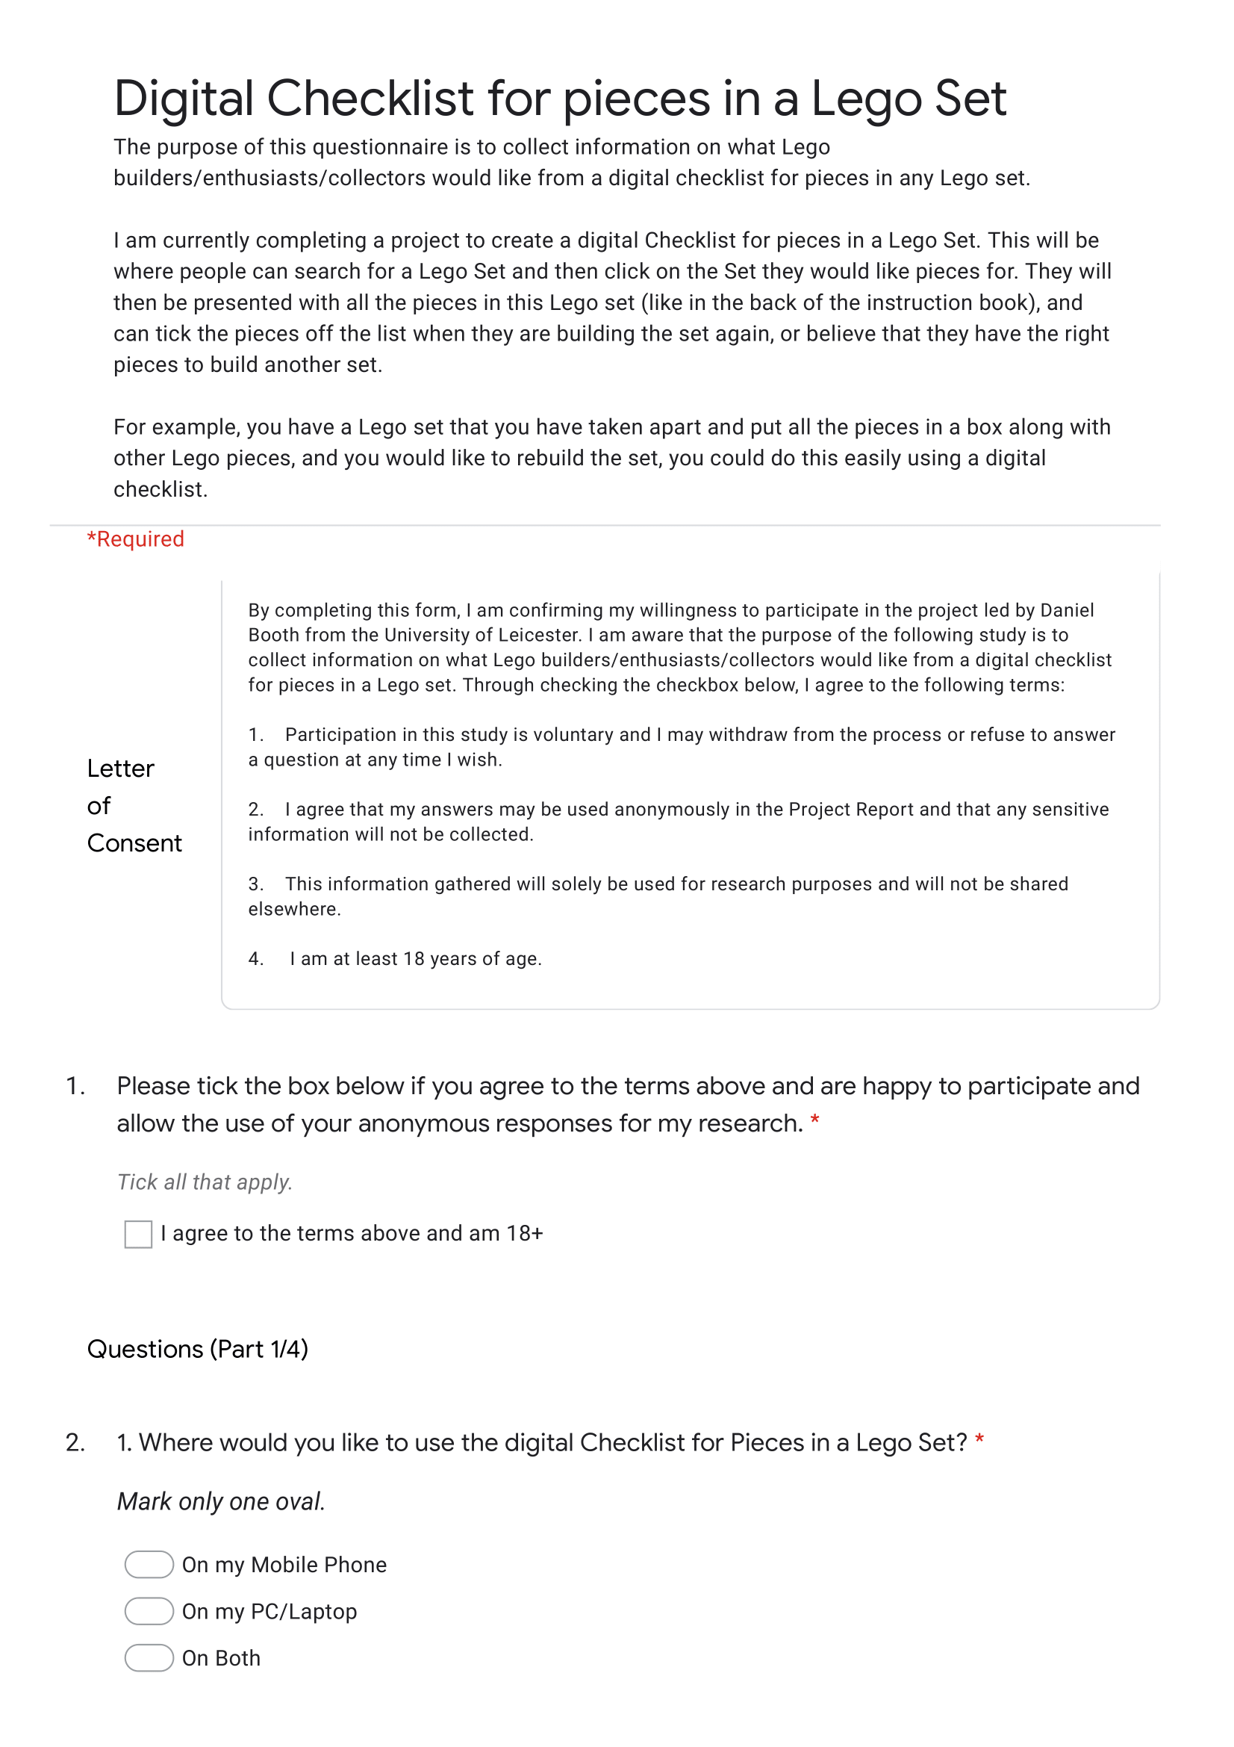

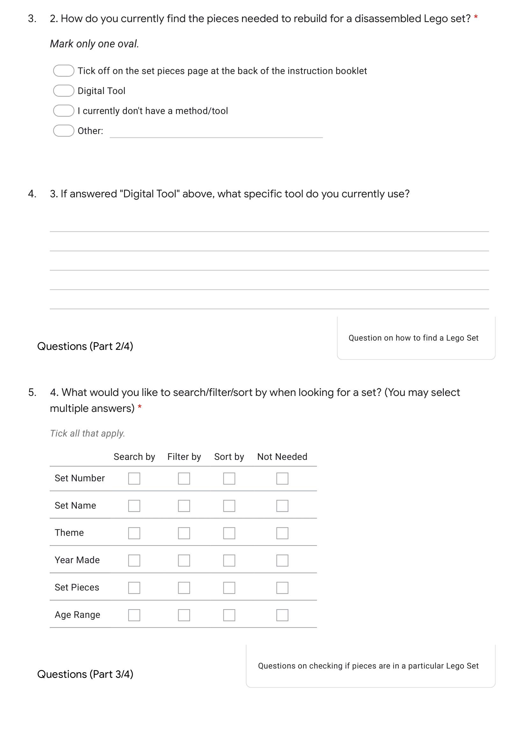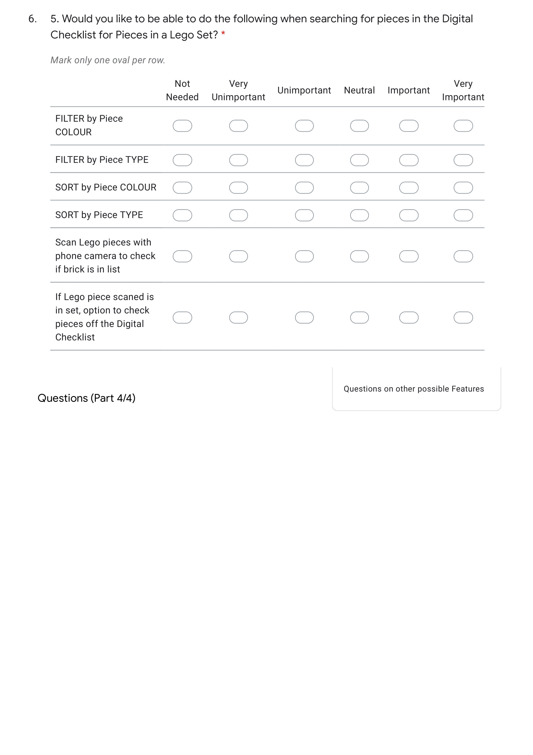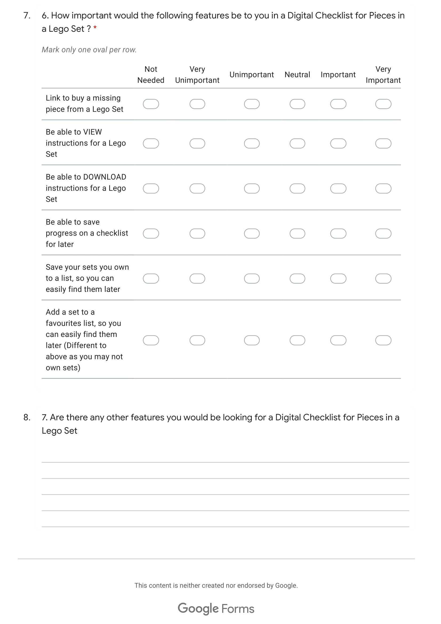

## Appendix B

Results from my questionnaire (see **Appendix A**).

Letter of Consent Result

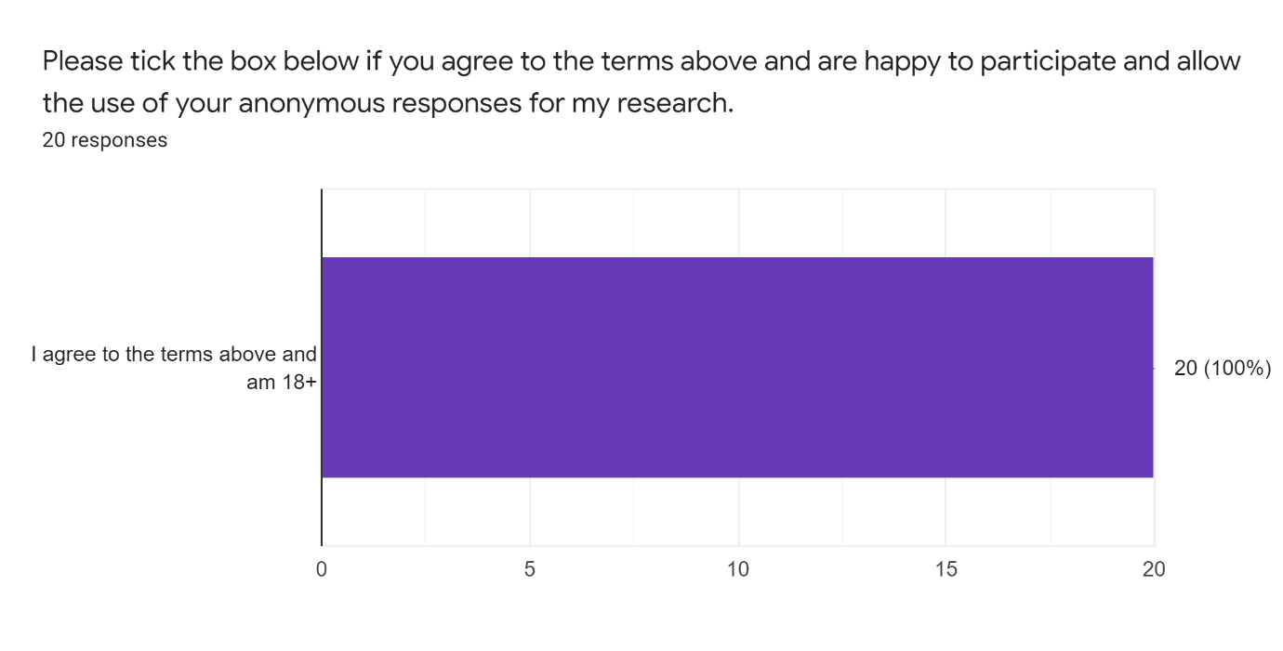



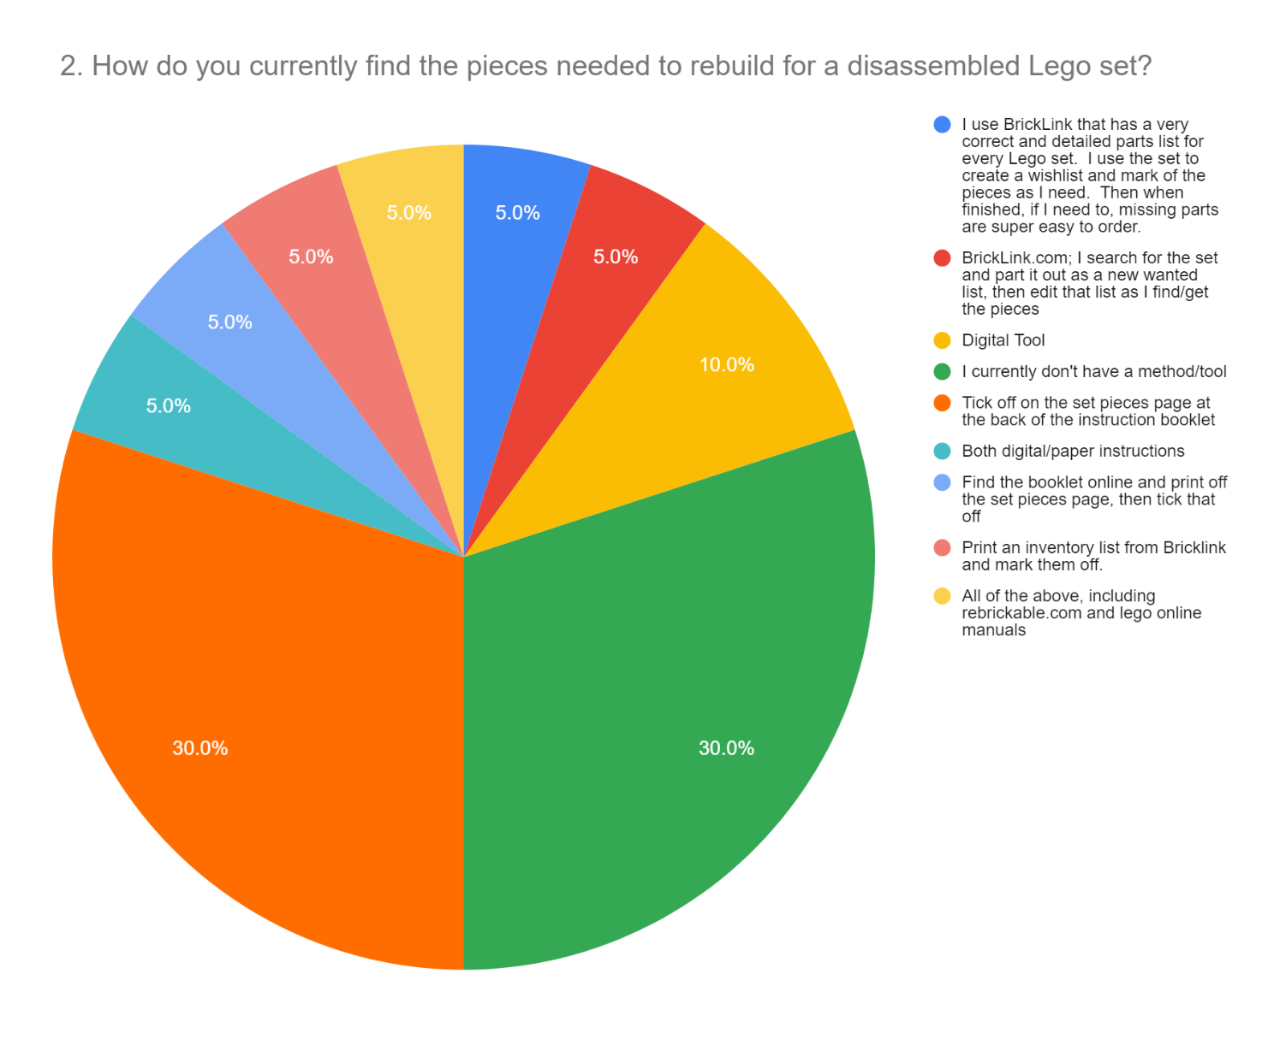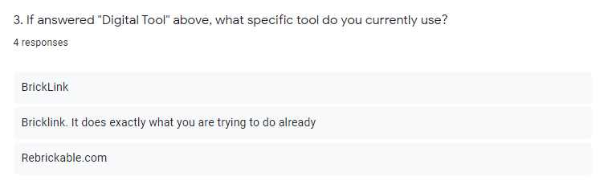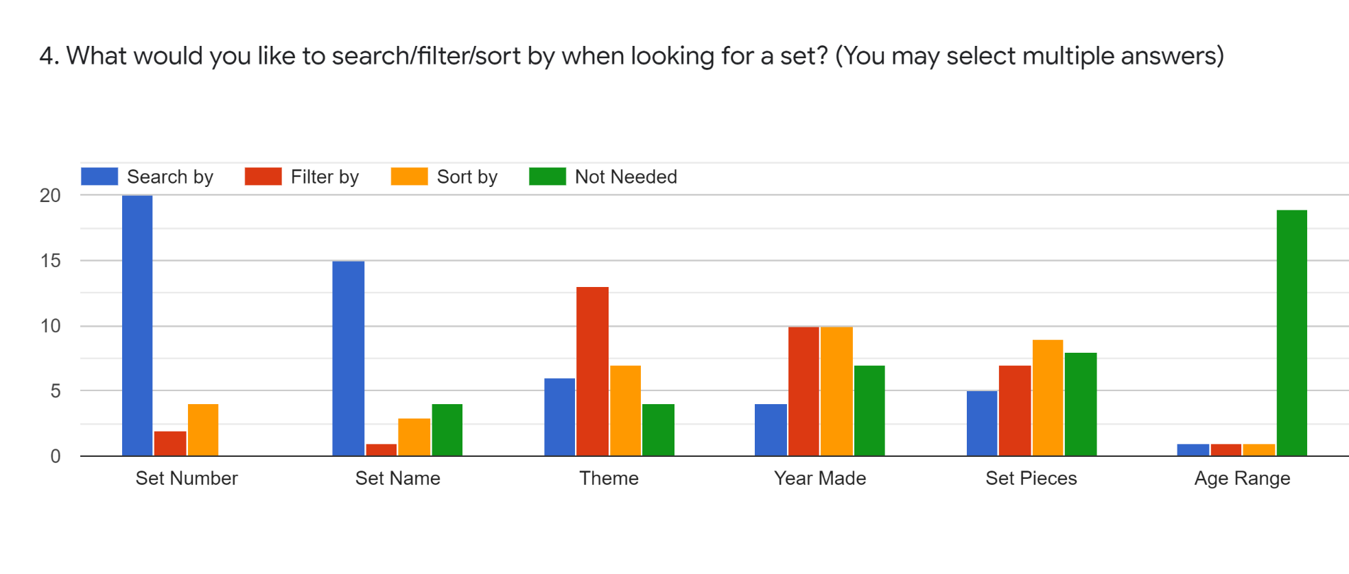

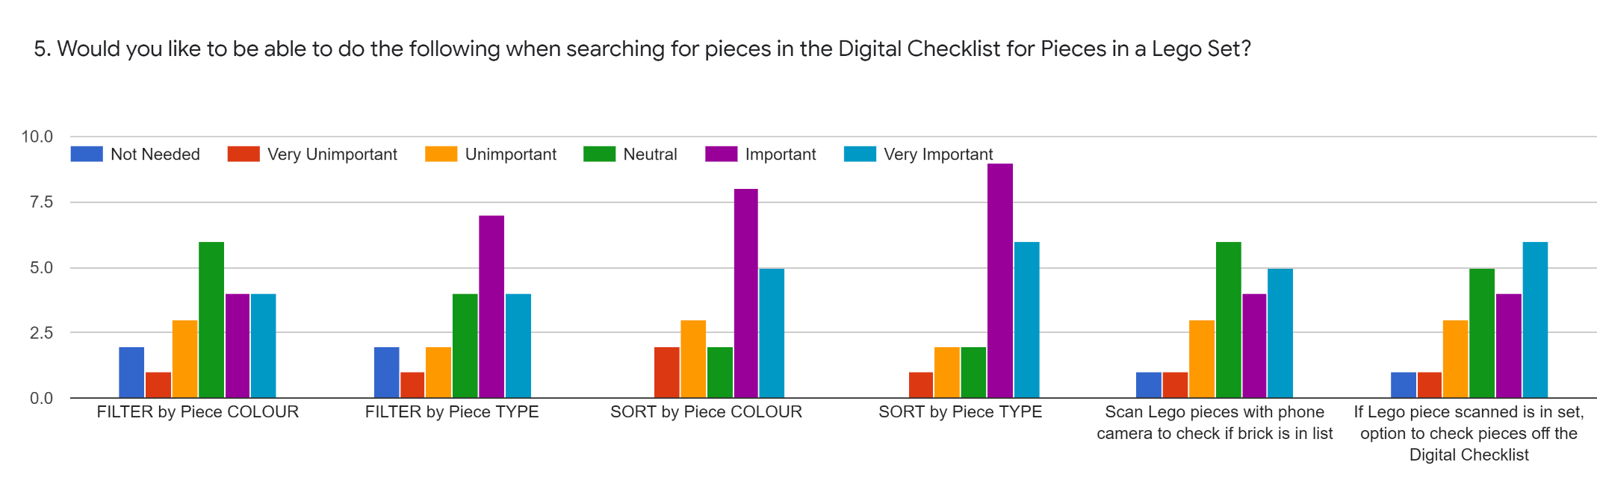

6. How important would the following features be to you in a Digital Checklist for Pieces in a Lego Set ?

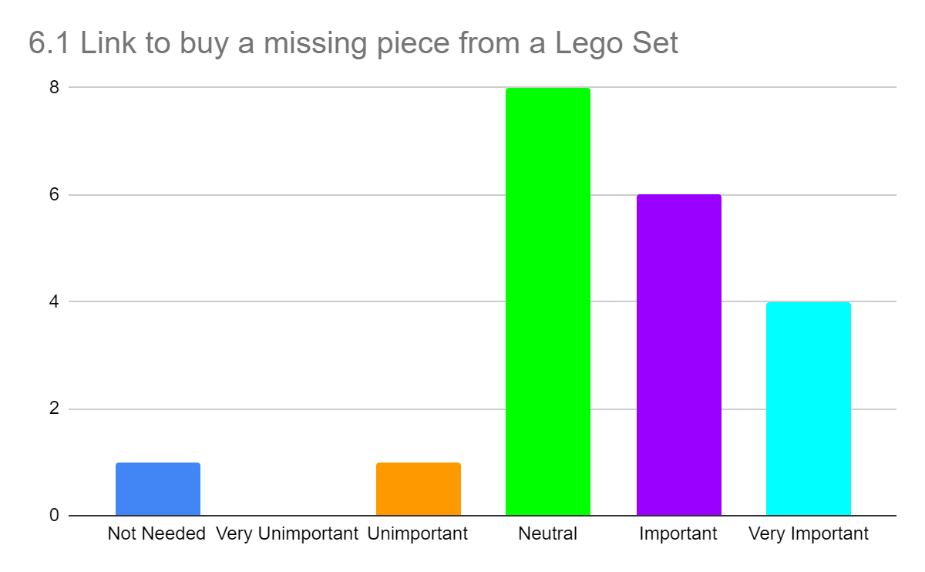

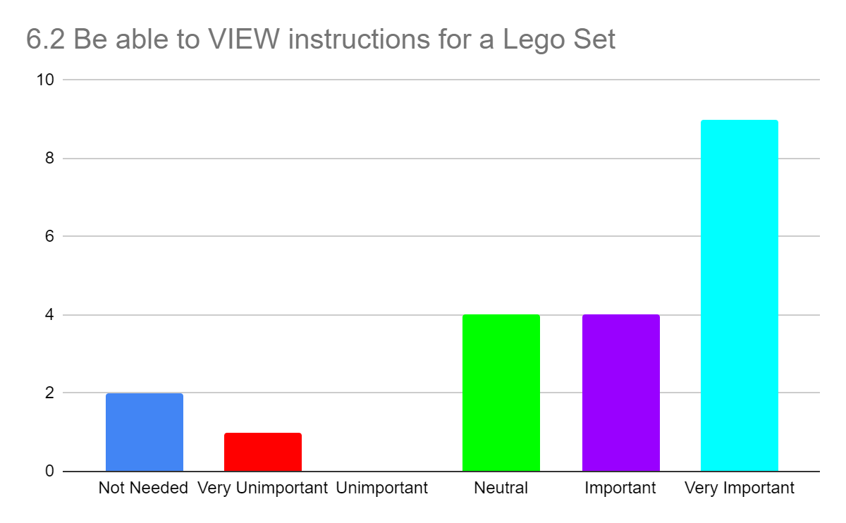

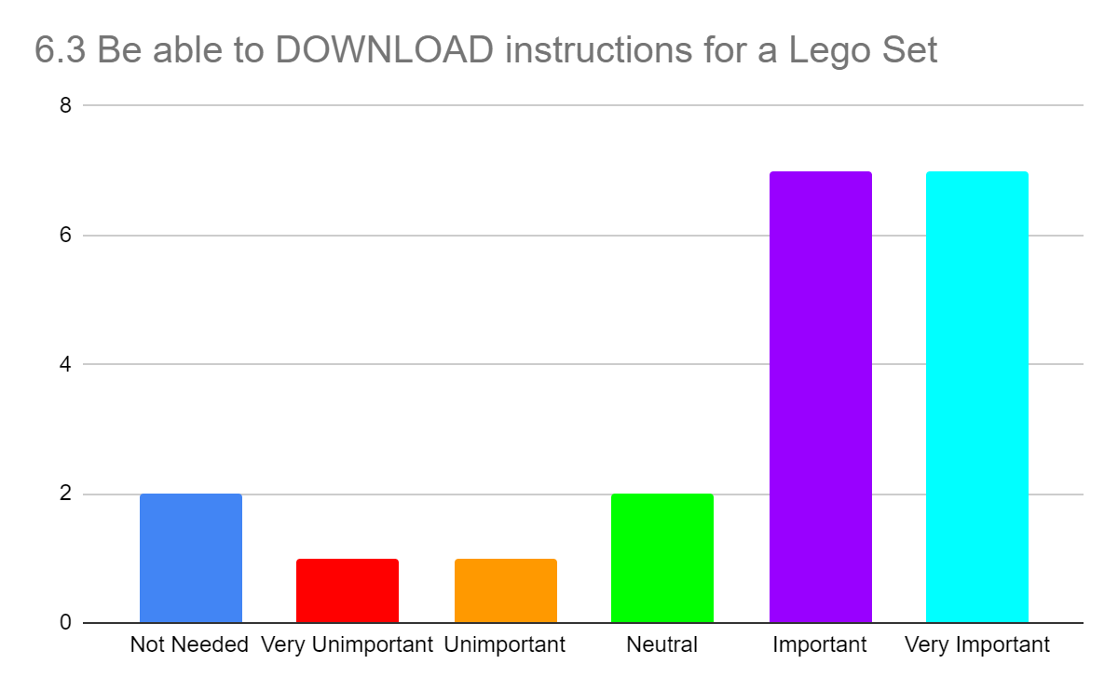

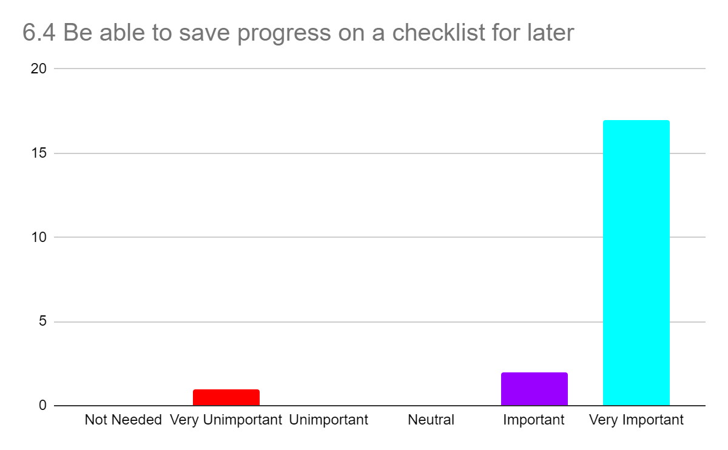

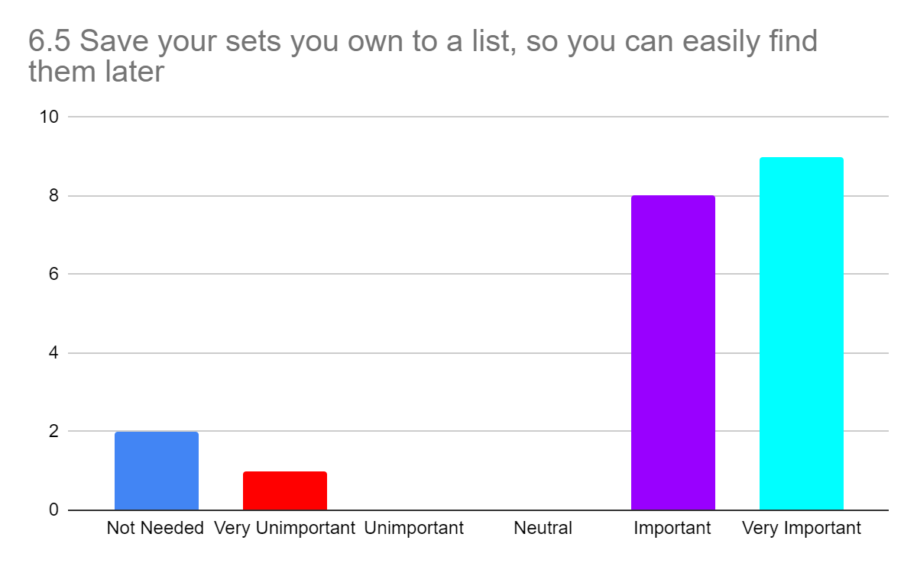

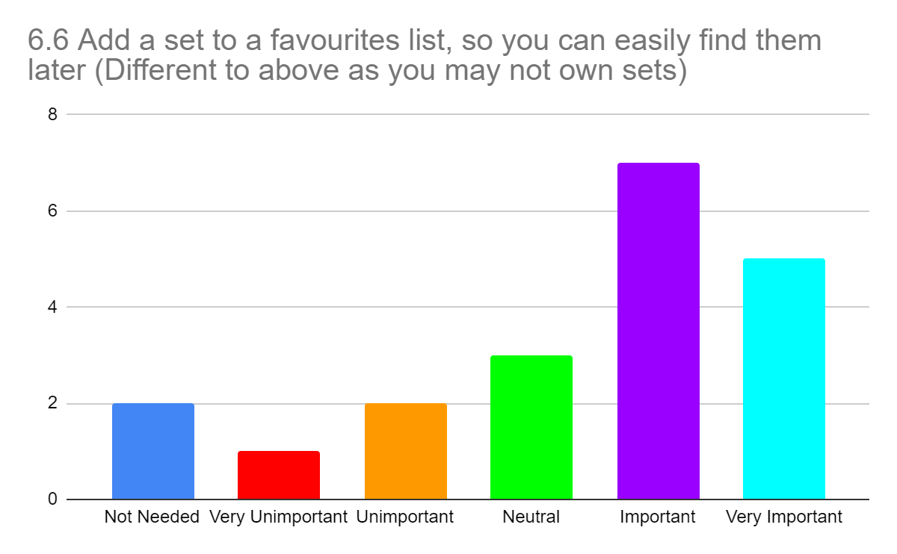



## Appendix C

List of tasks performed by each participant during the usability tests, first on a PC/Laptop and then on a mobile device.

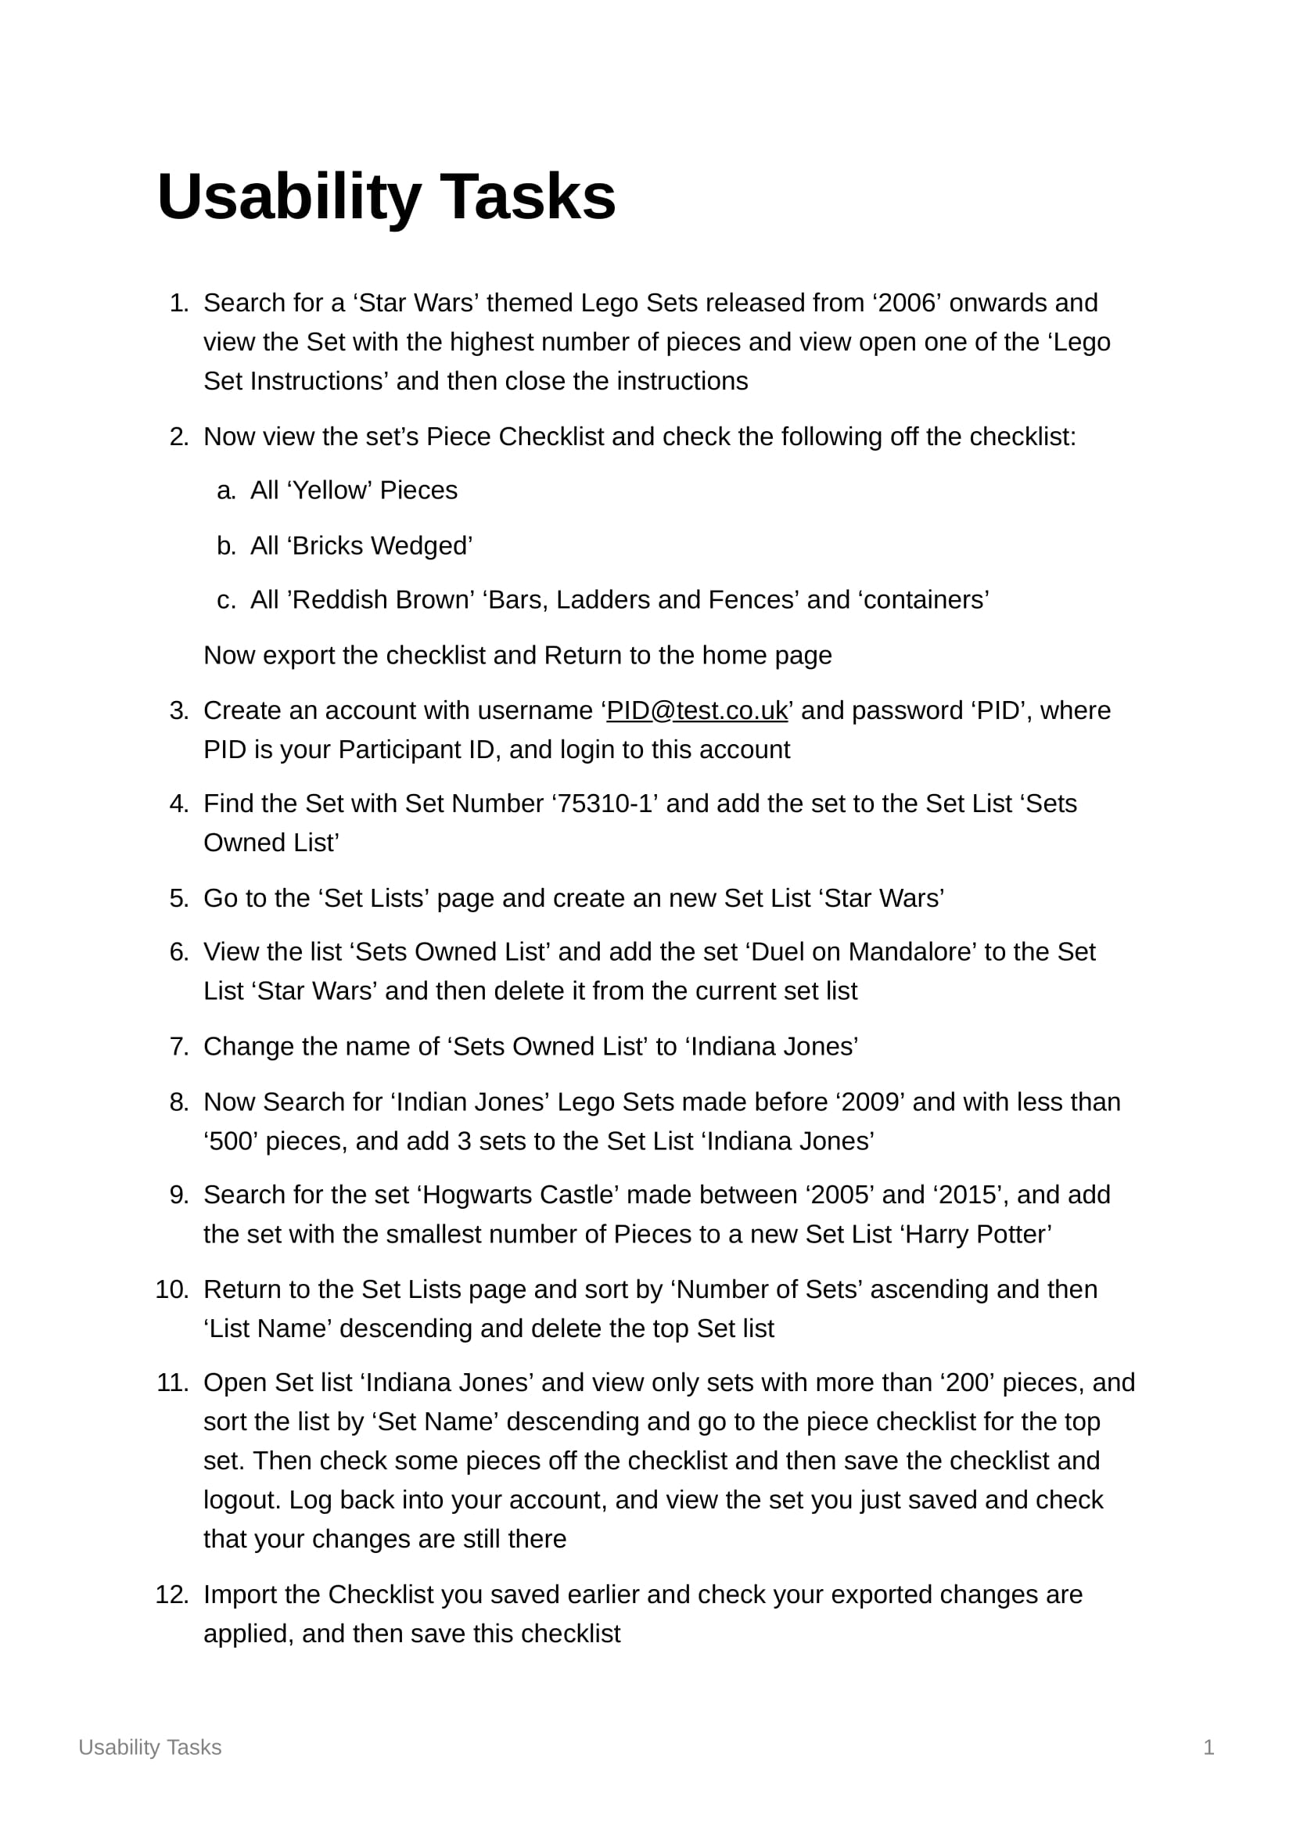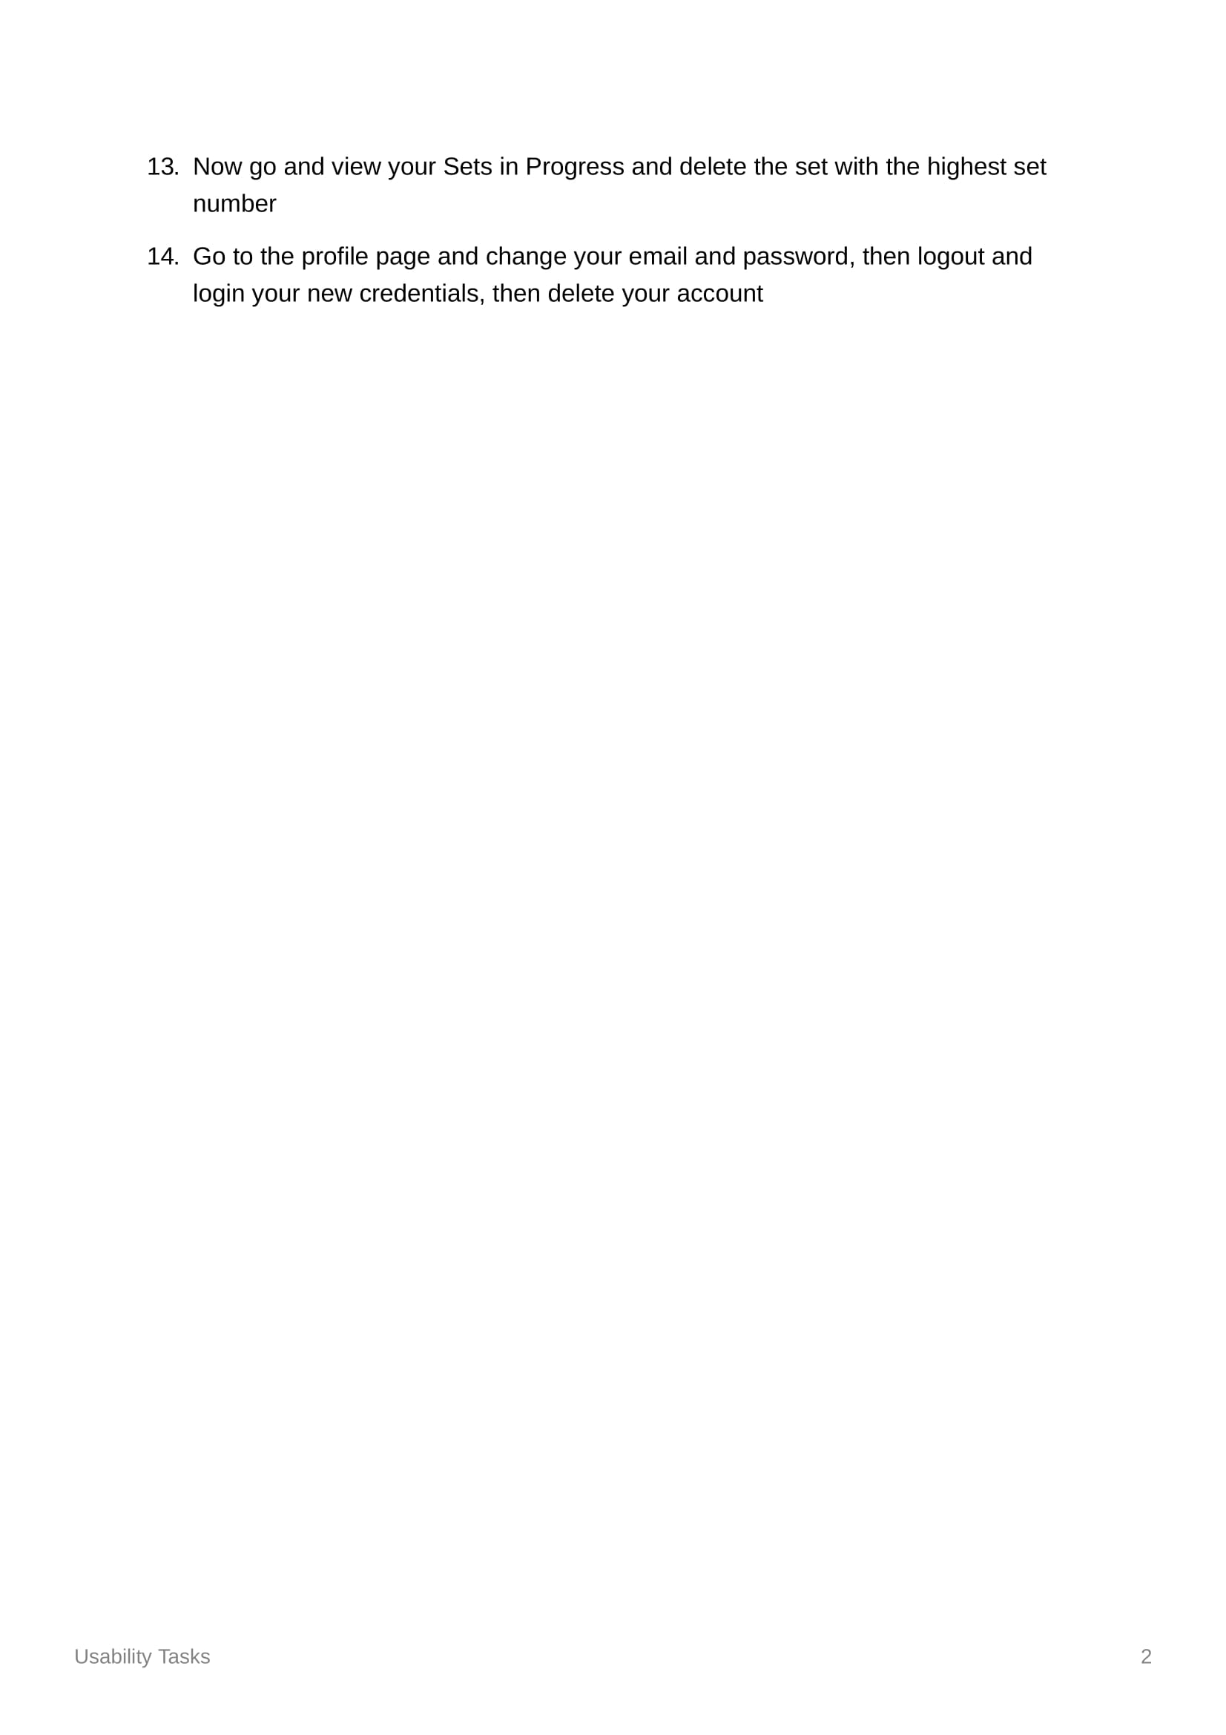

## Appendix D

Questionnaire on the Usability of my website.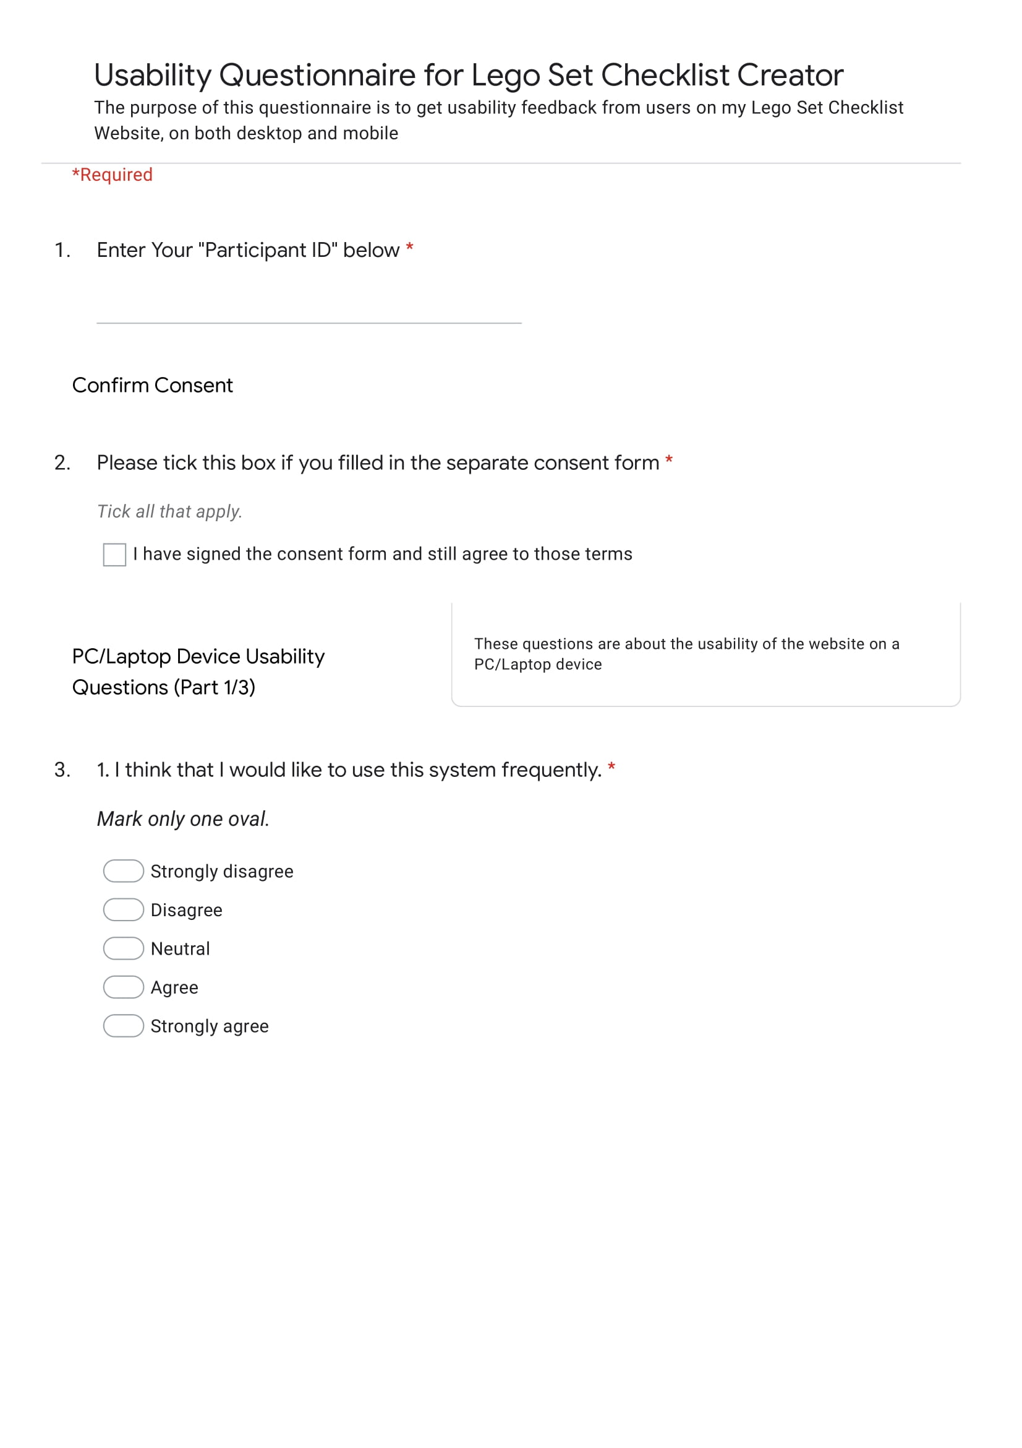 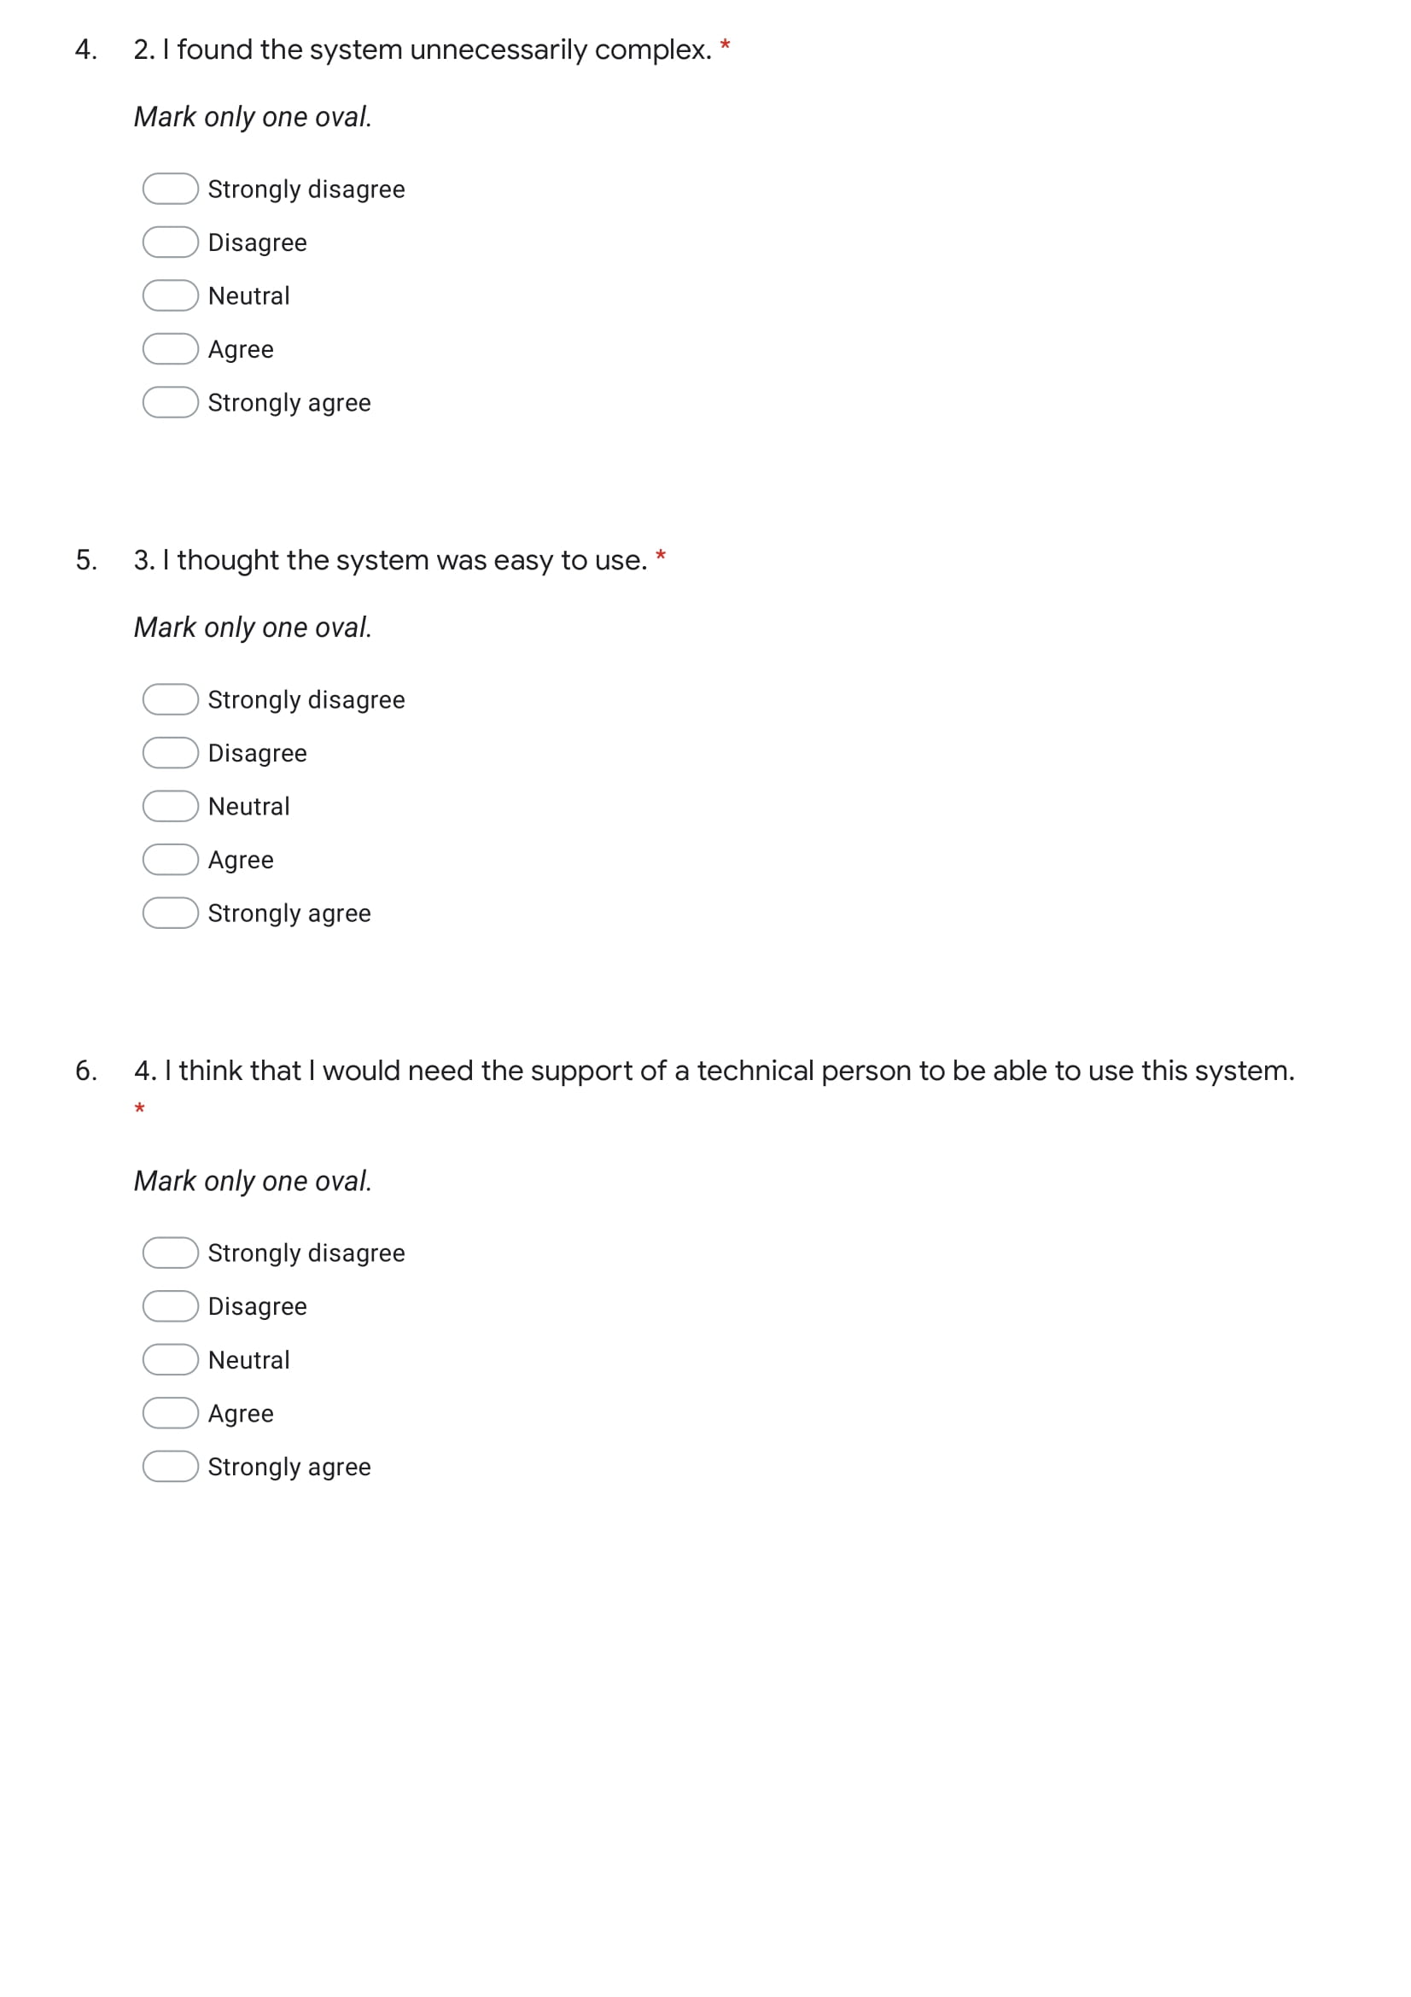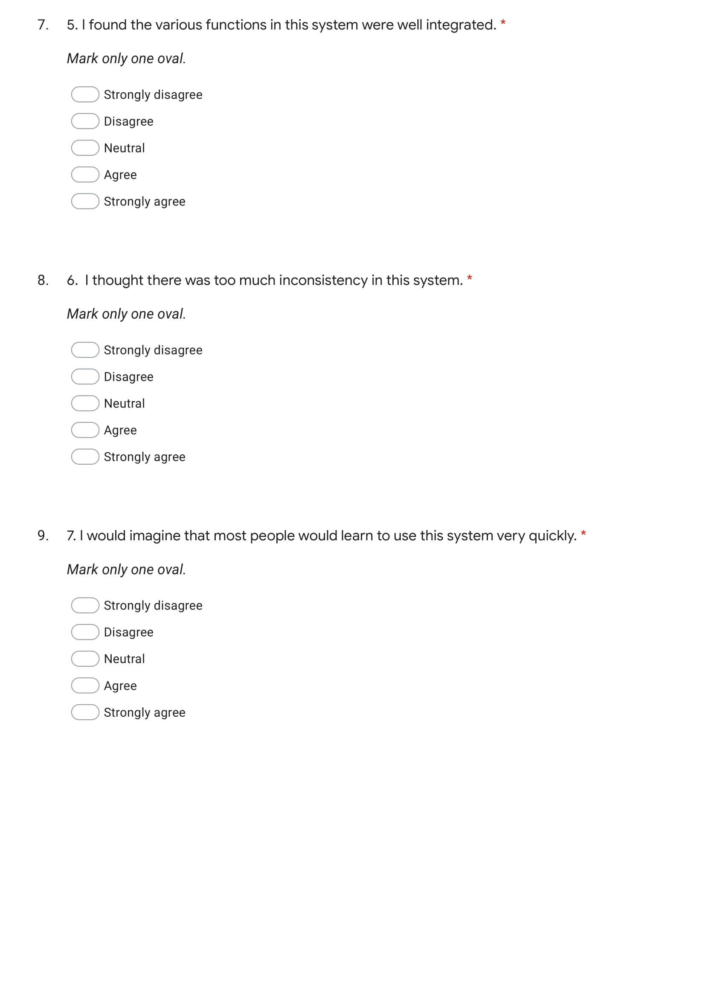

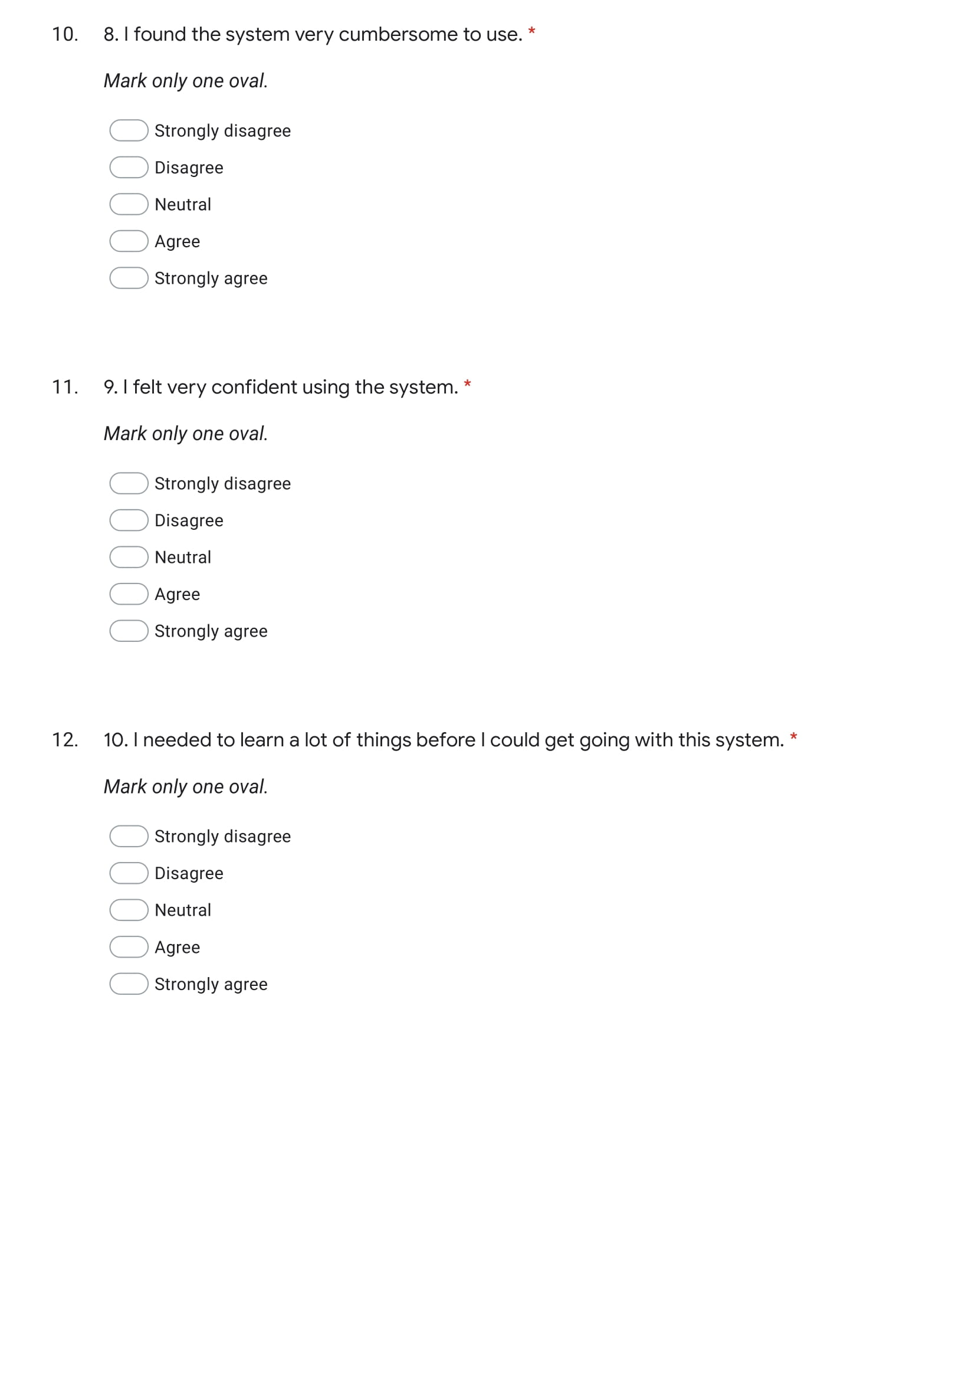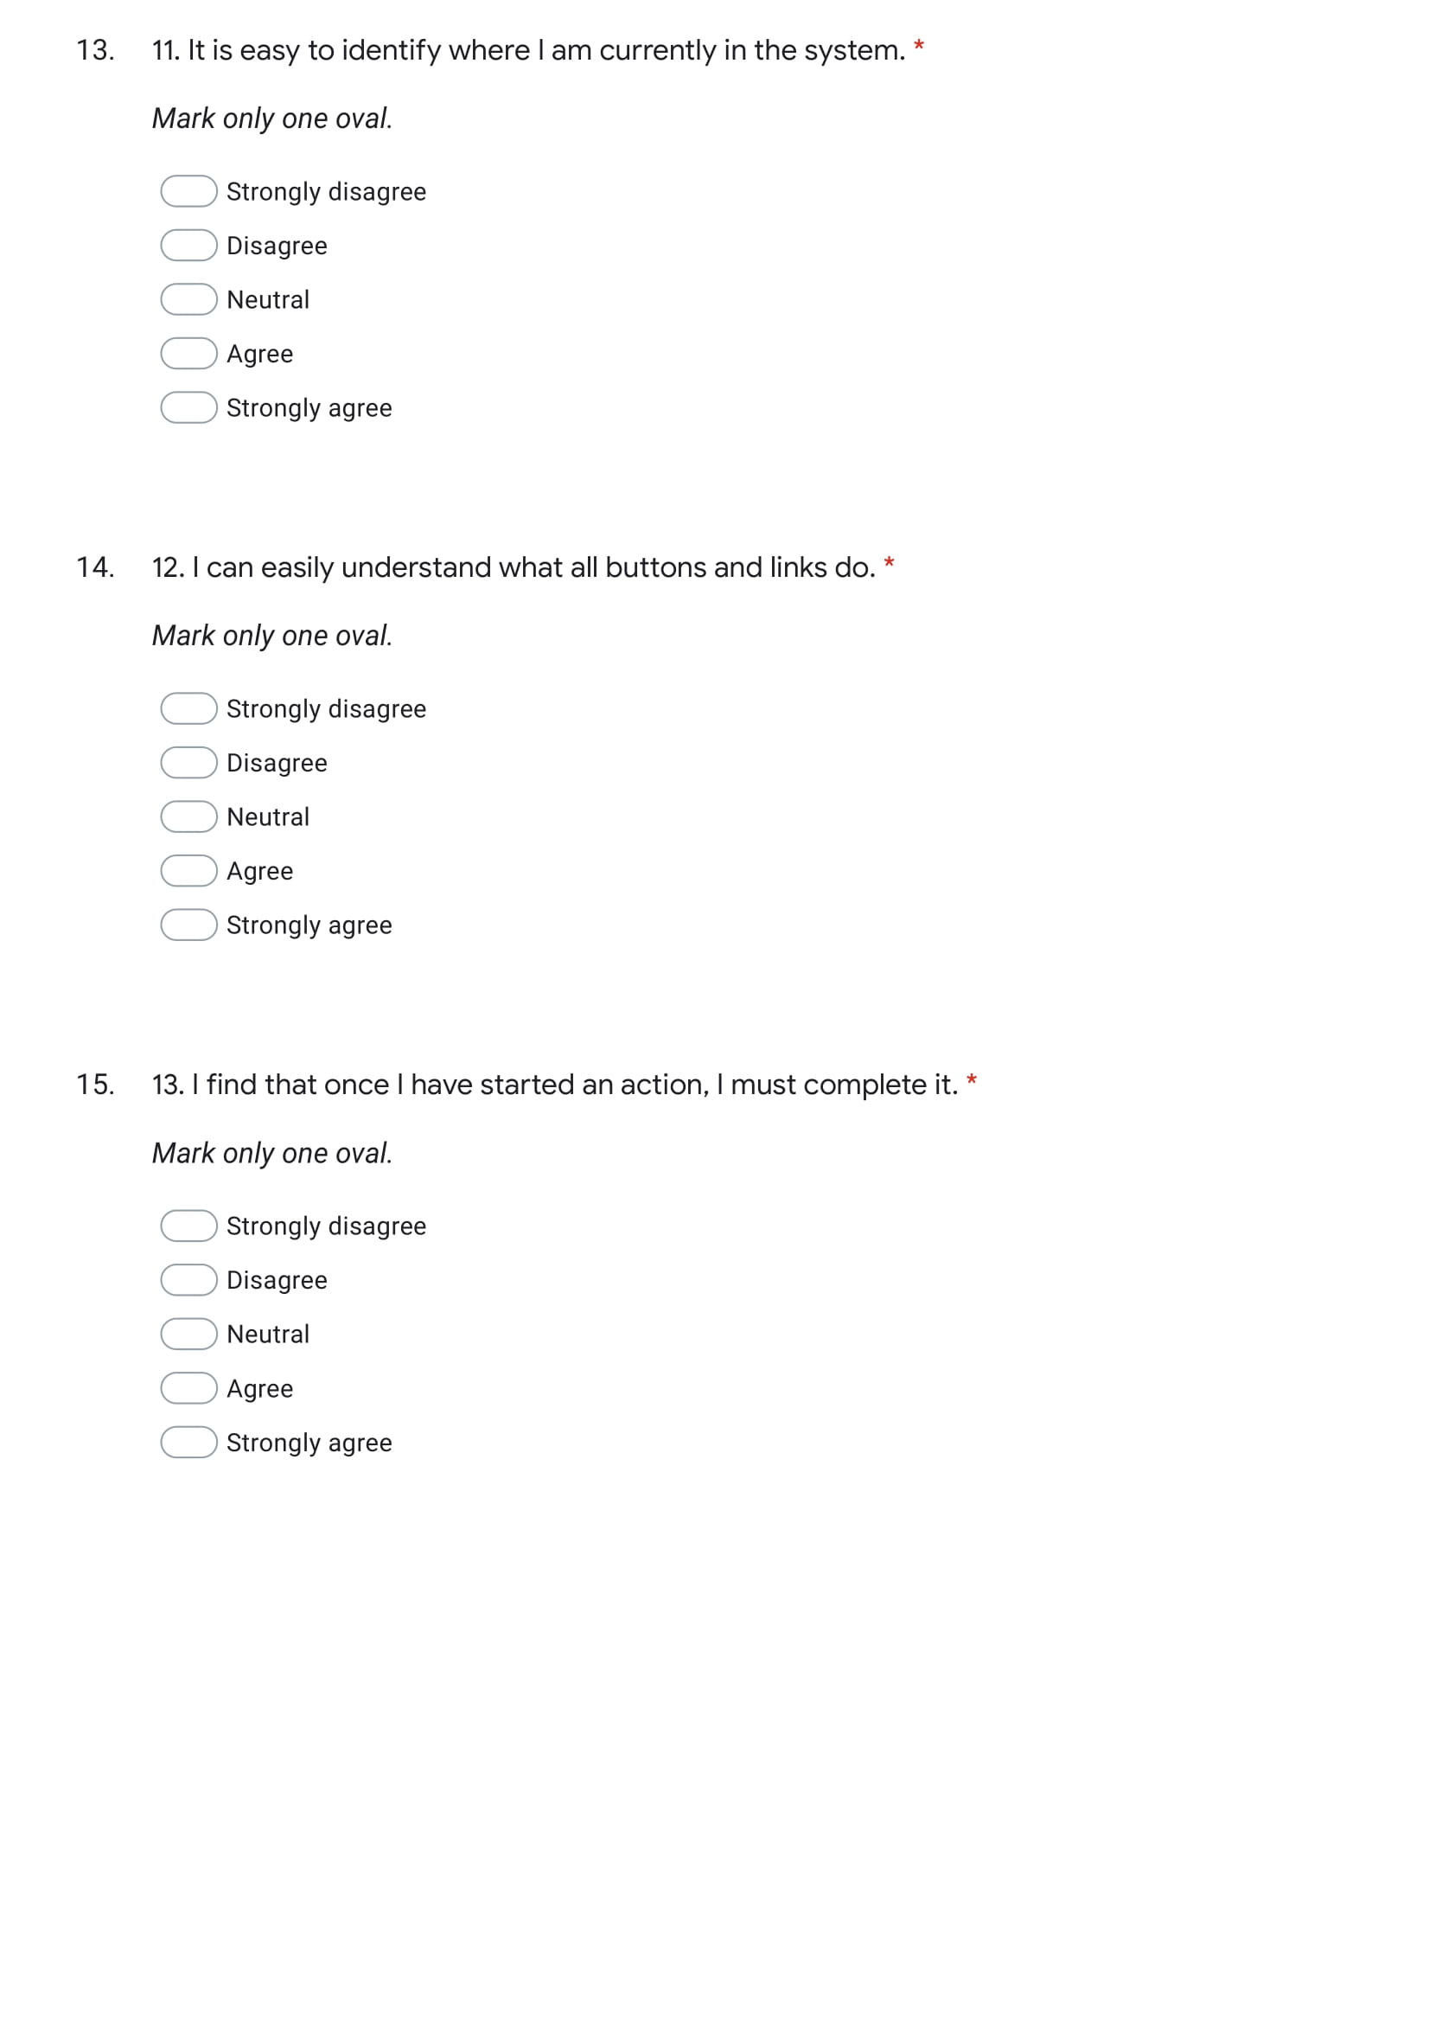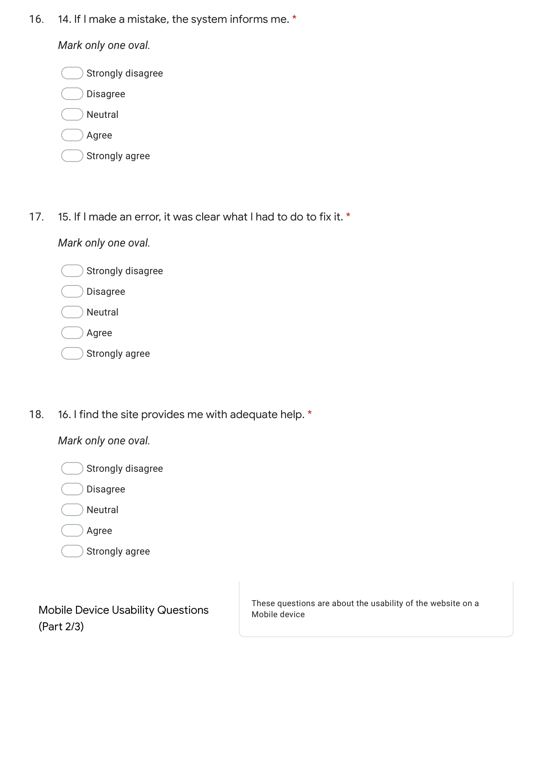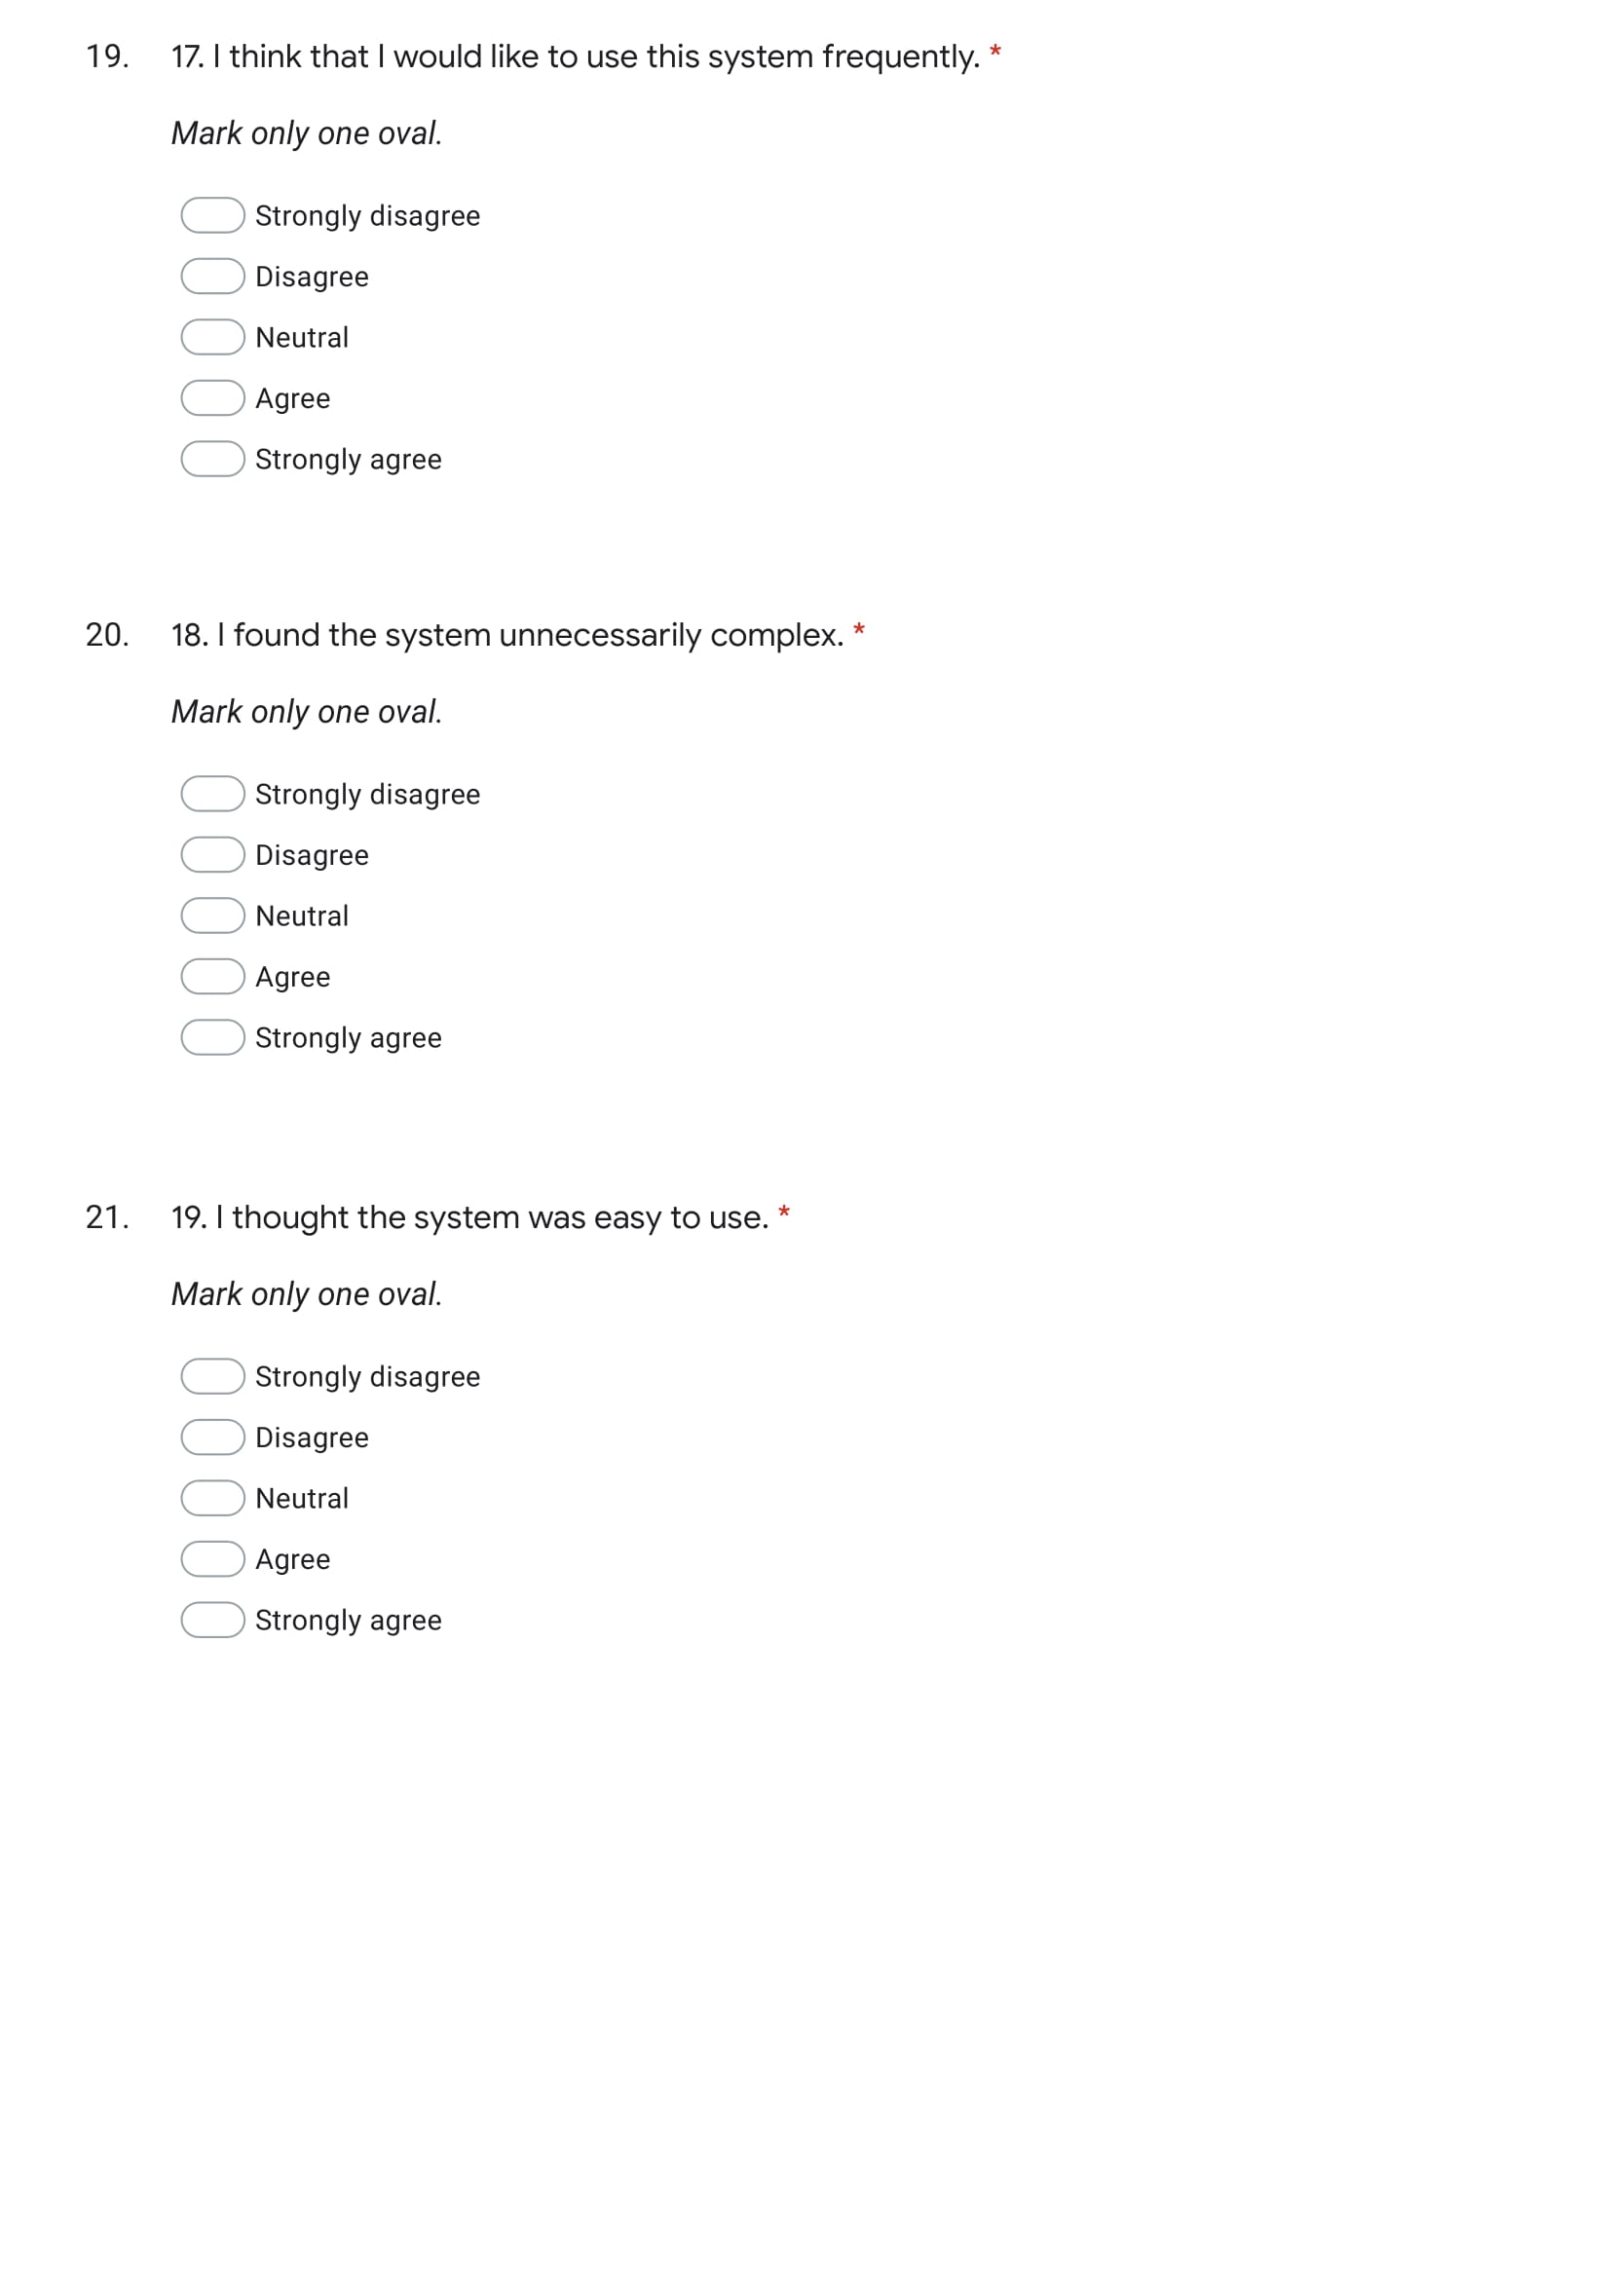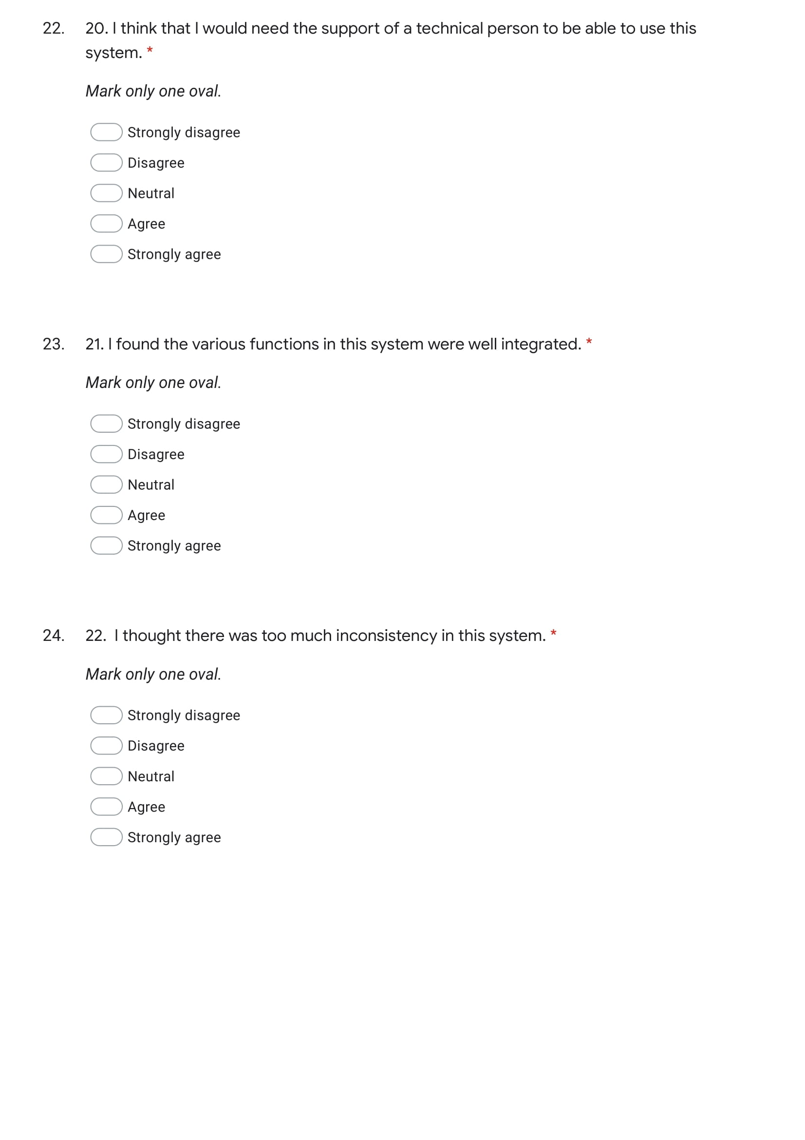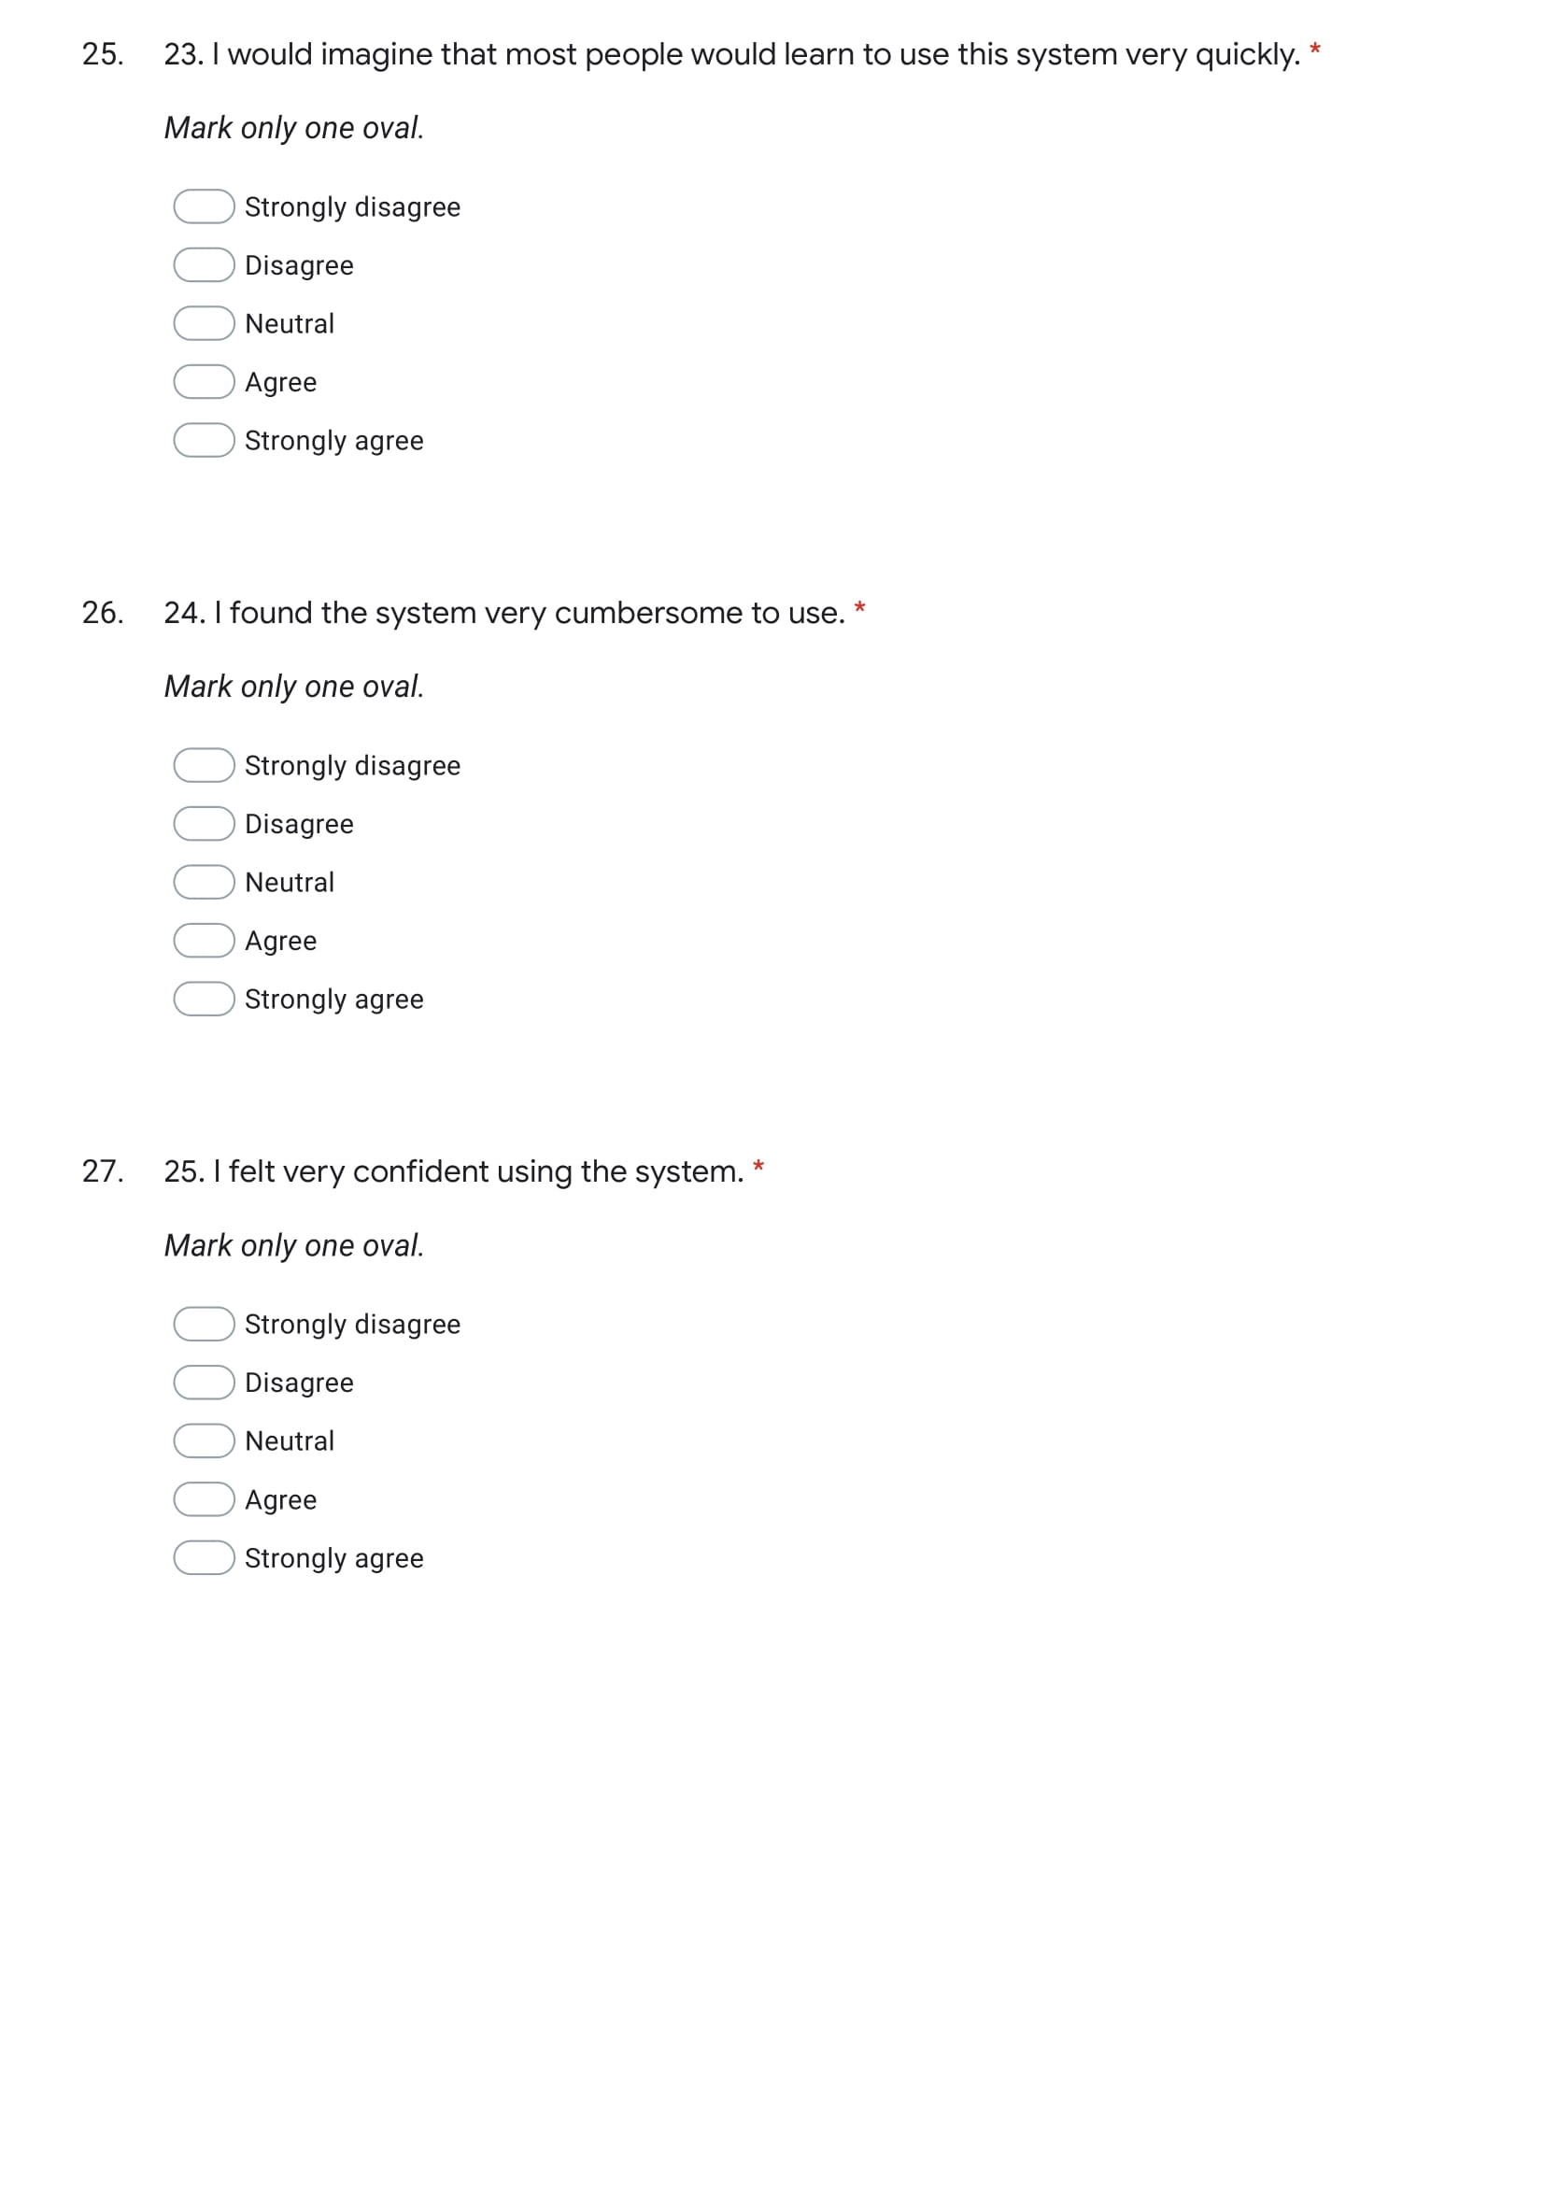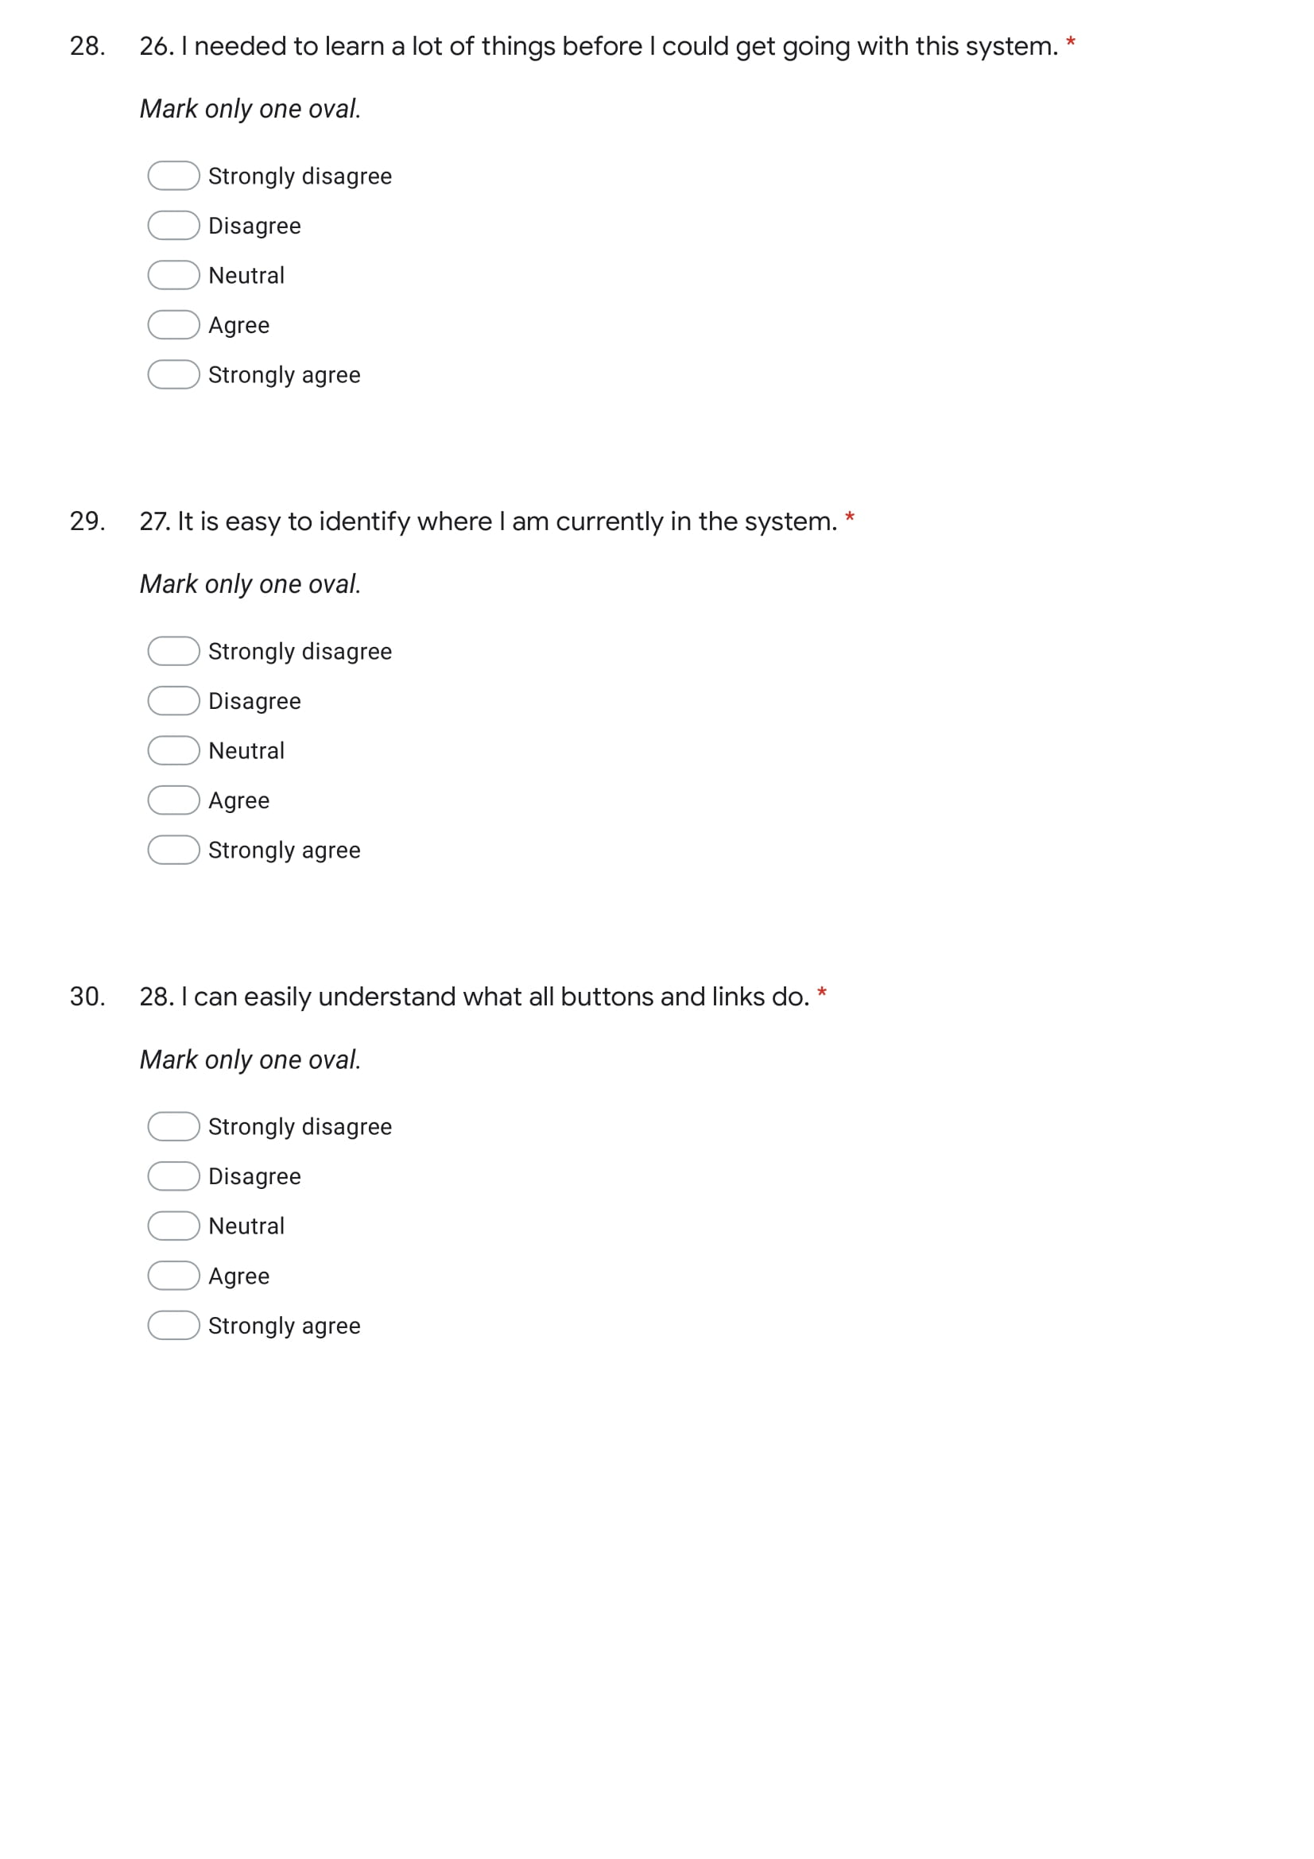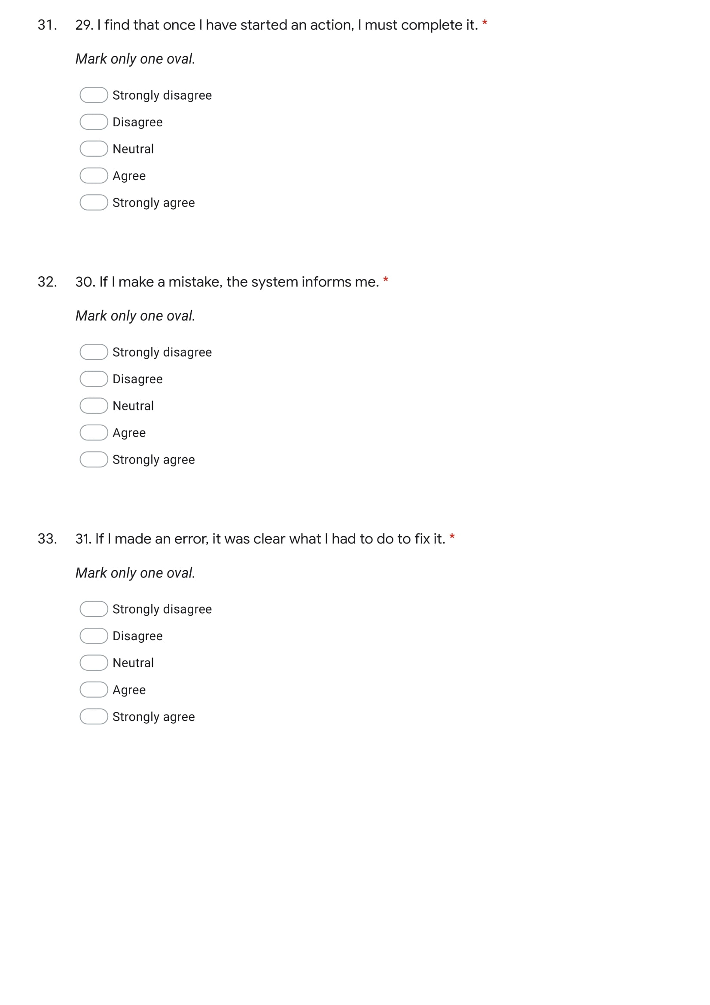

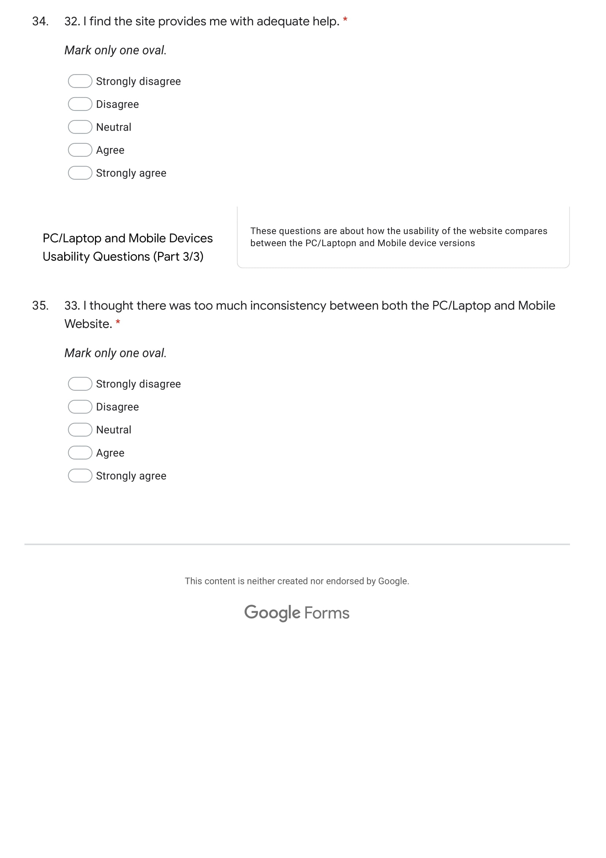



## Appendix E

Interview questions on the Usability of my website.

